Community Awareness Activity

Responding to Concerning Posts on Social Media

Time: 30-60 minutes

Objectives:
- Adults will understand what a ‘concerning post’ is
- Adults will identify themselves as a ‘Trusted Adult’
- Demonstrate and practice their understanding of the ‘View Care Plan’

Materials:
- Access the Responding to Concerning Posts on Social Media video: https://www.youtube.com/watch?v=tnAr5QqX29k
- A projector, screen, and audio equipment, if you’re showing it to a large group
- Double-sided copies of the Viewer Care Plan (pg. 5-6)
- Copies of the Role-Play Activity (pg. 7-14)
- Scissor
- Pencils/pens
- Box or container

Preparation:
Watch the Responding to Concerning Posts on Social Media video. Double check that your audio equipment (speakers and projector) are functioning and that the video is loaded for easy access. *If streaming from the Internet, you might want to buffer the video first (pull the video up, pause it, and wait until it is fully loaded – the grey bar at the bottom will show the full length of video). This will ensure you won’t have delays when playing the video. You can always download the video to your computer if you are showing the video away from Wi-Fi or have slow internet.

Research where youth can go in your community for mental health help (i.e. local counselor/clinic) and fill in pg. 6.

Print double-sided the Viewer Care Plan (pg. 5-6). Each attendee will need a copy.

Review the instructions, print, and cut the half-page prompts for the Role-Play Activity (starting on pg. 7). You will need 4 of each prompt (i.e. 2 copies of each page); one prompt for each member of the 4-person group. If you use all these prompts you’ll have enough for a group of 32. Repeat prompts, or take away depending on your group size. Put the half-page prompts in a box and mix them up. Have pens or pencils available as needed.

Invite a counselor to attend your event, in case youth participants would like to talk to someone after participating in the discussion.

Write on butcher paper or a white board local and national mental health resources: National Suicide Prevention Lifeline: 1-800- 273-8255 or Text START to 741741 We R Native: www.weRnative.org QPR Institute: www.qprinstitute.com

Depending on the amount of time available, the set-up of your facility, and the needs of your audience, please deliver one or more of the following activities:
- As a large group (5 minutes)
- Say, “Welcome and thank you for coming. Today we are going to watch a video on how to help youth who post or view concerning posts on social media. The video will take about a half an hour to watch.
As you know, our youth are constantly on social media channels, like Instagram, Facebook, Twitter, Snapchat, and YouTube. When they are there, youth report that they frequently see posts that reference concerning topics, like depression, substance use, suicidality, or intent to harm others.
We will learn more about this issue during the video. After the video is done, we will do a role-play activity to better understand: 1) what a ‘concerning post’ is, 2) who youth can turn to if they post or view a concerning post, and 3) the three steps for helping a youth, using a Viewer Care Plan.
This can be a hard topic to talk about, so if you are feeling like you need a break - it’s ok to step out for a moment, or to come talk to me about it after we’re done.”
Distribute the Viewer Care Plan (pg. 5) to each person and ask them to review it.
- Watch the Responding to Concerning Posts on Social Media video (30 minutes)
- Role-Play Activity (15 minutes)
        - Say, “Now we are going to do a role-play activity using the Viewer Care Plan. Each person will play a part in the role-play.”
        - Break participants into groups of 4 by having them pull a “concerning post” prompt out of the box.
Reminder: You will need 4 copies of each prompt (i.e. 2 copies of each page); one prompt for each member of the 4-person group. Put the half-page prompts in a box and mix them up. Have pens or pencils available as needed.
- Say, “Please come pull a prompt and find the other members in your group. As you walk around, find your group members with the matching prompt.”
- Say, “If the roleplay you picked has a statement on it that is too personal or hits too close to home, remember you can take a moment and come talk to me.”
        - Then say, “Once you have found your group, introduce yourself (Name, Tribe, Age, City you live in or your favorite food).
        - Say, “Next, count off one thru four, to assign your roles.” Then explain their assigned roles. People who are:
              - Ones – will act out Step 1: Start the Conversation
              - Twos – will act out Step 2: Listen Carefully and Gather Information
              - Threes – will act out Step 3: Plan & Act (QPR)
              - Fours – if any youth are involved they can read off the concerning post prompt to the group. Otherwise, an adult can act out the youth role.
- Say, “Let’s take a minute to think about how you will act out your assigned role. Read your prompt. Take a look at the Viewer Care Plan and I will let you know when your minute is up.”
- Use a timer, cell phone, or clock to time one-minute for thinking.
- Once the minute is up, say, “Have the person in your group who is a ‘four’ (or the youth in your group) begin by reading your “concerning post” prompt out loud to their group.
Starting with Step 1, have each member practice their role responding to the youth’s post, until each step has been role-played. Provide encouragement or suggestions to your group members as you go along. Remember, we are all in this together and each person in this room is a ‘trusted adult’.”
- Say, “We will take 10-15 minutes for this activity, then I will ask for a couple group(s) to act out their scenario. Any questions before we start? Okay, go.”
- Use a timer, cell phone, or clock to time ten-minutes. Monitor the discussion. Give them more or less time depending on the group. Let them know how much time they have left. For example, give them a five minute and one minute warning to let them know when it’s time to start wrapping things up.
- As a group (10 minutes)
- Ask the group to come back to their original seating, or stay where they’re at depending on room set-up.
- Ask a couple groups to share their scenario. They can come to the front of room, or share from their spots depending on their comfort level. Have them start with their prompt and work through each step.
- Have the whole group offer support or ideas to strengthen each scenario.
- Other tips you can share, if they don’t come up naturally during the discussion:
Try to respond quickly and give youth LOTS of reassurance so they know they did the right thing by reaching out to you: “I’m so glad you noticed this and shared it with me.”
Be clear about your roles moving forward: “I’ll follow-up with their [coach after practice].” Or “I’ll call their mom right now. Don’t worry, I’ll take it from here.”
Most importantly, take the responsibility off the youth to respond – you are better equipped to get help than they are.
- Closing (5 minutes)
- Say, “It can be hard to feel like you have all the answers when a youth tells you they have posted or viewed a concerning post on social media.
However, when it comes down to it, as a member of this community, youth need to know they can count on you to talk about concerning posts, show them that you care, and help connect them to appropriate resources. This is how we can protect our youth and take care of our community.
As a reminder, these are the resources you can connect youth to: (Point out the prepared butcher paper or white board with the list you prepared ahead of time – see ‘preparation’ section.)
Thank you all for your willingness to learn about Concerning Social Media Posts, and for supporting one another to protect our youth.

- End on a Positive Note (3 minutes)
- Debrief if needed.
- Remind folks that they can access the full training on the Healthy Native Youth website (https://www.healthynativeyouth.org/), along with print out the Viewer Care Plan poster, tip cards, handouts, and youth activities.
- End your session with a game, a song, a joke… something fun to lighten the mood.

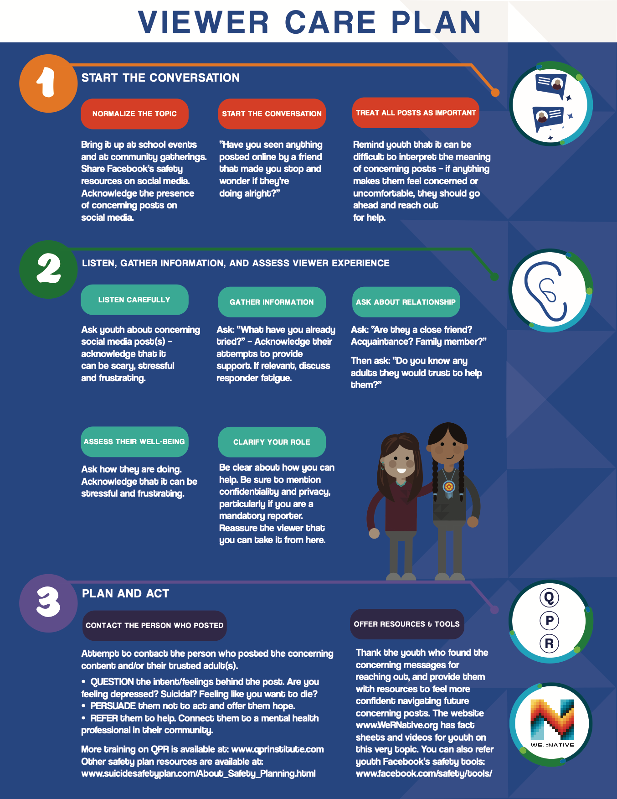
Local Resources:
(include names, location, and contact information for youth resources)

Name | Title | Location | Phone | Email
 | School Counselor
 | Tribal Clinic
 | Mental Health Counselor

My Phone # (optional – delete whole line, if you prefer not to give your # out)

Other Resources:
988 Suicide and Crisis Lifeline:
Call: 988
Text: NATIVE to 741741
Chat: 24/7 to https://988lifeline.org/chat

We R Native: https://www.wernative.org/
Ask Your Relative: https://www.wernative.org/ayr

SAMSHA – Type in your zip code to the web address below to find a clinic closest to you.
https://findtreatment.samhsa.gov/

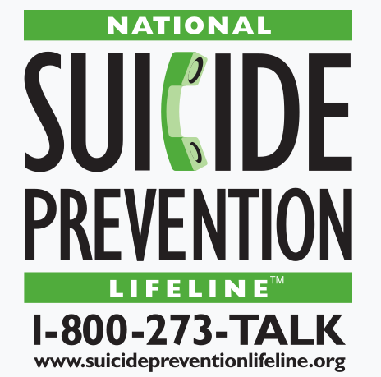
Role-Play Activity

Act out your assigned role.
One’s – will act out Step 1: Start the Conversation.
Two’s – will act out Step 2: Listen Carefully and Gather Information.
Three’s – will act out Step 3: Plan & Act (QPR).
Four’s – if youth are involved they can read off the concerning post prompt to the group. Otherwise, an adult can act out the youth role.

Review the Viewer Care Plan.
Provide encouragement to your group members as you go along.
Here’s your groups PROMPT:

-------------------------------------------------------------------------------------------------

Role-Play Activity

Act out your assigned role.
One’s – will act out Step 1: Start the Conversation.
Two’s – will act out Step 2: Listen Carefully and Gather Information.
Three’s – will act out Step 3: Plan & Act (QPR).
Four’s – if youth are involved they can read off the concerning post prompt to the group. Otherwise, an adult can act out the youth role.

Review the Viewer Care Plan.
Provide encouragement to your group members as you go along.
Here’s your groups PROMPT:

Role-Play Activity

Act out your assigned role.
One’s – will act out Step 1: Start the Conversation.
Two’s – will act out Step 2: Listen Carefully and Gather Information.
Three’s – will act out Step 3: Plan & Act (QPR).
Four’s – if youth are involved they can read off the concerning post prompt to the group. Otherwise, an adult can act out the youth role.

Review the Viewer Care Plan.
Provide encouragement to your group members as you go along.
Here’s your groups PROMPT:

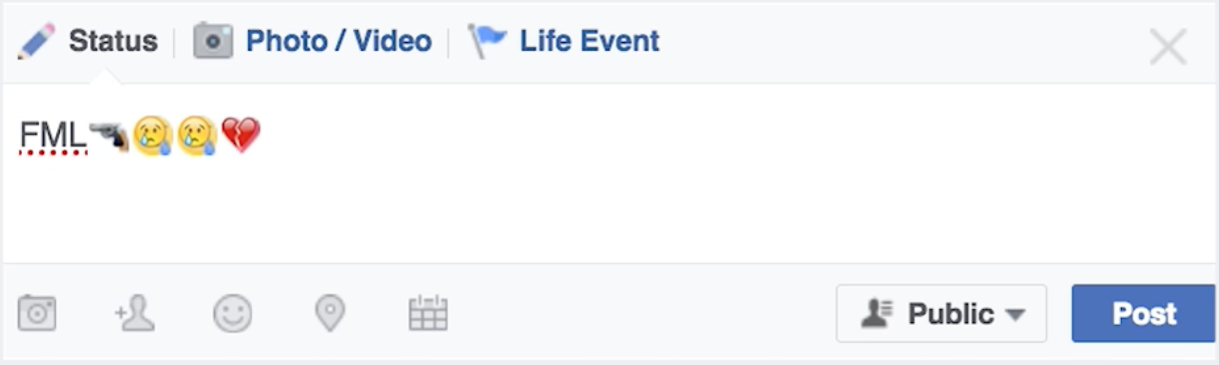
-------------------------------------------------------------------------------------------------

Role-Play Activity

Act out your assigned role.
One’s – will act out Step 1: Start the Conversation.
Two’s – will act out Step 2: Listen Carefully and Gather Information.
Three’s – will act out Step 3: Plan & Act (QPR).
Four’s – if youth are involved they can read off the concerning post prompt to the group. Otherwise, an adult can act out the youth role.

Review the Viewer Care Plan.
Provide encouragement to your group members as you go along.
Here’s your groups PROMPT:

Role-Play Activity

Act out your assigned role.
One’s – will act out Step 1: Start the Conversation.
Two’s – will act out Step 2: Listen Carefully and Gather Information.
Three’s – will act out Step 3: Plan & Act (QPR).
Four’s – if youth are involved they can read off the concerning post prompt to the group. Otherwise, an adult can act out the youth role.

Review the Viewer Care Plan.
Provide encouragement to your group members as you go along.
Here’s your groups PROMPT:

-------------------------------------------------------------------------------------------------

Role-Play Activity

Act out your assigned role.
One’s – will act out Step 1: Start the Conversation.
Two’s – will act out Step 2: Listen Carefully and Gather Information.
Three’s – will act out Step 3: Plan & Act (QPR).
Four’s – if youth are involved they can read off the concerning post prompt to the group. Otherwise, an adult can act out the youth role.

Review the Viewer Care Plan.
Provide encouragement to your group members as you go along.
Here’s your groups PROMPT:

Role-Play Activity

Act out your assigned role.
One’s – will act out Step 1: Start the Conversation.
Two’s – will act out Step 2: Listen Carefully and Gather Information.
Three’s – will act out Step 3: Plan & Act (QPR).
Four’s – if youth are involved they can read off the concerning post prompt to the group. Otherwise, an adult can act out the youth role.

Review the Viewer Care Plan.
Provide encouragement to your group members as you go along.
Here’s your groups PROMPT:

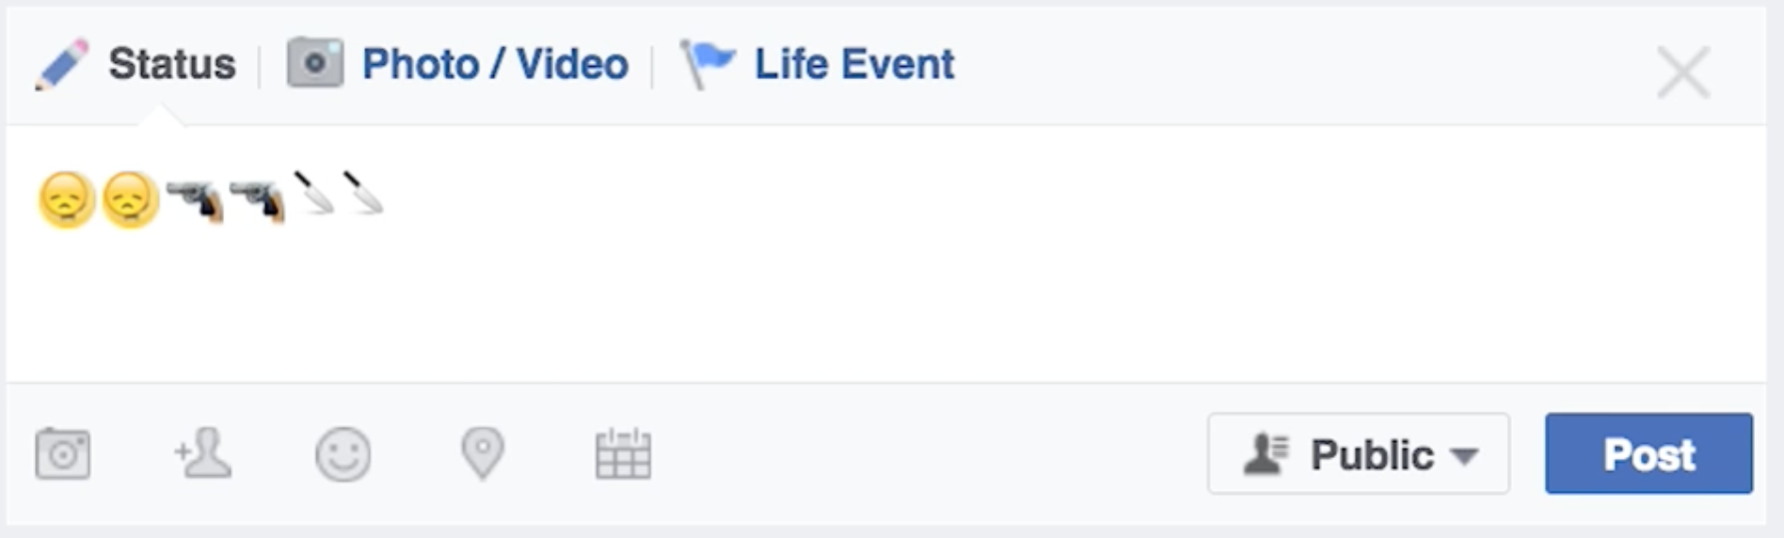

-------------------------------------------------------------------------------------------------

Role-Play Activity

Act out your assigned role.
One’s – will act out Step 1: Start the Conversation.
Two’s – will act out Step 2: Listen Carefully and Gather Information.
Three’s – will act out Step 3: Plan & Act (QPR).
Four’s – if youth are involved they can read off the concerning post prompt to the group. Otherwise, an adult can act out the youth role.

Review the Viewer Care Plan.
Provide encouragement to your group members as you go along.
Here’s your groups PROMPT:

Role-Play Activity

Act out your assigned role.
One’s – will act out Step 1: Start the Conversation.
Two’s – will act out Step 2: Listen Carefully and Gather Information.
Three’s – will act out Step 3: Plan & Act (QPR).
Four’s – if youth are involved they can read off the concerning post prompt to the group. Otherwise, an adult can act out the youth role.

Review the Viewer Care Plan.
Provide encouragement to your group members as you go along.
Here’s your groups PROMPT:

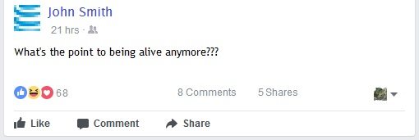

-------------------------------------------------------------------------------------------------
Role-Play Activity

Act out your assigned role.
One’s – will act out Step 1: Start the Conversation.
Two’s – will act out Step 2: Listen Carefully and Gather Information.
Three’s – will act out Step 3: Plan & Act (QPR).
Four’s – if youth are involved they can read off the concerning post prompt to the group. Otherwise, an adult can act out the youth role.

Review the Viewer Care Plan.
Provide encouragement to your group members as you go along.
Here’s your groups PROMPT:

Role-Play Activity

Act out your assigned role.
One’s – will act out Step 1: Start the Conversation.
Two’s – will act out Step 2: Listen Carefully and Gather Information.
Three’s – will act out Step 3: Plan & Act (QPR).
Four’s – if youth are involved they can read off the concerning post prompt to the group. Otherwise, an adult can act out the youth role.

Review the Viewer Care Plan.
Provide encouragement to your group members as you go along.
Here’s your groups PROMPT

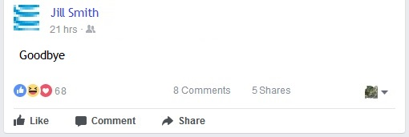
-------------------------------------------------------------------------------------------------

Role-Play Activity

Act out your assigned role.
One’s – will act out Step 1: Start the Conversation.
Two’s – will act out Step 2: Listen Carefully and Gather Information.
Three’s – will act out Step 3: Plan & Act (QPR).
Four’s – if youth are involved they can read off the concerning post prompt to the group. Otherwise, an adult can act out the youth role.

Review the Viewer Care Plan.
Provide encouragement to your group members as you go along.
Here’s your groups PROMPT

Role-Play Activity

Act out your assigned role.
One’s – will act out Step 1: Start the Conversation.
Two’s – will act out Step 2: Listen Carefully and Gather Information.
Three’s – will act out Step 3: Plan & Act (QPR).
Four’s – if youth are involved they can read off the concerning post prompt to the group. Otherwise, an adult can act out the youth role.

Review the Viewer Care Plan.
Provide encouragement to your group members as you go along.
Here’s your groups PROMPT

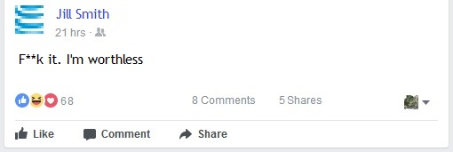
-------------------------------------------------------------------------------------------------

Role-Play Activity

Act out your assigned role.
One’s – will act out Step 1: Start the Conversation.
Two’s – will act out Step 2: Listen Carefully and Gather Information.
Three’s – will act out Step 3: Plan & Act (QPR).
Four’s – if youth are involved they can read off the concerning post prompt to the group. Otherwise, an adult can act out the youth role.

Review the Viewer Care Plan.
Provide encouragement to your group members as you go along.
Here’s your groups PROMPT

Role-Play Activity

Act out your assigned role.
One’s – will act out Step 1: Start the Conversation.
Two’s – will act out Step 2: Listen Carefully and Gather Information.
Three’s – will act out Step 3: Plan & Act (QPR).
Four’s – if youth are involved they can read off the concerning post prompt to the group. Otherwise, an adult can act out the youth role.

Review the Viewer Care Plan.
Provide encouragement to your group members as you go along.
Here’s your groups PROMPT

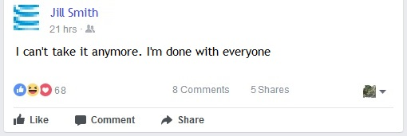
-------------------------------------------------------------------------------------------------

Role-Play Activity

Act out your assigned role.
One’s – will act out Step 1: Start the Conversation.
Two’s – will act out Step 2: Listen Carefully and Gather Information.
Three’s – will act out Step 3: Plan & Act (QPR).
Four’s – if youth are involved they can read off the concerning post prompt to the group. Otherwise, an adult can act out the youth role.

Review the Viewer Care Plan.
Provide encouragement to your group members as you go along.
Here’s your groups PROMPT

