Youth Awareness Activity

Responding to Concerning Posts on Social Media

Time: 30-60 minutes

Objectives:
- Youth will understand what a ‘concerning post’ is
- Youth will reach out to a ‘Trusted Adult’
- Identify local and national mental health resources

Materials:
- Access the Responding to Concerning Posts on Social Media video: https://www.youtube.com/watch?v=tnAr5QqX29k
- A projector, screen, and audio equipment, if showing the video to a large group
- Double-sided copies of the Youth Handout (pg. 6-7)
- Copies of the Role-Play Activity (pg. 8-15)
- Scissor
- Pencils/pens
- Box or container

Preparation:
Watch the Responding to Concerning Posts on Social Media video. Double check that your audio equipment (speakers and projector) are functioning and that the video is loaded for easy access. *If streaming from the Internet, you might want to buffer the video first (pull the video up, pause it, and wait until it is fully loaded – the grey bar at the bottom will show the full length of video). This will ensure you won’t have delays when playing the video. You can always download the video to your computer if you are showing the video away from Wi-Fi or have slow internet.

Research where youth can go in your community for mental health help (i.e. local counselor/clinic) and fill in pg. 7.

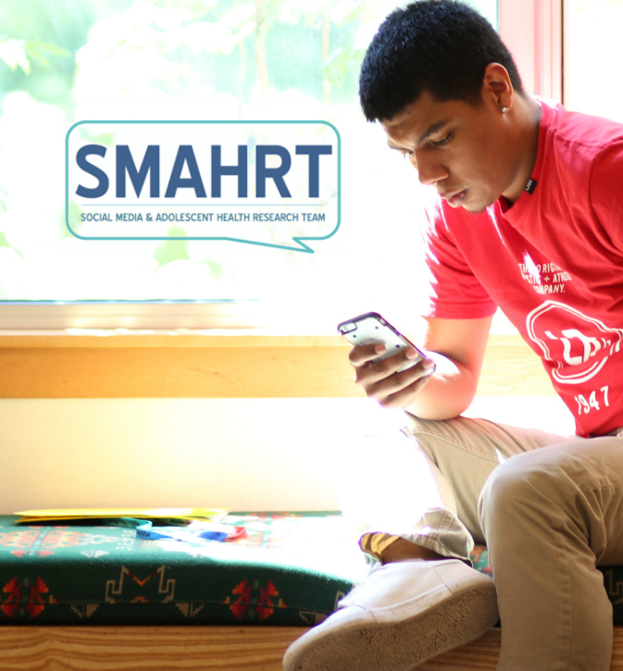
Print double-sided the Youth Handout (pg. 6-7), one copy for each participant.

Review the instructions, print, and cut the half-page prompts for the Role-Play Activity (pg.’s 8-15). You will need 4 copies of each prompt (i.e. 2 copies of each page); one prompt for each member of the 4-person group. If you use all these prompts you’ll have enough for a group of 32. Repeat prompts, or take away depending on your group size. Put the half-page prompts in a box and mix them up. Have pens or pencils available as needed.

Invite a counselor to attend your event, in case youth participants would like to talk to someone after participating in the discussion.
Write on butcher paper or a white board, local and national mental health resources: National Suicide Prevention Lifeline: 1-800- 273-8255
Text START to 741741 We R Native: www.weRnative.org

Depending on the amount of time available, the set-up of your facility, and the needs of your audience, please deliver one or more of the following activities:
- As a large group (5 minutes)
- Say, “Welcome and thank you for coming today. As you know, many of us use social media channels like Instagram, Facebook, Twitter, Snapchat, and YouTube.
Most youth say that they see posts about concerning topics, like depression, substance use, suicidality, or self-harm in their social media feeds.
Have any of you seen a post that made you worried about another person?
No need to raise your hand for this one, but have you ever posted something that would make someone worry about you?
Today, we will learn more about this by watching a short video. After the video, we will do a role-play activity to better understand: 1) what a ‘concerning post’ is, 2) who we can reach out to, and 3) connecting to local and national health resources.
This can be a hard topic to talk about, so if you are feeling like you need a break - it’s ok to step out for a moment, or to come talk to me about it after we’re done.”
- Show 6 minutes of the Responding to Concerning Posts on Social Media video – from time point 2:08 to 8:17. (The video was designed for adult health educators. We recommend that you do not show the entire video to a youth audience.) (15 minutes)
- Discuss: “What do you think of Rose and Terrell’s experience?”
- “What helped Terrell pull through when he was feeling low?”
- Distribute the Youth Handout and ask them to review it. (5 minutes)
- Say, “We know it can feel stressful to post or view concerning posts, and not know what to say or do. Don’t feel like you need to determine whether the post is real or just stirring up drama… if it makes you feel worried or concerned for yourself or another person, you should follow your instinct. Go ahead and reach out to an adult for help.”
- Say, “Please take a look at your Youth Handout.”
- Ask: “Can I have a volunteer read the text out loud that goes along with “Share”? And another read the text for “Talk”…Another to read “Report” …And another to read “Chat?”
- Discuss as a group: “What challenges do you think young people face when they see post or view messages that concern them on social media?”
- Ask: “Do you think your response would be different if it were an acquaintance posting? Versus a close friend or family member?
- Ask: “Have you ever seen or experienced friends or family supporting another person through social media? What did that look like?”
- Brainstorm Resources: “What resources or adults could you reach out to for help in this community?”
Include the actual names of people in their community (i.e. nurse Julie). If they don’t mention it, add:
Adults: Parents, coaches, school counselors, teachers, me!
We R Native’s Ask Your Relative: https://www.wernative.org/ayr-questions/friends-posting-things-like-fml
Facebook: If you’re worried about someone who has posted content about suicide or self-harm on Facebook, you can report it (*And they won’t call the cops!). Go on Facebook and try to find where you can report content. Hint: to report content, click on the upper right hand corner of the post and select report. Facebook will reach out to that person with info that can help. For more info, visit: https://www.facebook.com/help/contact/305410456169423
*However, be aware, if they say they are going to kill themselves RIGHT NOW on social media, and a friend reports it as a concern, then they might get a police wellness visit initiated by Facebook (police will knock on their door).
- Role-Play Activity (15 minutes)
        - Say, “Now we are going to do a role-play activity using the Youth Handout to “Share, Talk, Report, Chat.” Each person will play a part in the role-play.
        - Break youth into groups of 4 by having them pull a “concerning post” prompt out of the box.
Reminder: You will need 4 copies of each prompt (i.e. 2 copies of each page); one prompt for each member of the 4-person group. Put the half-page prompts in a box and mix them up. Have pens or pencils available as needed.
- Say, “Please come pull a prompt and find the other members in your group. As you walk around, find your group members with the matching prompt.”
- Say, “If the roleplay you picked has a statement on it that is too personal or hits too close to home, remember you can take a moment and come talk to me.”
        - Then say, “Once you have found your group, introduce yourself (Name, Tribe, Age, City you live in or your favorite food).”
        - Say, “Next we will count off one through four, to assign your roles.” Then explain their assigned roles. People who are:
Ones will play the role of the person who posted the concerning message.
              - Twos will play the role of a youth who notices the post and shares their concerns with a trusted adult.
Threes will play the role of a youth who notices the post and reaches out to the friend directly.
Fours will play the role of a trusted adult.”
- Say: “Now that you know what role you will play, let’s take one minute to think about how you will act out your assigned role. Read your prompt. Take a look at the Youth Handout and I will let you know when your minute is up.”
- Use a timer, cell phone, or clock to time one-minute for thinking.
- Instructions: Once the minute is up, have the ‘ones’ begin by reading the “concerning post message” out loud. Then have each member practice their role responding to the concerning post, until all four roles have been played. Provide encouragement to your group members as you go along.
- Say, “We will take 10-15 minutes for this activity, then I will ask for a couple group(s) to act out their scene. Any questions before we start? Okay, go.”
- Use a timer, cell phone, or clock to time ten-minutes. Monitor the discussion. Give them more or less time depending on the group. Let them know how much time they have left. For example, give them a five minute and one minute warning to let them know when it’s time to start wrapping things up.
- As a group (10 minutes)
- Ask the groups to come back to their original seating, or stay where they’re at depending on room set-up.
- Ask a couple groups to share their scenario. They can come to the front of room, or share from their spots depending on their comfort level. Have them start with their prompt and work through each step.
- Have the large group offer support or ideas to strengthen each scenario.
- Other tips you can share with participants, if they don’t come up naturally during the discussion:
You do not need to respond to concerning posts alone. Adults are better equipped to get help.
If the first adult you reach out to isn’t especially helpful, try, and try again!
- Closing (5 minutes)
- Say, “It can be hard to feel like you know what to do when you, or a friend, or an acquaintance posts a concerning message on social media.
The good news is that you don’t need to respond alone. I am an adult you can reach out to. We’re also training adults in our community to help intervene. All you need to do is speak up if you see something. Don’t try to interpret its meaning; just get your adult involved. Please take your youth handout with you. There are local and national #’s include. Keep it for yourself or share with a friend.
Thank you all for your willingness to learn about Concerning Social Media Posts today. Thank you for supporting each other and those who may be struggling.
I’m available to talk anytime.”
- End on a Positive Note
- Debrief if needed.
- End your session with a game, a song, a joke… something fun to lighten the mood.
Youth Handouts
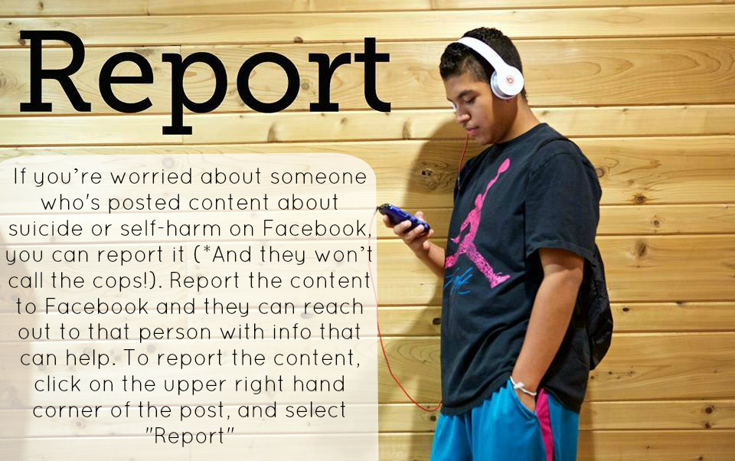
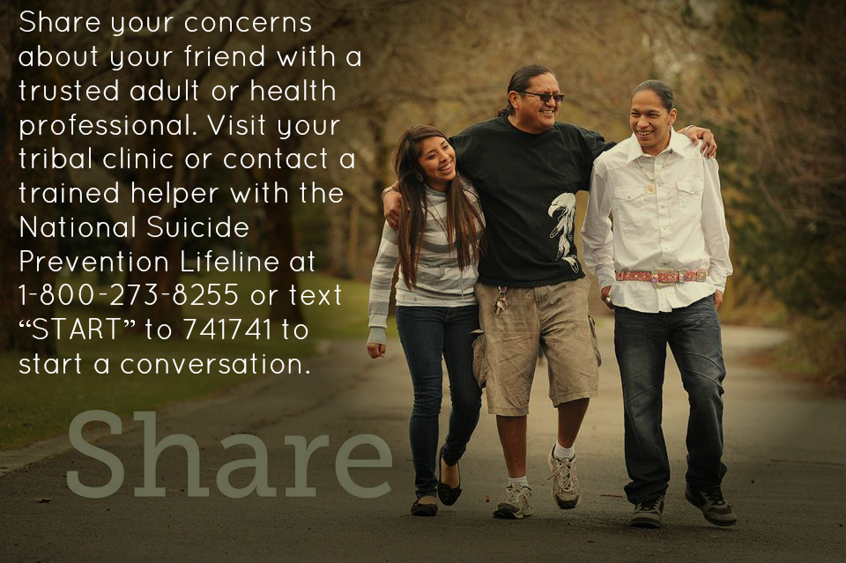

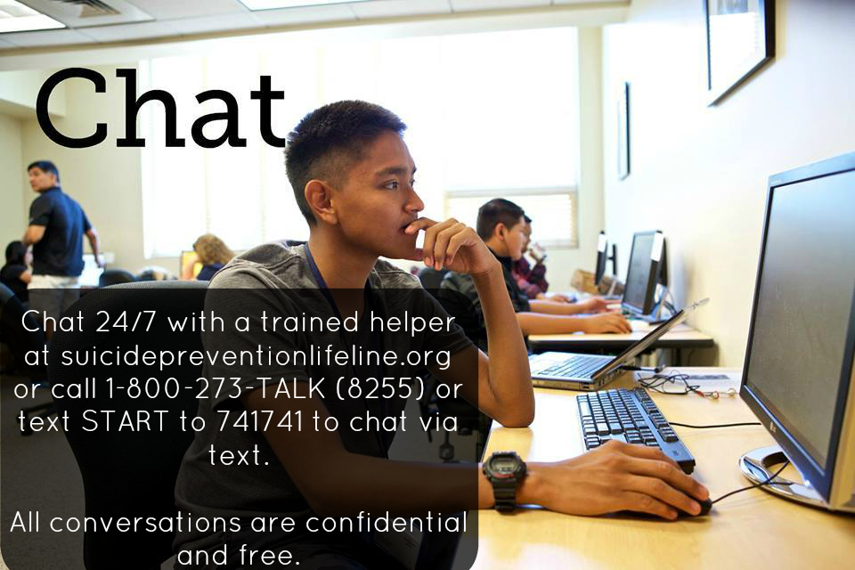
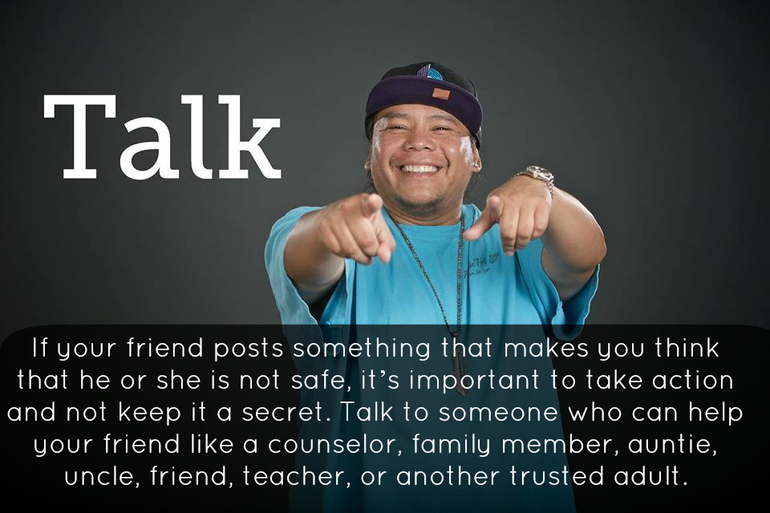

Local Resources:
(include names, location, and contact information for youth resources)

Name | Title | Location | Phone | Email
 | School Counselor
 | Tribal Clinic
 | Mental Health Counselor

My Phone # (optional – delete whole line, if you prefer not to give your # out)

Other Resources:
988 Suicide & Crisis Lifeline:
Call: 988
Text: NATIVE to 741741
Chat: 24/7 to https://988lifeline.org/chat/

We R Native: https://www.wernative.org/
Ask Auntie:
https://www.wernative.org/ayr

SAMSHA – Type in your zip code to the web address below to find a clinic closest to you.
https://findtreatment.samhsa.gov/

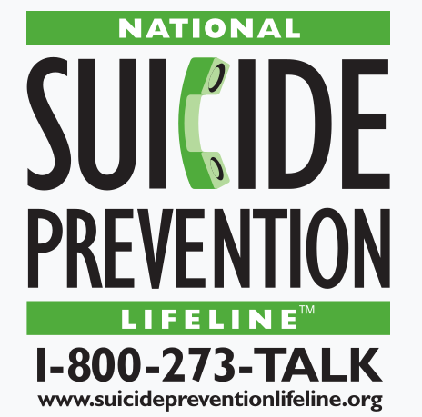
Role-Play Activity

Act out your assigned role.
Ones will play the role of the person who posted the concerning message below:
Here’s your groups PROMPT:
- Twos will play the role of a youth who notices the post and shares their concerns with a trusted adult.
Threes will play the role of a youth who notices the post and reaches out to the friend directly.
Fours will play the role of a trusted adult.
Review the Youth Handout for tips and ideas.
Provide encouragement to your group members as you go along.

-------------------------------------------------------------------------------------------------

Role-Play Activity

Act out your assigned role.
Ones will play the role of the person who posted the concerning message below:
Here’s your groups PROMPT:
- Twos will play the role of a youth who notices the post and shares their concerns with a trusted adult.
Threes will play the role of a youth who notices the post and reaches out to the friend directly.
Fours will play the role of a trusted adult.
Review the Youth Handout for tips and ideas.
Provide encouragement to your group members as you go along.
Role-Play Activity

Act out your assigned role.
Ones will play the role of the person who posted the concerning message below:
Here’s your groups PROMPT:
- 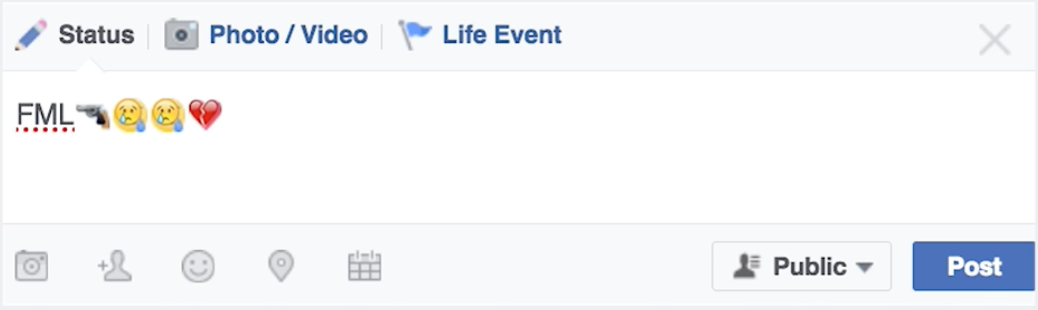
- Twos will play the role of a youth who notices the post and shares their concerns with a trusted adult.
Threes will play the role of a youth who notices the post and reaches out to the friend directly.
Fours will play the role of a trusted adult.
Review the Youth Handout for tips and ideas.
Provide encouragement to your group members as you go along.

-------------------------------------------------------------------------------------------------

Role-Play Activity

Act out your assigned role.
Ones will play the role of the person who posted the concerning message below:
Here’s your groups PROMPT:
- Twos will play the role of a youth who notices the post and shares their concerns with a trusted adult.
Threes will play the role of a youth who notices the post and reaches out to the friend directly.
Fours will play the role of a trusted adult.
Review the Youth Handout for tips and ideas.
Provide encouragement to your group members as you go along.
Role-Play Activity
Act out your assigned role.
Ones will play the role of the person who posted the concerning message below:
Here’s your groups PROMPT:
- Twos will play the role of a youth who notices the post and shares their concerns with a trusted adult.
Threes will play the role of a youth who notices the post and reaches out to the friend directly.
Fours will play the role of a trusted adult.
Review the Youth Handout for tips and ideas.
Provide encouragement to your group members as you go along.

-------------------------------------------------------------------------------------------------

Role-Play Activity
Act out your assigned role.
Ones will play the role of the person who posted the concerning message below:
Here’s your groups PROMPT:
- Twos will play the role of a youth who notices the post and shares their concerns with a trusted adult.
Threes will play the role of a youth who notices the post and reaches out to the friend directly.
Fours will play the role of a trusted adult.
Review the Youth Handout for tips and ideas.
Provide encouragement to your group members as you go along.
Role-Play Activity

Act out your assigned role.
Ones will play the role of the person who posted the concerning message below:
Here’s your groups PROMPT:
- 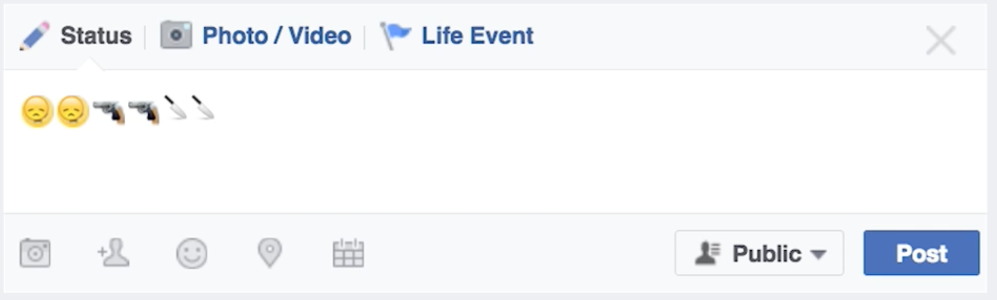
- Twos will play the role of a youth who notices the post and shares their concerns with a trusted adult.
Threes will play the role of a youth who notices the post and reaches out to the friend directly.
Fours will play the role of a trusted adult.
Review the Youth Handout for tips and ideas.
Provide encouragement to your group members as you go along.

-------------------------------------------------------------------------------------------------

Role-Play Activity

Act out your assigned role.
Ones will play the role of the person who posted the concerning message below:
Here’s your groups PROMPT:
- Twos will play the role of a youth who notices the post and shares their concerns with a trusted adult.
Threes will play the role of a youth who notices the post and reaches out to the friend directly.
Fours will play the role of a trusted adult.
Review the Youth Handout for tips and ideas.
Provide encouragement to your group members as you go along.
Role-Play Activity

Act out your assigned role.
Ones will play the role of the person who posted the concerning message below:
Here’s your groups PROMPT:
- 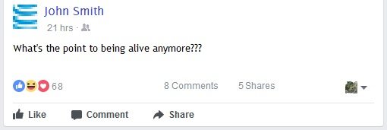
- Twos will play the role of a youth who notices the post and shares their concerns with a trusted adult.
Threes will play the role of a youth who notices the post and reaches out to the friend directly.
Fours will play the role of a trusted adult.
Review the Youth Handout for tips and ideas.
Provide encouragement to your group members as you go along.

-------------------------------------------------------------------------------------------------

Role-Play Activity

Act out your assigned role.
Ones will play the role of the person who posted the concerning message below:
Here’s your groups PROMPT:
- Twos will play the role of a youth who notices the post and shares their concerns with a trusted adult.
Threes will play the role of a youth who notices the post and reaches out to the friend directly.
Fours will play the role of a trusted adult.
Review the Youth Handout for tips and ideas. Provide encouragement to your group members as you go along.
Role-Play Activity

Act out your assigned role.
Ones will play the role of the person who posted the concerning message below:
Here’s your groups PROMPT:
- 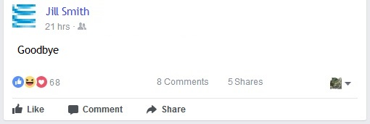
- Twos will play the role of a youth who notices the post and shares their concerns with a trusted adult.
Threes will play the role of a youth who notices the post and reaches out to the friend directly.
Fours will play the role of a trusted adult.
Review the Youth Handout for tips and ideas.
Provide encouragement to your group members as you go along.

-------------------------------------------------------------------------------------------------

Role-Play Activity

Act out your assigned role.
Ones will play the role of the person who posted the concerning message below:
Here’s your groups PROMPT:
Twos will play the role of a youth who notices the post and shares their concerns with a trusted adult.
Threes will play the role of a youth who notices the post and reaches out to the friend directly.
Fours will play the role of a trusted adult.
Review the Youth Handout for tips and ideas. Provide encouragement to your group members as you go along.
Role-Play Activity

Act out your assigned role.
Ones will play the role of the person who posted the concerning message below:
Here’s your groups PROMPT:
- 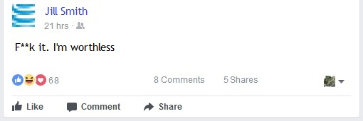
Twos will play the role of a youth who notices the post and shares their concerns with a trusted adult.
Threes will play the role of a youth who notices the post and reaches out to the friend directly.
Fours will play the role of a trusted adult.
Review the Youth Handout for tips and ideas. Provide encouragement to your group members as you go along.
-------------------------------------------------------------------------------------------------

Role-Play Activity
Act out your assigned role.
Ones will play the role of the person who posted the concerning message below:
Here’s your groups PROMPT:
Twos will play the role of a youth who notices the post and shares their concerns with a trusted adult.
Threes will play the role of a youth who notices the post and reaches out to the friend directly.
Fours will play the role of a trusted adult.
Review the Youth Handout for tips and ideas. Provide encouragement to your group members as you go along.
Role-Play Activity

Act out your assigned role.
Ones will play the role of the person who posted the concerning message below:
Here’s your groups PROMPT:
- 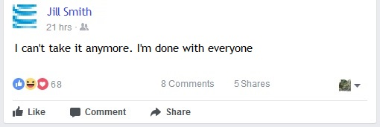
Twos will play the role of a youth who notices the post and shares their concerns with a trusted adult.
Threes will play the role of a youth who notices the post and reaches out to the friend directly.
Fours will play the role of a trusted adult.
Review the Youth Handout for tips and ideas. Provide encouragement to your group members as you go along.
-------------------------------------------------------------------------------------------------

Role-Play Activity
Act out your assigned role.
Ones will play the role of the person who posted the concerning message below:
Here’s your groups PROMPT:
Twos will play the role of a youth who notices the post and shares their concerns with a trusted adult.
Threes will play the role of a youth who notices the post and reaches out to the friend directly.
Fours will play the role of a trusted adult.
Review the Youth Handout for tips and ideas. Provide encouragement to your group members as you go along.

