TEACHER ANSWER SHEET: Is We R Native a Reliable Resource?

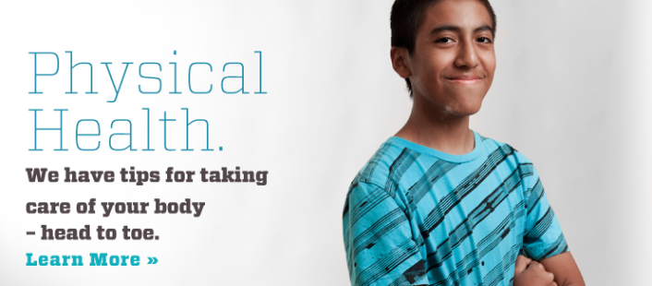

- Record one topic that you plan to investigate further:
Under Physical Health: Physical Health, Nutrition, Alcohol, Traditional Games and Sports, Fitness, Drugs, Abuse, Violence and Sexual Assault, Common Diseases and Illnesses
Under Sexual Health: Puberty, Sexual Identity, Relationships and Dating, Virginity, Birth Control, Abuse, Violence and Sexual Assault, Anatomy, LGBTQ – Two Spirit, Protection – Reduce your risks, STDs, Pregnancy

- List one internal page that addresses the topic you are investigating. Answers will vary.

  - Read the page to review the content. Use the handout Website Assessment and Evaluation to review the 5 Criteria for Evaluating the Quality of a Web Site. Use at least three of the five criteria to defend why you think this website should, or should not be considered a high quality health resource.
Answers will vary.

- List at least one external resource or link that is included under the topic you are investigating.
Under Physical Health Resources: ChildHealth USA National Hotline, National Child Abuse Hotline, Boys Town Suicide and Crisis Line, National Domestic Violence Hotline, Nationwide RAIIN National Rape Crisis Hotline, TeensHealth, Let’s Move, Drugs + HIV Learn More, Truth, National Drug Information Treatment and Referral Hotline, Just Think Twice
Under Sexual Health Resources: Amplify Your Voice, It Gets Better, The Trevor Project, Native Youth Sexual Network, Planned Parenthood, It’s Your Sex Life, I Know Mine, Sex Etc., Bedsider, National Sexually Transmitted Diseases Hotline, Scarleteen

  - Click on the external resource to review the content. Use the handout Website Assessment and Evaluation to review the 5 Criteria for Assessing the Quality of Information. Use at least three of the five criteria to defend why you think this resource should, or should not be included on the We R Native website.
Answers will vary.

TEACHER ANSWER SHEET: Is We R Native a Reliable Resource?

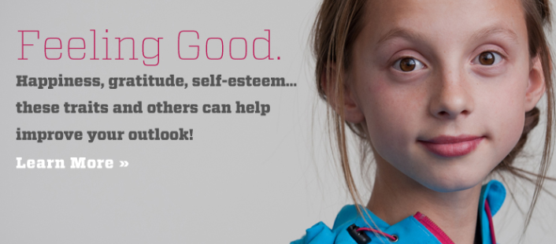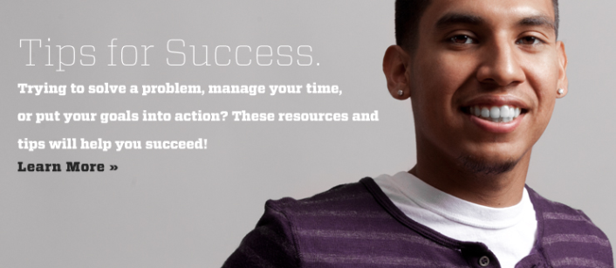

- Record one topic that you plan to investigate further:
Under Mental Health: Feeling Good, Depression, Mental Health Difficulties, Suicide, Grief, Anger, When Life Sucks, Improve Your Mood, Anxiety
Under Education & Life Skills: Managing School Pressures, Becoming Independent, Friendships, Bullying, Digital Life and Social Media, Communicating, Life Transitions, Dealing with Adoption or Foster Care, Family, Social Life, Life Tips, Gangs

- List one internal page that addresses the topic you are investigating. Answers will vary.

  - Read the page to review the content. Use the handout Website Assessment and Evaluation to review the 5 Criteria for Evaluating the Quality of a Web Site. Use at least three of the five criteria to defend why you think this website should, or should not be considered a high quality health resource.
Answers will vary.

- List at least one external resource or link that is included under the topic you are investigating.
Under Mental Health Resources: Reach Out, Suicide Lifeline, National Mental Health Association, Boys Town Suicide and Crisis Line, National Youth Crisis Hotline, Honoring Native Life, National Teen Dating Abuse Hotline, National Domestic Violence Hotline, Teen Line, Facebook Suicide Prevention Tool, Think b4 You Speak, Stop Bullying, Cyberbullying Research Center, Bullying Awareness Guidebook
Under Education & Life Skills Resources: Teen Safety on the Internet, Wired Safety, Project Respect, Love is Respect, That’s Not Cool, Where’s Your Line?, American Indian College Fund, Center for Native American Youth, Young Worker Safety

  - Click on the external resource to review the content. Use the handout Website Assessment and Evaluation to review the 5 Criteria for Assessing the Quality of Information. Use at least three of the five criteria to defend why you think this resource should, or should not be included on the We R Native website.
Answers will vary.

TEACHER ANSWER SHEET: Is We R Native a Reliable Resource?

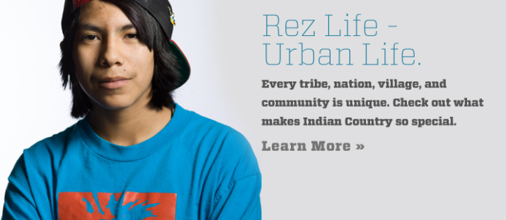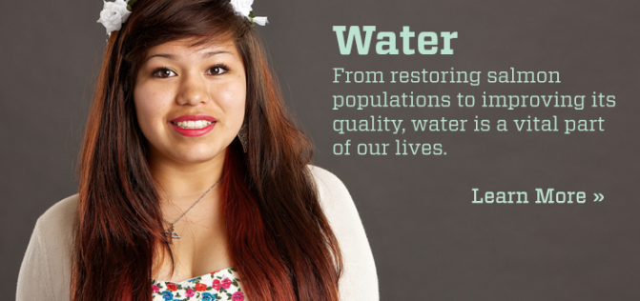

- Record one topic that you plan to investigate further:
Under My Culture: Sacred Elements, History, Language, Identity & Native Pride, Rez Life – Urban Life, Traditional Stories & Teachings, Life Transitions & Coming of Age, Powwows, Wellness & Healing, Sovereignty
Under My Environment: Water, Native Energy, Take Action, Recycling, Land

- List one internal page that addresses the topic you are investigating. Answers will vary.

  - Read the page to review the content. Use the handout Website Assessment and Evaluation to review the 5 Criteria for Evaluating the Quality of a Web Site. Use at least three of the five criteria to defend why you think this website should, or should not be considered a high quality health resource.
Answers will vary.

- List at least one external resource or link that is included under the topic you are investigating.
Under My Culture Resources: Native American Encyclopedia, Indian County Today Media Network, Reconnecting the Circle, National Museum of the American Indian, Do Something, Amplify your Voice, United National Indian Tribal Youth (UNITY), Reach Out
Under My Environment Resources: Ecotrust, The Affiliated Tribes of Northwest Indians, Bonneville Power Administration, Office of Indian Energy Policy and Programs, Indigenous Environmental Network, Columbia River Inter-tribal Fish Commission, Food Sovereignty, Tribal Gardens

  - Click on the external resource to review the content. Use the handout Website Assessment and Evaluation to review the 5 Criteria for Assessing the Quality of Information. Use at least three of the five criteria to defend why you think this resource should, or should not be included on the We R Native website.
Answers will vary.

TEACHER ANSWER SHEET: Drugs and Alcohol Research Guide

- How do drugs effect...Your Body wernative.org/articles/impact-of-drug-use-on-your-body
Physical injuries. When you’re under the influence of drugs, you might do things that you wouldn’t’ normally do.
Violence. Some drugs can increase the likelihood of violent behavior. Violence is never an acceptable way to react in a situation, and if you become violent when you use drugs, it’s a good idea to re-evaluate your drug use.
Internal damage. Use of some drugs can damage your internal organs, like your liver, brain, lungs, throat and stomach. For example, ordinary household glue can be characterized as a drug if sniffed. The chemicals in glue can cause hearing loss and kidney damage if they’re inhaled over a long period of time. And continuous marijuana use can harm the parts of the brain that control memory, attention and learning.
Pregnancy and STDs. While you’re under the influence, you might be less likely to remember to have safe sex. Unprotected sex can lead to pregnancy or the spread of STDs like HIV/AIDS.
Risk of other infectious diseases. Sharing needles from injecting certain types of drugs can put you at major risk for getting diseases like Hepatitis C, Hepatitis B, as well as HIV.
Addiction. When you take drugs, there’s a chance that you could become dependent on them. This means that you might feel like you can’t operate without drugs in your system or that you spend a lot of your time and energy finding and using the drug.
Your Mental Health wernative.org/articles/impact-of-drug-use-on-your-mental-health
Stress. You might think that using certain drugs will help you relax and forget about the issues that cause stress. But long-term drug use can have a big impact on the way your brain works, and lead to increased anxiety and stress.
Depression. Feeling low after using some drugs-including alcohol-is common. You might feel depressed because of the drug itself, or because of something that happened while you were using. Sometimes people use drugs as a way to cope with their depression, but drug use can often worsen these feelings.
Mental illnesses. Although scientists generally agree that there is a link between drug use and serious mental illnesses like schizophrenia, the National Institute on Drug Abuse says that it’s still unclear whether serious drug use leads to these illnesses, or if having an illness increases a person’s chances to abuse drugs.

Your Life wernative.org/articles/impact-of-drug-use-on-your-life
Legal issues. Making, selling or having illegal drugs in your possession is against the law. It’s also against the law to give prescription drugs to people who don’t have a prescription from a doctor. Punishments for breaking these laws include having to go to court which might result in being sent to jail, having to pay hefty fines, or enter a rehabilitation program.
Your relationships. When drug use becomes a larger part of your life, your relationships suffer. Conflict and breakdowns in communication can become more common.
Your safety. Being under the influence of drugs could increase your chances of being in dangerous situations. The effects of some drugs can cause you to do things you might not usually do. You might also be putting yourself at risk of overdosing. Buying drugs or trying to get the money to buy drugs can also put you at risk.
Your school work. You might not immediately notice the impact that your drug taking is having on your school work, but habitual drug use can prevent you from focusing on your responsibilities, like homework or concentrating in class. Your grades will suffer as a result.
Your job. Drug use can also affect your ability to concentrate at work. The side effects of using drugs-like a hangover, or a “coming down” feeling-can reduce your ability to focus. Poor performance at your job could cause you to lose your job all together.
Financial pressures. Regular drug use can become expensive. In extreme situations, people who are addicted to drugs might try anything-including illegal activities like theft-to secure money to get their next fix.
Homelessness. Spending most of your money on drugs might not leave much money to cover your living expenses, like rent, food, or utility bills. If you can’t pay these necessary costs, you could even get kicked out of your home.

- What are some things you could do to “get help for drug use”? wernative.org/articles/getting-help-for-drug-use
Make it difficult to access drugs. For example if you are trying to stop smoking, throw out all your smokes, lighters and ashtrays so they are not tempting you.
Have things you can do to distract yourself when you feel like taking the drug. Like hanging out with friends who are not taking the drug, going for a run or walk, listening to music.
If possible get support from your family and friends. They may be more supportive of you if they know that you are trying to reduce its use.
Talking to someone - talking to someone you trust may be helpful in reducing your drug intake. This person may be a friend, family member or youth worker.
Counseling - It may be helpful for you to talk to a counselor. A good counselor can help you to work out how best to manage your drug use. Counseling can either be done in a group or individually.
- Can people drink smart? wernative.org/articles/drinking-smart
There are a number of things that people can do to keep their drinking under control:
- Set limits for themselves and stick to them
- Start with a non-alcoholic drink
- Alternate non-alcoholic drinks with alcoholic drinks
- Drink slowly. Take sips not gulps
- Try a low alcohol alternative to a pre-mixed drink
- Eat before or while they are drinking. Avoid salty snacks that make them thirsty
- Avoid rounds or shots
- Have one drink at a time
- Avoid drinking games
- Stay busy. Don’t just sit and drink
- Be assertive. They shouldn’t give into drinking more than they want or intend to.

- What are 3 things you can do to help a friend with a drinking problem? wernative.org/articles/helping-a-friend-with-a-drinking-problem
Be informed. It is a good idea to have general knowledge about some of the reasons people drink alcohol to excess and ways to manage alcohol consumption and drink at a low level of risk. By taking this approach, you will be able to stick to the facts when talking with your friend. For specific information about alcohol and its effects, check out this Partnership for a Drug Free America Fact Sheet: http://www.drugfree.org/drug-guide/alcohol

Discuss alcohol issues openly. Letting the person you are concerned about know that you are open to listening to them without being judgmental can facilitate an open discussion. An open dialogue may encourage them to discuss their alcohol use with you. If they know you are open-minded about the issue and have thought about your own use, they may feel more comfortable discussing their alcohol use with you.

What to do if someone says they have a problem. Acknowledging a problem with alcohol consumption is a big step for anyone. If someone has come to you admitting they have a problem, you may be able to assist them by finding out what help is available in your local area. Your local doctor, school or campus counselor, hospital, community health center, or youth worker are people who may be able to help.

TEACHER ANSWER SHEET: Contact a Help Line

- Write two questions that you would like the hotline to help answer for you:
Answers will vary, but should be specific to the hotline the student is calling/texting.

- Which advice line did you contact:
Answers will vary.

- How quickly were they able to respond to your call/text?
Answers will vary, but should be less than an hour.

- How did they respond to your first question? Answers will vary.

- How did they respond to your second question? Answers will vary.

- What was the interaction like? Would you recommend the service to a friend? Why, or why not?
Answers will vary.

TEACHER ANSWER SHEET: “Ask Auntie” Drugs and Alcohol Advice
Navigate to the “Ask Auntie” section of the website: wernative.org/ask-auntie/ask-auntie
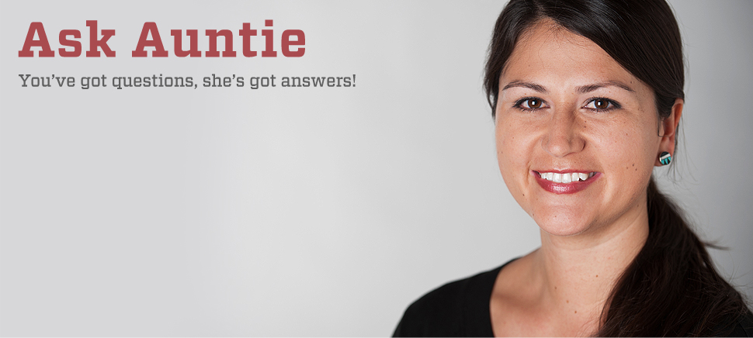

- Read or watch at least three “Ask Auntie” questions and answers related to drug a drug or alcohol problem.

- Use two of the 5 Criteria for Assessing the Quality of Information online to defend whether or not “Ask Auntie” is a reliable resource.
Answers will vary, but something like:
- Accurate – The information provided by Auntie was accurate. She provides links to other sites so we can verify the accuracy of her claims.
- Authority – Auntie is Zuni, is a teacher, and has a lot of experience answering health questions.
- Objective –Auntie is an unbiased source. She works for a health and wellness nonprofit that is run by Tribes in Oregon, Washington and Idaho.
- Current – Auntie’s advice is up-to-date. She answers new questions every week.
- Well-defined Coverage – Auntie provides life advice to Native teens and young adults.

- Did you notice any similarities in the way Auntie framed her advice?

Auntie usually thanks the person for their question and tries to reassure them that their question is important. She often encourages readers to get help from a trusted adult.

- Write down and submit your own question for Auntie. Answers will vary.

TEACHER ANSWER SHEET: Native VOICES Review Sheet

Let’s take a look at some of the choices the individuals in the video made…

- During the video, Jamie gives several reasons why he doesn’t want to use condoms. Record at least two reasons Jamie gives for making this decision.
- I don’t care, as long as I’m getting some.
- A condom, no way. It doesn’t even feel the same.
- Christina’s not even like that…
- How do you bring it up?
- One time I had one and put it on…and…
- Just like pulling out a condom can really kill the mood.

- Record the “comebacks” Jamie’s friends’ use in response to Jamie’s reasons for not using condoms.
- Don’t be stupid man. You don’t want a little Jamie running around in 9 months.
- For real man. Use a condom. Wrap it before you tap it.
- Is it going to feel the same when your thing burns when you piss?
- Pay $5 dollars now for a box of condoms or $40 dollars for a box of pampers later.
- There’s more to worry about than just getting some chick knock up. There’s tons of stuff out there…herpes, syphilis, gonorrhea, AIDS.
- Were you awake in sex ed…you can’t tell from just looking at her.
- When it’s happening, the best thing to do is just use one. If you guys are ready, just put it on. You don’t have to say anything. She’ll probably be relieved she doesn’t have to bring it up herself.
- They can even make you last longer.

- Write your own “comeback” to Jamie. Answers will vary.

- Many people find discussing protection with someone they are interested in difficult. Even though Christina and Jamie both had condoms with them, they still CHOSE not to use them. Write two reasons that may have influenced their choice not to use protection. Answers will vary.
- Suggest a way Christina or Jamie could have brought up protection. Answers will vary.
- Think about the relationship that drugs and alcohol have on the decisions people make around sexual encounters. Write a one-sentence statement that reflects your belief about this. Answers will vary.

TEACHER ANSWER SHEET: Native VOICES Personal Rules

Choosing whether or not to have a sexual relationship is a big decision. There is a lot to think about! There are many important things to consider when deciding whether you’re ready for sex, like your life goals & personal values and whether or not you are willing to take the risks involved with sex.

- What are some of the most important things to you in life?
Answers will vary, but something like:
- Family
- Friends
- Sports
- Hobbies
- What is an important goal you have for your life?
Answers will vary, but something like:
- Finish High School
- Go to college
- Get a job I like
- Start a family
- What’s a personal rule you have for your relationships?
Answers will vary, but something like:
- Honest with each other
- Respect each other
- Look out for each other
- What are your personal rules around sex? What’s ok, what’s not?
Answers will vary, but something like:
- Ok – kissing, snuggling, holding hands
- Not yet - sex
- What are some things you could do to PROTECT your personal rules around sex?
Answers will vary, but something like:
- Communicate openly and honestly with my partner
- Talk about these things before hand
- Stand up for myself, if they don’t agree with or respect my boundaries

TEACHER ANSWER SHEET: Suicide Prevention Research Guide

“My Mind”: Topics – Suicide For this section, type in the website address wernative.org/my-life/my-mind/suicide. Or you can find the Suicide section of weRnative.org by visiting “My Mind,” and selecting the topic “Suicide.”
- What are some common suicide warning signs? wernative.org/articles/suicide-warning-signs
- Feelings of hopelessness
- Feelings of rage, anger, or seeking revenge
- Acting reckless or doing in risky activities without thinking
- Feeling trapped—like there's no way out
- Increasing alcohol or drug use
- Withdrawing from friends, family or usual activities
- Feeling anxious, agitated, being unable to sleep, or sleeping all the time
- Having dramatic mood changes
- Seeing no reason for living or having no sense of purpose in life
- Giving away their things
- Feeling that there’s no one that cares about you

- What are some things you can do if a friend is talking about suicide? wernative.org/articles/when-your-friend-is-talking-about-suicide
Take Action. If you are worried about your friend, ask if they are thinking about killing themselves. Listen without judging them or acting shocked. Having someone to talk to honestly can help them. Many of these suggestions will work whether you are talking to your friend in person, on the phone, texting or interacting online.
Don’t keep it a secret! A secret can be dangerous if it hurts your friend. It is important to tell someone who can help you and can help your friend stay safe.
The Get Help section can give you more information about how these people can help.
Offer your support. Let your friend know that you want to help them. Just knowing that somebody cares can be reassuring since your friend might feel very alone.
Choose what to say. If you’re not sure what to say, you might try saying “I’m worried about you” or “I don’t like seeing you upset,” or “I want to help you.” Whatever you decide, please be direct and don’t act shocked by what they say.
Offer to go with your friend to get help. Go with them to talk to an adult they trust about how they are feeling. Find someone they trust and who will be able to help.
If your friend refuses to get help, you should go to talk to a parent, family member, teacher, counselor, or someone you trust. Or call the Lifeline (1-800-273-8255). It is important to take their words seriously.
If you think your friend is in immediate danger, call 911. If you are with your friend, stay with your friend until help gets there. If you are on the phone with them, stay on the phone and see if you can get word to someone else who can call 911. If you are online with someone that you only know from online interactions, it’s still a good idea to alert 911 and the Lifeline (1-800-273-8255).
- When should someone get immediate help? wernative.org/articles/suicide-warning-signs
Get immediate help from a mental health provider or call 911 when you see someone:
- Saying they want to hurt or kill themselves
- Looking for ways to kill themselves: looking for pills, weapons, or other means
- Talking or writing about death, dying, or suicide

- List resource(s) for getting help:
Suicide Lifeline, National Mental Health Association, Boys Town Suicide and Crisis Line, National Youth Crisis Hotline, Facebook Suicide Prevention Tool.
If you need someone to talk to now. Try calling the National Suicide Prevention Lifeline at 1-800-273-8255 or the Boys Town National Hotline at 1-800-448-3000. Both hotlines have trained volunteers ready to listen 24/7.

- What can you do to improve your mood? Hint: visit wernative.org/my-life/my-mind/improve-your-mood
Get informed. Once you figure out what might be causing you to feel bad, you can do something about it. On the ReachOut site, you’ll find tons of info on different issues, including depression, family and relationships.
Talk to someone. Talk to someone you feel comfortable with, like a friend, family member, teacher, or counselor, can be a great way of expressing your feelings and figuring out why you’re feeling this way.
Chill out. This might include going for a walk or listening to your favorite music, reading a book, going to the movies, or whatever works for you.
Express your feelings. Writing down your feelings or keeping a journal can be a great way of understanding your current emotions. Express your feelings in a way that won’t cause bodily damage to yourself or another person. Try yelling or crying into a pillow, dancing around the room to loud music or punching a pillow.
Look after yourself. Take time out to spoil yourself by doing something that you usually enjoy. Even though you might not feel like it, exercising and eating well can help too. Eating well and getting plenty of sleep is important.
Avoid drugs and alcohol. Try not to use alcohol or other drugs (including lots of caffeine or other energy-boosting drinks) in the hopes of feeling better.
- Check out the September 2015 monthly contest winners by visiting wernative.org/my-impact/monthly-contest-all-winners. What would you tell someone who is thinking about suicide?
Answers will vary.

TEACHER ANSWER SHEET: Bullying Research Guide

“My Mind”: Bullying For this section, type in the website address wernative.org/my-life/life-hacks/bullying-prevention. Or you can find the Bullying section of weRnative.org by visiting “My Mind,” and selecting the topic “Bullying.”
- What is bullying (wernative.org/blog-posts/bullying-definition) ?
Bullying usually involves one or more people teasing, being violent towards, or harassing somebody on an ongoing basis. Bullying can happen in person and online and through cell phones.

- What is a bystander (wernative.org/articles/be-more-than-a-bystander)?
A person who is witness to an event or incident but does not do anything.

- What is cyberbullying (wernative.org/articles/Cyberbullying) ?
Cyberbullying is a form of bullying that is carried out through an Internet service such as e-mail, chat rooms, discussion group, online social networking, instant messaging or web pages. It can also include bullying through mobile phone technologies such as text messaging.

- What’s the first thing you need to do to help someone being bullied?
Notice the Event. (wernative.org/articles/notice-the-event) Before you can do anything to help in a bullying situation, first you have to notice it.

- What’s the second thing you need to do to help someone being bullied?
Identify the Situation as One Needing Intervention. (wernative.org/articles/identify-the-situation-as-one-needing-intervention) To be prepared to intervene and help people out, you need to know the signs of a bullying situation.

- What’s the third thing you need to do to help someone being bullied?
Take Responsibility.( wernative.org/articles/take-responsibility) So, you’ve noticed a problem situation that you think could be stopped if someone stepped in. Now is the time to step up.

- What’s the fourth thing you need to do to help someone being bullied?
Decide How to Help. (wernative.org/articles/decide-how-to-help)By learning the right skills, you will know how to safely step in the next time you see a bullying situation.

- How can you intervene when someone is being bullied?
Don’t Just Stand By: Intervene. (wernative.org/articles/don-t-just-stand-by-intervene) You know the situation isn’t okay. You know you should intervene. You know you can intervene. So, why don’t you?
Stand Up. Stand Strong
Don't just Stand by.

- Think about the five steps to intervene with a bully: 1) Notice, 2) Identify, 3) Take Responsibility, 4) Decide to Help, 5) Intervene. (wernative.org/articles/be-more-than-a-bystander) Do you think this would work? Go through each step and defend your argument. Give specific examples of how you would change it, or defend why you would keep it the same.
Answers will vary.

TEACHER ANSWER SHEET: In What Ways Have You Ever Felt Bullied?

In What Ways Have You Ever Felt Bullied?

Answers will vary.

TEACHER ANSWER SHEET: Make a Difference in Your Community

- Projects Funded by We R Native - Success Stories in the Community. On We R Native’s page, there are examples of youth who received $475 to carry out a community service project. Review at least five of the projects. Write about your favorite one and talk about what it means to you.

Virlencia Begay(Navajo), age 20, hosted a youth day called Nee'Niji. Activities included health awareness presentations, traditional teachings, physical activities (5k run, basketball, kickball, volleyball), college prep advice and a water balloon fight :) The group applied for and received a We R Native mini grant for $475 to help advertise, provide food and purchase school supplies to give out. They promoted their event by hanging up fliers, word of mouth and shared on social media. The event was a huge success and created a fun and supportive environment for over 200 people!
Jaycee Carrywater Jr.(Cheyenne/Lakota), age 15 and the Niitssitapi Nation (Ferris H.S. Leadership Club) from Spokane, Washington helped break down stereotypes while giving back to their community. The group applied for and received a We R Native mini grant for $475. They budgeted their money and purchased deodorant, toothbrushes, toothpaste, socks, bread, deli meat and cheese. After going to the store and purchasing these materials, they put together care packages to bring to their local homeless shelter.
Summer (Oglala Lakota), age 15, hosted an AIDS Awareness Day booth at her community event. She handed out fliers on nutrition and HIV/AIDS awareness. The booth was a hit as almost everyone in attendance stopped by and picked up materials. She even got to meet some new people who were very supportive of her and promoting HIV awareness. Summer said she had a lot of fun so didn't stop there. She then organized a Holiday Teen Party to hand out gifts:) About 100 people attended, she made new friends and had great community support.
Luke Harris (Cherokee), age 19, helped host a field day for about 130 Native youth at Nike World Headquarters. Renowned speaker Howard White came and gave an inspiring speech as well as Nike N7 founder Sam McCracken. The event was about inspiring Native youth from throughout Oregon and Luke was most proud of the speakers and leaders. They spent a lot of time prepping for the event and the result was a great success. Participants were able to partake in traditional games, football, soccer, stick ball and many other events...they even were able to give away college scholarships!
Youth from the Lawrence High Inter-Tribal Club held a book drive where they collected books to bring to the Little Nations Academic Center at Haskell University. Not only did they hold a month long book collection, they also purchased books by Native authors, and created a book of their own "N8TIV3 Numbers." The club then brought the books to the Center and spent time reading to the children (ages 1-5). The event was a huge success! The club was able to incorporate Native American values by giving books to the children, and they were able to get the entire community involved through their book donations.
Dahkota Brown held a gathering for Native youth from Northern California through a program he started called NERDS, which stands for Native Education Raising Dedicated Students. He brought together 9 different tribes & youth organizations, who brought almost 100 students & 23 booths including colleges, health resources, scholarship opportunities, cultural resources, future career options, and many more. They had keynote speakers and fun events planned throughout the day. The main event consisted of a scavenger hunt that gave all the booths an equal chance to have students gain information and required the students to work together…
Youth from Nimiipuu held a teen night where they learned about condoms, the importance of reducing your risk, and protecting the ones they love. Kiara Garcia and Jessica Douglas led the STD game. The event was a huge success and they even had a participant approach them about wanting to do their own teen night.
Whitney, Tashina, Savanna and Noella planned, planted and enjoyed eating from a community garden. One of the best things they learned "...that it takes all of us working together to accomplish this".
The Nulato Tribal Council (NTC), Nulato life project (NLP), State of Alaska and Tanana Chiefs Conference (TCC) held a boating safety class in Nulato. This was a two day class and covered risky and safe behavior while on or near the water. William Agnes, James Patsy II, Marvin Cimeon Mountain IV and Elizabeth Stanley each presented a subject to the community and gave out free life jackets.
Students from the Sisters in Healing Group in Oregon hosted a Walk a Mile in Her Shoes Fun Walk/Run to raise awareness of sexual violence. The group formed a movement to inspire people to heal and to reach out for help. After making posters and flyers to put up around their school, over 50 students and staff attended.
Students from the Helena Indian Alliance All Nations Youth Council in Montana hosted a Round Dance for their community that focused on issues such as commercial tobacco and diabetes prevention. The event also featured singers, a hand drum contest and a meal with healthy foods. Over 300 youth and elders from throughout community attended the event, and learned and shared from each other.
Students from the American Indian Community House (AICH) Youth Council in NYC collaborated with the Shinnecock UNITY Youth Council to host an indigenous youth identity workshop that focused on artistic expression and cultural identity. The popular DJ group, A Tribe Called Red, was invited to share how their work confronts the many stereotypes that face Native people.
Students from the Shoshone Bannock Healthy Empowered Youth (HEY) program offered yard clean-up services to elders in their community. Students borrowed lawn mowers, rakes, and a trailer, and spent the day mowing and planting flowers at two elder’s homes. Afterwards they shared a meal with the homeowner.
The Northern Diné Youth Committee hosted an all-day Get Yourself Tested (GYT) event. The event was open to the public, and included a 5K run/1 mile walk, a dodgeball tournament, food, and special performances by DJ Smash and Digital Divide. To help folks get tested, the youth committee partnered with Navajo AIDS Network to offer free, confidential STD/HIV testing to those who attended.
- Looking for Ideas? See What’s going on this month.
Review the health observances for at least three different months in the rotating calendar. List the health issue(s) highlighted during each of those months.
- January - National Drug Facts Week
- February - American Heart Month
- March - National Nutrition Month
- April - Alcohol Awareness Month
- May - Skin Cancer Detection and Prevention Month
- June - National Safety Month
- July - Health Observances...
- August - National Immunization Awareness Month
- September - National Suicide Prevention Week
- October - Teen Driver Safety Week
- November - National Meth Awareness Day
- December - World AIDS Day

- Read through the list: 100 Ways to Make a Difference in Your Community. (education.com/reference/article/Ref_100_Ways_Make/) Select one that interests you. Describe the activity and include at least two ways you believe your community might benefit from hosting such an event.

Answers will vary, but includes things like:
- Help teach a younger child to read.
- Help cook and/or serve a meal at a homeless shelter.
- Gather clothing from your neighbors and donate it to a local shelter.
- Make “I Care” kits with combs, toothbrushes, shampoo, etc. for the homeless.
- Pack and hand out food at a local food bank.

- Go to the website DoSomething.org and review at least four projects. Use the website titles to select a CAUSE, a TIME and a TYPE. Record your selections and briefly describe three ideas the website generated.

Answers will vary, but includes things like:
- 50 Cans: Collect and recycle (at least) 50 aluminum cans.
- Grandparents Gone Wired: Teach older adults how to text using emojis.
- Baby, It's Cold Inside: Decrease your oil dependence by turning off the heat for a day.

- Back on We R Native’s website, look at the Apply for a Grant attachment. Identify at least three questions that are included in the grant application.

See pages 70 – 73.

TEACHER ANSWER SHEET: Make a Plan to Change Your Community

AND….ACTION! Now that you have spent the last few weeks learning more about how to live a healthy lifestyle while staying true to your culture…it’s your turn to pass on this knowledge.

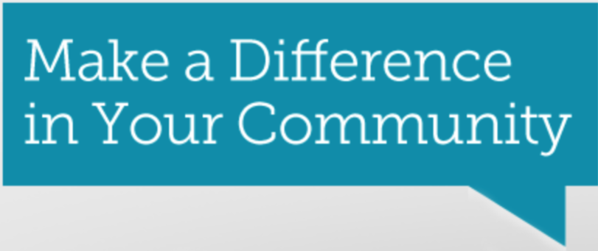

Brainstorm (5 minutes)
Use the butcher paper provided. As a group decide:
- What is an area of need that your community has?
- What are some ideas for addressing this need?
- Select one project idea for your group.

Now let’s start planning… (10 minutes)

- Where will your event or activity take place?

Answers will vary, but could include things like:
- School, Head Start
- Community center
- Elder’s Center
- Food Bank

- Who will you need to consult/include in the decision making process?

Answers will vary, but could include things like:
- Principle, Teachers, School Counselor
- Health Department
- Youth Recreation Coordinator

- What adult might serve as your team representative/mentor?

Answers will vary.

- Who on your team will be responsible for completing requited tasks/activities?

Task | Person Responsible
Create fliers | Sarah
Make an announcement over the PA system | Jim

- What components of your event or activity would cost money?

Answers will vary, but could include things like:
- Food
- Shirts
- Toiletries
- Plants – for elder’s yard clean-up
- Books – for head start kids
- Gardening supplies – for a community garden
- Print posters and fliers

Note: We R Native awards mini grant for $475. Partnering with other organizations is a great way to share costs.
6. How will you promote your event or activity, to let your community know about?

Answers will vary, but could include things like:
- School newspaper
- Tribal paper
- Tribal website
- Facebook page
- Radio station
- School announcements

7. Are there resources or organizations in your community that might be willing to partner with you?

Answers will vary, but could include things like:
- School Clubs
- Health Department, Tribal Clinic, Wellness Center
- Elder’s Program

