**HOC Curriculum Training Manual   
INTRODUCTION**

**The Healing of the Canoe (HOC) Project** is a collaborative research project between the Suquamish Tribe, the Port Gamble S’Klallam Tribe, and the University of Washington Alcohol and Drug Abuse Institute (ADAI). Now in the final phase of the project, the Healing of the Canoe team is focusing on dissemination of the life skills curriculum that was developed by each tribal community to promote a sense of cultural belonging and prevent substance abuse among tribal youth. We are now holding trainings to train other tribal members and service providers in how to adapt and implement the Healing of the Canoe curriculum in their communities.

This training manual has been put together as a reference tool and guide for successful adaptation and implementation of the Healing of the Canoe curriculum. We expect that each community or agency will find its own way of augmenting and adapting what we have laid out here so that it best fits its community and needs. We humbly offer this manual as a way of sharing what we have learned over the last 8 years of our project and in working with our tribal youth.

**Training Objectives**

Our objective for this training is for you to leave with core knowledge about how to:

1. Engage your community
2. Assess community needs/resources
3. Adapt the HOC curriculum (integrating culture as prevention)
4. Implement the curriculum
5. Employ teaching strategies to build a learning environment that will support effective implementation
6. Establish a sustainable intervention
7. Evaluate intervention effectiveness

**Training Manual Topics**

The training workshop and manual have been designed to guide you through the process of adapting and implementing the Healing of the Canoe curriculum; from laying the foundation in the community, to how to ensure that the resulting intervention is sustainable over time.

During the course of this workshop we will be covering the following topics:

* History of the Healing of the Canoe project
* Healing of the Canoe Curriculum Sessions
* Importance of a Mutually Respectful Learning Environment
* Implementing the Curriculum: Structure and Activities
* Facilitating the Suicide Prevention and Intervention Chapters
* Engaging the Community: Laying the Foundation for the Curriculum/Intervention
* Assessing Community Needs & Resources
* Adapting the Curriculum to Fit Your Community and Culture
* Sustainability Over Time
* Evaluation: Defining Success

We hope that these topics, and the accompanying materials both in the manual and the included appendices, will help you and your community or agency take full ownership of your unique version of the Healing of the Canoe curriculum, and use it as a tool to benefit your youth and your community as a whole.

**NOTES**

**HISTORY OF HEALING OF THE CANOE**

The Healing of the Canoe project has evolved in three phases, each of which required a separate competitive grant application and each with a specific focus. The project is funded by Grant #R24 MD001764 from the National Institute on Minority Health and Health Disparities, and was awarded in three phases. Phase I was three years and focused on partnership development, needs and resources assessment, and initial intervention development. Phase II was five years and consisted of intervention refinement, feasibility testing, implementation, and evaluation. Phase III, which is currently underway, is three years and focuses on dissemination of the intervention to other tribal communities and organizations. Through all of its phases, HOC has been guided by Community Advisory Boards and Tribal Councils to ensure that the work is culturally appropriate, and that sovereignty is respected in the research process.

Throughout the project, the research team has used the Community-Based/Tribally-Based Participatory Research (CBPR/TPR) model to work in partnership to plan, implement and evaluate culturally grounded interventions to reduce health disparities and promote health with both tribes. This means that all steps in this project are taken collaboratively with, and under the guidance of, tribal leadership. Suquamish and Port Gamble S’Klallam both identified the prevention of youth substance abuse, and the need for a sense of cultural belonging and cultural revitalization among youth, as primary issues of community concern. Both tribes also identified their Elders, youth and traditional culture and teachings as their greatest resources. The Suquamish Cultural Co-op and Tribal Council provide guidance and oversight for HOC in Suquamish, and the Port Gamble S’Klallam Chi-e-chee Committee and Tribal Council provides guidance and oversight in PGST.

Through our needs and resources assessment in each community we learned from the tribal members and providers that in order to effectively address and prevent substance abuse, it would be necessary to strengthen youth connection to tribal traditions, culture and values. The Healing of the Canoe partnership has sought to address these issues through two community-based, culturally grounded, life skills prevention and intervention curricula for youth that build on community strengths and resources. The curricula use the Canoe Journey as a metaphor, providing youth the skills needed to navigate their journey through life without being pulled off course by alcohol or drugs – with tribal culture, tradition and values as compass to guide them, and anchor to ground them.

A wonderful benefit of the Healing of the Canoe Project in both communities is that it helped to shift some of the long held mistrust of academic institutions and researchers. The use of Community Based-Participatory Research meant that both communities were able to get to know and trust the University of Washington research team, and the mutually respectful relationship that developed between all three partners helped to develop and increase capacity in each group. The academic university partners participated in regular cultural trainings to learn more about the tribal communities with which they were working, as well as the importance of cultural humility. The two tribal communities were able to learn from the university team about research method, data collection and evaluation, academic grant preparation, and conducting human subjects research. And finally the two tribal communities benefitted from working collaboratively with each other, further strengthening already existing relationships.

For more information about the history and background of the Healing of the Canoe project, please see the published journal articles included in the appendices of this manual.

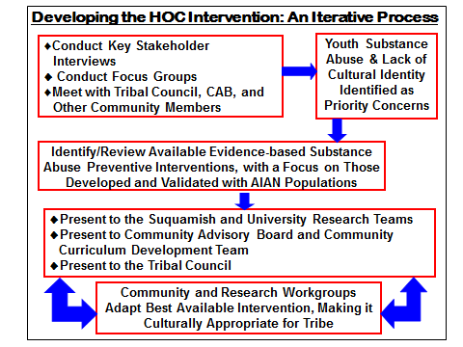

**Notes**

**The Healing of the Canoe Curriculum**

The Healing of the Canoe curriculum is a life skills and substance abuse prevention curriculum for use with tribal youth. It was designed to be adapted by tribal communities – using unique tribal traditions, practices, beliefs, values and stories to teach youth the skills they need to navigate life’s journey, and to promote a sense of belonging to their tribal community. The curriculum consists of 13 chapters plus an honoring ceremony, and uses the Pacific Northwest Tribal Canoe Journey as a metaphor for life. Traditional stories, cultural activities and speakers from the community are woven into each chapter.

**Chapter 1 – Four Seasons and Canoe Journey Metaphor**The goals of this session are 1) to introduce and discuss the Four Seasons, a traditional tribal concept used to frame daily life and teach life skills, a schedule set by nature that tribal livelihood revolved around, and 2) discuss the Northwest Native traditional Canoe Journey and how it can serve as a metaphor for life. Each session ends with a reflection back to this concept. Other traditional tribal beliefs are also discussed.  Information about alcohol is also included.

**Chapter 2 – Who I am: Beginning at the Center**Participants learn about tribal values, traditional ways to introduce oneself, self-awareness, genealogy, family ties and integrity, and how to use the concept of the Four Seasons as a part of self-definition. Participants are encouraged to explore the idea of a physical self, mental self, emotional self and spiritual self. Information about marijuana is also included.

**Chapter 3 – How Am I perceived?**This session focuses on how American Indians and Alaska Natives are portrayed in the media. Participants learn how to recognize when stereotypes are being used, how AIAN culture has been exploited, how AIAN history has been misrepresented, and how to stand up against stereotypes. Information about prescription drugs is also included.

**Chapter 4 – Community Help and Support**  
Participants learn about the importance of community, how they are a part of many communities, and the importance of giving back to their community. Youth learn how to identify where they can go for help in their own community. Participants also learn about what it means to be a mentor and how they can become mentors for those around them. Information about club drugs and stimulants is also included.

**Chapter 5 – Moods and Coping with Emotions**  
Participants learn about different emotions and positive and negative self-talk. They also learn about depression and suicide, how to cope with negative emotions and difficult situations, and how to find a safe person or place to express emotions. Information about inhalants is included.

**Chapter 6 – Staying Safe: Suicide Prevention**The focus of this chapter is suicide prevention and what that means. Participants learn what increases and decreases the chance of suicide (in themselves in others) and learn how to help themselves and others stay safe. Participants find out about local resources and also talk about the role alcohol and drugs play in increasing the risk of suicide.

**Chapter 7 – How Can I Help? Suicide Intervention**The goal of this chapter is for participants to learn how to identify suicide warning signs and help someone who wants to harm or kill himself/herself. The chapter also talks about the importance of reaching out for help if one finds themselves struggling. Finally, participants learn about ways to cope with the reality of suicide and its impact on the community.

**Chapter 8 – Who Will I Become? Goal Setting**  
The focus of this session is to explore what kinds of goals are important and to learn a step-by-step approach to setting goals. Participants will begin to understand the importance of goal setting and learn how to cope with obstacles that might hinder achieving set goals. Information about hallucinogens is also included.

**Chapter 9 – Overcoming Obstacles: Solving Problems**Participants learn how to recognize when they are having a problem, learn ways to solve problems and make good decisions, and discuss where they can go when they do have a problem. Participants learn how to define a problem, brainstorm solutions, pick the best solution, make and act on a plan, and review and revise the plan if needed. Information about nicotine is also included.

**Chapter 10 – Listening**  
The focus of this session is teaching listening skills. Effective listening is discussed, and the importance of listening is illustrated through storytelling and other traditional activities. Tribal values stress respect and the belief that you must be an effective listener before you can become an effective communicator. Information about methamphetamines is also included.

**Chapter 11 – Effective Communication: Expressing Thoughts and Feelings**  
The goal is to teach participants effective communications skills, how to disagree respectfully, refusal and assertiveness skills and how to deal with peer reactions to assertiveness. In this session, participants practice positive ways to resolve conflict and to express feelings. Information about opiates is also included.

**Chapter 12 – Safe Journey without Alcohol and Drugs**

The goal for this session is to learn about addictions, to learn how expectancies influence perception and to learn about the consequences of drug and alcohol use.

**Chapter 13 – Strengthening Our Community**  
This last session focuses on finding leaders within the tribal community to serve as role models, learning about the Boldt decision, learning about leadership, and learning how to make good choices within the tribal community. This session includes field trips into the community to volunteer with important community projects.

**Chapter 14 – Honoring Ceremony**This ceremony is a way to acknowledge youth for the completion of the program and honor their unique attributes. Mentors are invited by the youth to attend the ceremony and the mentor has the opportunity to talk about the youth and their accomplishments. Tribal Elders, leaders and families are also invited to witness the ceremony and share a meal.  Gifts are prepared and formally given, and digital stories are shared.

**Adaptable Curriculum**

The Healing of the Canoe curriculum is intended to be used in a way that best fits YOUR community or organization. Some tribal groups or organizations will not identify with the Canoe Journey as a metaphor for life, or even with using the four seasons as a teaching metaphor for balance (emotional, physical, mental, spiritual). We encourage each community or organization to fully adapt this curriculum to their culture, values, beliefs and traditions. Any metaphor that can be used to represent a life journey or experience is valid. This could be a coming of age ritual, huckleberry harvest time, preparing for a whale hunt, or any important ritual or tradition.

Another important aspect of this curriculum is that although it is currently focused on preventing drug and alcohol abuse through education about alcohol/drugs, the focus could also be shifted depending on what the community or organization finds is most important to address. For example, the curriculum could be used for mental health treatment, chemical dependency treatment, or to help with job readiness. The sections about alcohol and drugs could be removed and replaced with information about any other important topic.

What matters most is to find out your community/organization primary issues of concern, and what metaphors would be most useful in teaching life skills to youth. We have some specific suggestions on how to explore issues and strengths in the Assessing Community Needs & Resources section of this manual.

**Core Life Skills**

Although we encourage extensive adaptation of the curriculum, we do strongly recommend that the core life skills taught remain intact in order for the curriculum to still be considered an evidence-based best practice. The core life skills that are taught are:

* Self-awareness and self-definition
* Recognizing and standing up against stereotypes
* Getting help from one’s community
* Mentoring others
* Coping with negative emotions
* Goal setting
* Overcoming obstacles and solving problems
* Listening, effective communication
* Understanding consequences of substance abuse
* Community leadership, serving the community

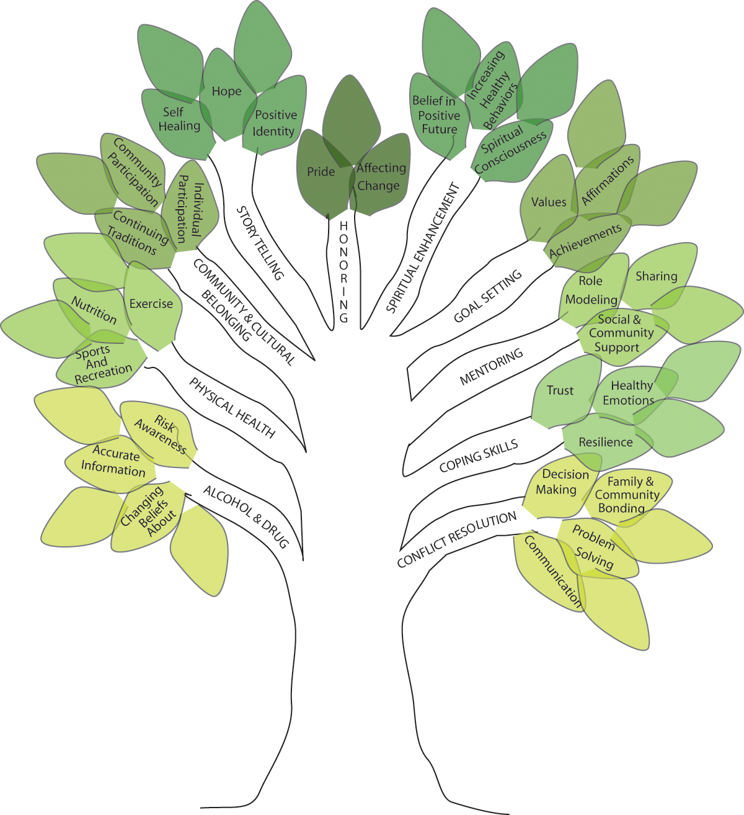**Blending Tribal traditions and cultural values with evidence-based practices**

**The deeper the roots, the stronger the branches**

**IMPORTANCE OF A MUTUALLY RESPECTFUL LEARNING ENVIRONMENT**

*“The attitude in which the facilitator enters the classroom.”* – Nigel Lawrence

Have you seen “The Guardian,” with Kevin Costner and Ashton Kutcher? Imagine Top Gun but set in a Coast Guard rescue swimmer school. Kevin Costner is the instructor who tells a panic stricken student that “*The only difference between you and the victim is the attitude in which you enter the water*.” (<http://www.youtube.com/watch?v=mURq1OSZCWk>) How does that relate to facilitating our curriculum?

We believe that you have to have the right attitude to facilitate the HOC curriculum. It works best if the facilitators build and maintain relationships with every youth in the class. Show interest in their life. How many times have you heard a student explain a bad grade by saying, “the teacher doesn’t like me?” Some students are motivated to do well, not by good grades but by the relationship with their teachers.

Most youth can spot a phony a long ways off. You need to be genuine with them so they will trust and listen to you. If the facilitator walks in the room believing that they are experts on Indian culture, they’ve lost the students. Instead, we enter the room as a co-learner, respecting that each person in the room has expertise.

**The attitude of a facilitator is one of humility, caring and respect. It is not an attitude of superiority.**

The most important thing to keep in mind while crafting/adapting your curriculum is that the curriculum works best when taught *quite* differently than the way that many mainstream Western education systems teach. We teach from a place of mutual respect between youth and adults. We intentionally build and maintain relationships with the students, as we believe that is how anybody learns best, especially young Indigenous people. Instead of a lecture style of instruction and asking students to take notes, we prefer more of a seminar format with group discussions, and soliciting knowledge from all students to share with the group.

We prefer the term facilitators over teachers as we hope to all be learners, and our job is to help make that happen.

**Who are the facilitators?**

At least in our communities and in our experience, we have found that it works best if you have at least 2 facilitators (similar to teachers), one female and one male, as well as a Youth Peer Educator. They need to be people who are trusted by the community and the youth. Not only is it powerful to model a successful partnership between a man and a woman, but each gender experiences culture differently, so having both genders represented is important. The Youth Peer Educator has been incredibly instrumental in getting the point of the lesson through in a way that younger people will listen to (i.e. acts as an interpreter to convey meaning).

Why should a Native youth listen to you talk about Native culture if they’ve never seen you at any cultural events? Part of establishing credibility of the facilitators is selecting appropriate people who are knowledgeable of Native culture – people the youth have seen in the community, people the youth can look to as role models.

As you go over the rest of this manual, keep asking yourself which community members are capable of being the facilitators in the room.

Potential facilitators

**Mutual respect and learning – making it clear that you will be learning from the youth as much as they may learn from you.**

Respect is a two way street. You may have to give it before you get it. That’s ok – it’s a traditional value for Native people. Call on the youth with open ended questions and listen and discuss, rather than “correcting” their responses. Ask youth for examples from their experiences. Create an environment that respects the perspectives of the youth from the beginning. We acknowledge that the youth are the experts on themselves. We know that if you ask 100 Tribal members about their tribal culture, you would get 100 different answers, and they are all “right.” Sometimes our job is to acknowledge and/or point out that the youth know more culture than they are aware of. We learn as much from the youth as they learn from us, and as much as they do from each other. In a learning community, everybody learns, including the facilitator.

**Use harm reduction approaches rather than “telling them what to do” (e.g. using alcohol, having sex).**

HOC leans towards the harm reduction approach to prevention. We respect that youth have the ability to make informed decisions. We tell them about physical effects of abusing drugs and alcohol, and the risks of sexual intercourse. We discuss the consequences of different choices and develop problem solving skills. Youth have enough people telling them what to do; our approach is to teach them how to do things themselves.

**Create a safe learning community.**

“*This is not an easy class. We talk about* emotions *in this class. Do you know how hard it is to talk about emotions*?!” –HOC student

Much of our curriculum discusses culture as a way to pull lessons learned out of their traditional context and apply them to everyday life. Many topics, like identifying and regulating emotions, can be difficult to discuss and only possible after building two-way respect and trust in the classroom.

In the first session, the students develop their own ground rules for the classroom. The facilitators point out that the adults are held accountable to these rules as well. Invariably, “what’s said in the room stays in the room” gets added to the list, allowing the students to speak with the confidence of knowing that their words are not being repeated (of course to an extent, we are mandatory reporters).

Facilitators help youth feel comfortable talking in a group discussion setting by being respectful and modeling these skills. Some youth may have never had the opportunity to speak in public or participate in a group discussion. The facilitators can role play respectful group discussions.

The curriculum discusses elements of history, culture, emotions, and drug and alcohol abuse. These can be touchy subjects and getting youth to talk about them requires a lot of mutual trust.

**Room layout – Circle**

Just like King Arthur’s Round Table, arranging the desks in a circle sends the message that everybody in the room has an equal voice. HOC believes that if everyone, youth and adults, share their perspectives in the classroom, we are all the richer for it; our understanding is deepened. You may have heard this described as a “Learning Community.”

Building relationships with the kids and having a good rapport – e.g., the auntie/uncle relationship, canoe skipper, looking to traditional relationships outside of the parent/child relationship, and teaching as a mentor – is key. We are not there to judge them, but rather to support and encourage.

**Getting to know you games and ice breakers**

An easy icebreaker is an introduction game. Go around the room and ask each person (including the facilitators) to introduce themselves and add something about them. The statement can be the standard, “Something you may not know about me,” or it can be more in line with their interests, “The concert I want to go to/my favorite concert that I’ve been to is…” This is helpful to get everybody sharing about themselves. You may want to add a step asking everybody in the room to remember what each person before said (e.g. “my name is Joseph and I want to go to Summer Jam. That’s Jennifer and she went to see Alicia Keys. That’s Savannah and she also wants to go to Summer Jam…”). Try doing this every day for a while and switch up the additional statement. Silly and fun statements are perfectly acceptable.

You may even want this to become a regular Monday check in, “What I did over the weekend was…” and find ways to be supportive of what they did. If they stayed home and were bored all weekend, maybe say, “Oh that sounds so relaxing! I wish I did that.” Having a recurring check in is especially helpful when you start working on emotions.

After everybody gets to know each other better and becomes more comfortable as a group, this check in could eventually turn into starting every class going around the room with “I am (name) and I feel (emotion).” This is to differentiate who they are from how they feel. As opposed to saying “I am happy/sad/mad,” change it to an emotion by saying “I feel happy sad/mad.” This gets the group comfortable talking about emotions and this gets built upon when it’s time to discuss regulating those emotions. Once this becomes an established routine, then you can have the group pick a new emotion every time, no repeats. You may even want to start a chart on the wall with the running list of emotions so they know which ones have been used. This serves to expand their emotional vocabulary to better describe how they are feeling.

The board games that we liked for getting to know each other were, “Cranium Whoonu,” “Apples to Apples,” and “Would you Rather…?” If you can’t the “Would you Rather…?” game, you can do an internet search for the phrase “would you rather” and you will find lots of websites with suggestions on how to play it without the board game.

For other icebreakers, you may want to try physical activities, especially ones that have a teamwork/interdependence theme. Our favorites were the human knot and the tennis ball game. For the human knot, everybody gets up, faces each other in a circle and holds the hand of somebody across them and does the same with the other hand, but it has to be a different person. The goal is to get untangled, without letting go of anybody’s hand, and form one big circle. It’s usually pretty fun because they have to duck under and step over people – but know that some people may have issues with being that close to others. After trying it once, you may want to ask them to try it again without talking (this ties in to the session on non-verbal communication).

The tennis ball game requires as many tennis balls as people and a big enough space to form a large circle with the whole group and to be able to toss the tennis balls to each other. Once a circle is formed, start with one tennis ball and identify (and remember) a person to throw it to, preferably on the other side of the circle. Then that person will throw it to somebody else. This is repeated until everybody has caught and tossed the ball to someone else. The important part is for each person to remember who to throw it to and who to catch it from. Once the ball has gone around the circle a couple of times, add another ball. Keep adding balls until there are as many balls as people. The goal is to try and have as many balls in the air as people and catch them all. Tell the students that they can’t watch to see if the other person caught it because they have to look for the ball flying at them.

**Humility is important - you are an expert too, but this is about mutual learning. Examine your attitude towards the students, and what frame of mind are you in when you enter the room.**

Cultural sensitivity and cultural awareness are not enough. HOC facilitators should also be “culturally humble.” This means that we need to be aware of our preconceived notions regarding culture and be willing to suspend assumptions. Different cultures values different things, concepts, skills, etc. Before assigning value or judgment on any matter, we need to first inspect it to see if others would feel the same way about it. Almost always, the answer is “no.”

A small example of humility is using words like “parents.” When you say something like, “make sure to have your parents sign your permission slips,” you may be unintentionally hurting the feelings of a student. There may be children in your class that live with their grandparents, aunties and uncles, or are even foster placed with other community members. Whether this is due to the high level of value that most indigenous people place on extended family, or the long lasting effects historical trauma/colonization (or both), the point is to be aware of their situation and intentional in the language you use in the classroom.

**Guest speakers – how do you choose them, how do you prepare them?**

HOC often has guest speakers come into the classroom. There are a variety of reasons to have guest speakers come in. In general we try to line up a guest speaker with a topic from the curriculum. We’ve had tribal planners and college counselors come and talk about setting goals and objectives. We’ve had tribal artists come teach about their craft (working with wool, cedar bark, drums, painting, etc.) and we may try to line that skill up with one that we are trying to teach in that session. A storyteller can share Creation stories, which are always full of morals and life skills. Sometimes we may have an Elder come in just to share their life story. Another reason to have guest speakers come into the class is to introduce the students to more community members, with the hopes of increasing their sense of connection to the community.

The guest speakers should work well with young people. To prepare them we tell them about the concept of the “Canoe Journey as a Metaphor for Life” and discuss the topic that we are currently studying. That way they can tailor their teachings to the specific subject.

**Create a relationship with the organization in which the curriculum is embedded, and with the tribal/Indian organization**.

This approach to working with youth may be different than the approach currently used by your department or organization. Sometimes a brief “orientation” meeting with other staff at your department/organization can be helpful and allows you to describe the approach used by the Healing of the Canoe curriculum and why.

**NOTES**

**IMPLEMENTING THE CURRICULUM**

Implementing your curriculum can feel like the most daunting part. The curriculum is very personal for each community and the facilitators and program managers have a responsibility to present it in a respectful way. The feeling of carrying forward the community’s culture and values can increase apprehension, and also excitement. This is what the team has worked so hard for, and your hard work is about to pay off.

The key is preparation and teamwork. The development of a detailed syllabus, task lists and an agenda for the first day/session can greatly aid this process. When preparing these documents, be sure to include:

* Structure – how will the room be set up, who will the guest speaker be.
* Venue – where will it take place, is it reserved.
* Community engagement – who will be presenting, have they been confirmed, agencies to visit.
* Traditional activities & art projects – is there a mentor who is helping, is the mentor comfortable presenting to youth, do you have the supplies you need, who is bringing the supplies.
* Community service projects – plan a few weeks in advance when possible, are permission slips needed.
* Movies – remember to leave time for discussion, prep questions beforehand.
* YouTube videos – have them bookmarked.
* Technology – confirm internet access, DVD player, speakers and projectors.
* Develop an agenda prior to each session that outlines who will be taking each section, and how much time is needed for each section. Remember to schedule in breaks and snacks.
* Plan your ice breakers and games.
* Develop task list with deadlines for each team member.
* Develop shopping lists and decide where items will be stored.

Now that you are prepped for everything, remember that IT WON’T GO AS PLANNED!

This is a good thing. Each group is unique and it is our job as facilitators to work with the energy of the group, while still striving to meet our session goals. Part of the reason for this is because we are developing trust among the group. Leaving the first few sessions flexible and light (emphasizing games, movies, guest speakers, field trips) allows for trust to develop through shared experiences.

Remember:

* You may not be able to always get through everything.
* Be patient and consistent – this is new to you and the students; consistency helps develop trust in you and the program.
* Be flexible and be ready to pull out tools and teachings to match the needs of community and youth – look for ways to tie the curriculum into current events, e.g. celebrations, deaths, per capita payments, Canoe Journey, Council elections.
* Know the curriculum so you can draw from other sections when needed: “In a few weeks we were going to be discussing how to prevent suicide, but in light of the recent suicide we would like to introduce that section today.” Go through the basics and study up for the next session.
* Resources – develop a list of tribal, county, school and internet resources for the students and their families. Refer to it as needed and be sure to provide a copy to students.

**Digital Stories**

The Healing of the Canoe project has embraced the use of digital stories both for increasing community knowledge and as an exercise for the youth. Digital stories build on our culture of storytelling by utilizing technology to document and preserve our stories. Digital stories have also provided a great platform to develop trust, respect and a personal relationship with the youth.

Story themes we have recommended to youth include:

* Something that is meaningful to you
* An event or happening that impacted your life
* Your personal goals, dreams, plans for the future

Positive relationships are strengthened by working as advocates and mentors with youth during the digital story process. This exercise embodies many of the life skills outlined in the curriculum including goal setting, communication, values and public presentations. Please see our example syllabi and lesson plans in the appendices to see how creating digital stories was integrated into the curricula.

The process for learning how to create (and guide others in creating) digital stories involved our staff attending an introductory training by the indigenous-focused training company nDigidreams ([www.ndigidreams.com](http://www.ndigidreams.com)), as well as a multi-day “Facilitator in Training” workshop by the Center for Digital Storytelling ([www.storycenter.org](http://www.storycenter.org)). While attending workshops or trainings would be ideal for learning this process, there are many resources online, including extensive YouTube videos and tutorials.

*“Something that is always powerful to me about the digital stories is that they end up being a big part of the efficacy. To be able to pull so many of the curriculum concepts (goal setting, communication, values and public presentations - plus technological skills) together into something new that the youth create is impressive, and they seem to get a lot out of it.”*

*- Nigel Lawrence, Suquamish Tribal member, skipper and HOC facilitator*

**NOTES**

**FACILITATING THE SUICIDE PREVENTION & INTERVENTION CHAPTERS**

The curriculum’s two suicide prevention and intervention chapters are focused on suicide awareness and prevention. Although our intent is to focus on strength and hope, the topic is still very sensitive and can be difficult to facilitate. Some participants (and adults) may have had experience with suicide in their family, community, or personally so they may be especially sensitive to the discussions. Discussing suicide can be difficult even for mental health counselors who are trained for those discussions. Remember to use the skills learned in earlier sessions. For example, in the “Coping with Difficult Emotions” session, you practiced different ways to calm or soothe emotions (mindfulness, breathing, etc.) and also discussed the difference between thoughts, feelings, and behaviors. It can be helpful for participants to review and practice these skills during the suicide awareness and prevention sessions. We encourage you to review the points below to help you feel prepared.

* Be sure to carefully and thoroughly review both chapters before working on them with the participants – the more familiar you are with the chapters the easier it will be to facilitate the difficult parts. By reviewing them ahead of time, you can allow time to process your own emotions around suicide before discussing them with participants. If needed, you can make an appointment with a mental health counselor in your community to walk through the sessions with you and address your thoughts/emotions.
* Send a letter home to parents/guardians explaining the two chapters, how they will be facilitated (strengths based) so participants’ families are aware that the sensitive topics are being discussed. Because participants may react to discussions around suicide, it is important that the adults in their life are aware of the topics. Also, participants may have questions or want to talk with their parents, guardians, Elders, etc. A sample letter is included on page 62 of the training manual appendix.
* If any of the materials are confusing or make you very uncomfortable, work with your co-facilitator or another team member ahead of time to become more comfortable in preparation for discussions with the participants. You can also work with a mental health counselor in your community to review and prepare for the discussions. Feeling prepared can make difficult topics much easier to facilitate.
* Review the suggested videos or those you might find on You Tube in advance so you know what to expect when they are shown. That way you will have the opportunity to process any thoughts/feelings that you have in response to them and feel prepared to answer questions and engage in discussions with the participants.
* Be aware of local resources so that you can direct individuals to them if needed. Discussions about suicide can bring up difficult thoughts and emotions, especially for people who have friends/family members who have struggled with suicide or if participants have struggled themselves. Having a list of resources in the community ready can be very helpful. In fact you will need to prepare a list of local suicide prevention resources as a handout for Chapter 6 of the curriculum (there is a template included with that chapter’s handout materials). You can include this handout with the letter that is sent out to parents/caregivers.
* If you have mental health counselors available and it is comfortable for everyone, you can invite the counselor to be present during the sessions focused on suicide awareness and prevention to provide support, answer questions, and let participants know that resources are available to them if needed. Sometimes youth and families are reluctant to seek mental health services and support; having the counselor in the room provides an opportunity for participants to meet them and, hopefully, make them feel more comfortable and willing to seek services if needed/wanted.
* Be prepared to be more flexible with implementing these two modules. It may be that they will require more time and take more than two sessions. Be aware of the participants’ responses to the discussions and be prepared to take more breaks during the sessions if participants are feeling uncomfortable. If participants are beginning to feel overwhelmed by the topics you may need to discontinue the discussion and take a break (i.e. do a physical activity inside or outside, have a snack, engage in a cultural activity with an Elder, go for a walk, etc.). It is likely that it will take a number of sessions to complete the two chapters.
* Have hands on activities available to the participants during these discussions – stringing beads, working with play dough, etc. Having something hands-on to do while engaging in difficult discussions can reduce stress and provide a soothing activity.
* Check in with yourself regularly during these sessions to make sure you are feeling grounded and positive – if you are feeling overwhelmed, take a break and do another activity with the participants. Identify someone who you can talk with if you find yourself feeling overwhelmed by the discussions – a friend, Elder, counselor, etc.
* The Northwest Portland Area Indian Health Board offers QPR training (Question Persuade Refer - http://www.qprinstitute.com/) – a resource that may be helpful when preparing to facilitate these chapters. Please see their website for more information on who to contact regarding training: <http://www.npaihb.org/thrive/>

**Engaging Community**

Laying the foundation for curriculum development and youth intervention

**Tribal Community & Tribal Agency Approval**

It is important to have strong support and approval from tribal leaders, community members, and agency and program directors to develop “buy-in” or ownership of the project and encourage community acceptance and involvement. The benefits of the program, such as assessment findings, intervention with youth and archival contributions, are valuable resources these leaders will appreciate.

Leadership in my community to involve

**Identifying Champions to Navigate Community**

It is important to identify who the experts on tribal-specific culture and protocol are in the community. Knowledge of how to navigate the community, develop alliances, and identify resources, advocates and advisors is an important skill. Having community members with these skills involved in the project is important for its acceptance and success.

Potential community members

**Engaging Elders**

Tribal Elders hold a treasure of knowledge, whether they know or admit it themselves. Their help and expertise on the tribal community are of great benefit to the program, and their mentorship a valuable resource. Engaging elders is a delicate matter. Often a personal visit or face-to-face invitation is the polite and most effective way to ask for their help and involvement.

Elders in my community

**Importance of Engaging Parents and Family**

Family support is important in the implementation process and early involvement is good for building bridges with the future “target population”.

Families to involve

**How to Build Bridges**

If partnered with an academic institution or other non-tribal program, it is important to develop understanding and trust so that your partnership will be mutually beneficial. The partnership must value tribal knowledge and expertise in knowing how to proceed – with the best timing, direction and objectives.

Partners

**How to Identify Your Advisory Board**

It is important to find an advisory board with a broad representation from the community. It is best to have a mixture of ages and backgrounds – i.e. Elders, youth, staff, community leaders – to help with the development and success of the program. Remember your tribe may already have an advisory board in place that may be able to work with you.

Possible advisory board and/or members

**Identify Strong Staff Leaders**

To assure success and cultural/ political competence, it is important to identify and partner with knowledgeable and capable community leaders who can fulfill program goals and objectives for their community, and who have a vested interest in seeing the job done right.

Possible community leaders

**How to Identify the Best Tribal Agency to Take the Lead**

There are many tribal programs or agencies that the Healing of the Canoe program could benefit. Programs working with youth, Elders, prevention and intervention, culture, health, fitness, education and wellness would all be a good fit. Finding one that is ready to take on a leadership role is important.

Possible programs

**Importance of Community Meetings**

To get support and involvement from the community, it is important to hold public meetings to share information and recruit tribal expertise and interaction. Hosting a meeting with a meal is often a cultural norm, and will draw families in. By keeping the community well informed you are building trust and a good rapport.

Ideas for community meetings

**Accountability and Transparency**

Writing articles for community newsletters and memos is an important way to keep the community updated and well informed of the ongoing efforts and progress of the program. It also helps develop the transparency needed for developing trust that the program is being sensitive to tribal needs. Social media can also be a useful resource.

Ways to inform the community

**Community Driven Curriculum Adaptation Committee**

To assure cultural competence and credibility, it is important to recruit community members to serve on the curriculum adaptation committee who can contribute tribal knowledge, expertise, guidance and ownership of the curriculum through the adaptation process.

Who could serve on the Adaptation Committee

**Value of Personal Contact and Involvement**

It is important to develop respect and good rapport in the community by showing a genuine vested interest in the community through active involvement in tribal events and activities. This approach shows you as being approachable and trustworthy. Face-to-face contact or personal phone calls work best for communication, especially with Elders.

Ways to become personally involved

**Determining Target Population for Curriculum**

It is important to identify who the curriculum will be serving, especially as the content is being adapted and developed. Knowing who will be facilitating the curriculum, and the environment in which the implementation will take place, will affect curriculum adaptation goals.

Who will the curriculum be serving?

**NOTES**

**ASSESSING COMMUNITY NEEDS & RESOURCES**

Identifying, understanding and documenting the issue(s) of concern in your community, as well as the current strengths and resources that exist to address those issues, is a critical step in adapting the curriculum for your community. Doing this allows the curriculum to be tailored to fit the needs and strengths of your community, and can also facilitate evaluation – does the curriculum reduce the issues of concern and increase the strengths? (See the evaluation section for more information about this).

Your community may have already determined its needs and strengths. If not, we recommend that you work with your advisory board to identify key individuals and groups (e.g. youth, Elders, service providers, etc.) to do interviews and hold focus groups with. You can develop a set of key questions or use an assessment that is available to the public. We recommend holding focus groups to identify the primary issue of concern, as well as the strengths in your community. You can then use the Community Readiness Model (CRM) developed at the Tri-Ethnic Center at Colorado State University (see appendix for a copy of the questions) <http://triethniccenter.colostate.edu/communityReadiness_home.htm>. This is a semi-structured set of questions that allow you to assess the level of awareness, knowledge and readiness of your community to move forward with addressing the primary issue of concern. We adapted the CRM questions to make them more relevant to both the Suquamish and Port Gamble S’Klallam tribal communities. We have included the adapted set of interview questions in the appendix at the end of this manual.

This approach also broadens awareness of the curriculum in your community, and quotes and other information gained from the interview can be used in adapting the curriculum. We found it helpful to hold focus groups with youth, Elders, service providers and the general community. We also found it helpful to do 10-15 key stakeholder interviews using the CRM questions. This provided rich and thorough information, and ensured that the curriculum was grounded in the community and the culture.

Below are some questions to keep in mind:

* How will you conduct focus groups and key stakeholder interviews?
* What are the major constituent groups you want to include - youth, Elders, etc.?
* Do you want to audio record and transcribe the interviews/focus groups or only take notes?
* What will be some challenges (length of time, name of interview (not “informant”), etc.)?
* Will you compensate participants for their time?
* How will you compile and analyze findings (range of ways: transcriptions, note taking, qualitative data analysis software like Atlas-ti or Dedoose, etc.)?
* Will you want to use information and quotes from interviews and focus groups in other grants or maybe annual reports?

**Focus groups and Interviews**

A focus group brings 6-8 people together to discuss a particular topic. We find it helpful to have 2 facilitators so you can take turns asking questions, prompting people and taking notes. Plan for approximately 2 hours to allow everyone to arrive, get settled, and answer and discuss the questions.

Here are some things to consider:

* If possible, find a private, quiet place for the focus group
* Arrange the seats in a circle if possible to facilitate discussion
* Provide coffee, tea and a light snack if possible
* Facilitators should introduce themselves and explain the purpose of the focus group, as well as what will be done with the information that is shared. Explain why the focus group is being recorded and what will be done with the recording. If you are unable to record or decide not to record, taking notes is a good option; discuss what will be done with the notes.
* Discuss issues of confidentiality and respect for each other. Let them know that names will be removed from the transcripts/notes.
* Answer any questions the group may have.
* After this introductory discussion, begin with the first question.
* If possible, have flip charts and write the questions as well as responses. This allows people to reflect and respond, and is especially important if you won’t be recording
* Work with your co-facilitator to make sure that everyone has a chance to participate.
* Be mindful of time and finish when you said you would, unless the group wants to continue.
* Thank the group for their contribution and answer any remaining questions. If you’ve decided to provide a small thank you, distribute them.

Focus group ideas

Interviews are done with a single individual and tend to be more focused and can take anywhere from 30 minutes to a couple of hours. The process is similar to the focus group.

* If possible, provide the person with a copy of the interview questions before the actual interview.
* If possible, find a private, quiet place for the interview.
* Provide coffee, tea and a light snack if possible.
* Introduce yourself and explain the purpose of the interview, as well as what will be done with the information that is shared. Explain why the interview is being recorded and what will be done with the recording after the interview.
* Discuss issues of confidentiality. Let them know that names will be removed from the transcripts/notes.
* Answer any questions the individual may have.
* After the above discussion, begin with the first question.
* Try to limit your opinions and knowledge, which is hard to do if you are part of the community. Explain to interviewee that you will be trying not to answer any questions with or for them, that you want their valued expertise.
* Be mindful of time and finish when you said you would, unless the individual wants to continue.

Thank the individual for his/her contribution and answer any remaining questions. If you’ve decided to provide a small token of thanks, provide him/her with that token.

Interview ideas

**Information and data**

There are three important things to consider with regard to the information gathered in the focus groups: ownership, analyzing/summarizing, and how you are going to use it.

Before you begin collecting information, work with your advisory board and, as appropriate, your leadership to determine who will “own” the data, including who can use it (you may already have guidelines for this). You may decide that after you are done adapting the curriculum you will destroy all of the information from the focus groups and interviews. You may decide that you want to archive the information in Tribal/organization archives. Some Tribes/organizations may have data ownership and use agreements in place. Each community will have a different process and different guidelines, but it is important that you discuss and determine yours before you collect information. This can be shared with people who are participating in the focus groups and/or interviews so they are informed.

Ideas for managing information

Before, during and after you conduct the focus groups and interviews, it is important to determine how you want to analyze and/or summarize the information. This can be as simple as your team reading through the transcripts and notes, and highlighting key themes and quotes, or as formal as using qualitative software to thoroughly code and analyze the information (possibly by hiring a consultant).

Ways to summarize information

Finally, before you do the focus groups and interviews it is important to discuss and determine how you will use the information you’ve gathered.

* You may decide that it will only be used to facilitate the adaptation of the curriculum.
* You may provide the information to your leadership for broader strategic planning.
* You may want to hold a community meeting to share the information broadly.
* You may want to develop a brief summary, e.g. a brochure, and distribute it to your community.
* You may want to share it with your grants department to assist in application for other grants and funding.
* You may choose to use some of the quotes in community documents, e.g. an annual report.

Ways we might use the information

**NOTES**

**ADAPTING THE HOC CURRICULUM**

Adapting the curriculum for your community and/or organization is a fun and important process. Below is a bulleted list of things to consider for adaptation, followed by brief sections providing more information about each point. Not all of the suggestions will work for everyone and your community/organization may have some unique ideas to add. We look forward to working with and learning from you!

**List of things to consider when preparing for and adapting the curriculum:**

* Issue(s) of concern to the community that the curriculum will address.
* Strengths and resources that already exist in the community to address the issue(s) of concern.
* What is your “journey” or teaching tool/metaphor?
* Foundation of Tribal/inter-Tribal/organization cultural beliefs, practices, values, etc. that will be incorporated into the curriculum.
* How do you develop an adaptation committee, how and who to choose.   
  + Importance of a core group committed to the full adaptation plus open-door policy for inclusion and trust.
* Example of a session.
* Process of adaptation.
* Integrating culture as prevention, bring in culture unique to your tribal community (stories, activities, values, beliefs, traditions). Tailoring it to your own community.
* Examples of movies, resources, etc. that we have used are in the training manual appendix.

**Focus of curriculum adaptation**

As you work with your adaptation team, you will be focusing on (1) the issue of concern that the curriculum will address; (2) the strengths and resources that already exist in your community to address that concern; (3) grounding the curriculum in your Tribe’s/organizations unique cultures, traditions, beliefs, practices, etc.; and (4) determining the “journey” or teaching tool and metaphor that you will use. Selecting the appropriate team for the adaptation committee ensures that your culture is respected and appropriately incorporated. Conducting a needs and resources assessment in your community/organization is addressed in the previous section called “Assessing Community Needs and Resources.”

List issues of concern in your community/organization

List strengths and resources in your community/organization

List some important cultural traditions, practices, teachings, values, etc.

Our “journey” – ideas for teaching tools and metaphors

**NOTES**

**Adaptation Committee**  
As you prepare for adapting your curriculum, it is important to consider who may be most appropriate and how they are selected. In some cases, a community/organization may already have a standing committee that can serve as the adaptation committee. Alternatively, a standing committee or a Tribal Council can nominate individuals to serve on the adaptation committee. Depending on how much adaptation you will need, the process can take 1-6 months. Some of the things we learned that may also be helpful for you are:

* Select a core group who can be present at the weekly (or bi-weekly) adaptation sessions. Let them know about the time commitment. Personal invitations seem to be most respectful and effective.
* Maintain an “open door” policy so people can drop in to observe and, possibly, contribute. This provides transparency, can increase community knowledge and buy-in of the curriculum, allows for more inclusive incorporation of culture, and can develop a pool of community members willing to be guest speakers.
* If possible, hold adaptation meetings at a time and location that allows Elders to observe and participate, e.g. right after Elders lunch.
* Set up and maintain a regular and consistent adaptation meeting schedule until the adaptation is complete.
* Send regular reminders about the meetings to people to keep them engaged.
* In our experience, this is a very enjoyable experience for everyone!

Standing committees in our community/organization that might be appropriate

Possible core committee members

**NOTES**

**Adaptation Process**

The process of adapting the curriculum is fun and requires a committed team with knowledge about the community/organization and culture. The generic template has 11 sessions plus an honoring at completion of the curriculum. Each session focuses on important life skills with multiple perspectives for learning them. Each session has placeholders for incorporating Tribal/organization specific knowledge, teachings, practices, values, etc., that allow you to tailor the session to your community. We will walk through a session with you. The adaptation process is iterative, or circular, and often requires going back and revising earlier sessions. Some of the things we’ve learned that might be helpful for you:

* Provide copies of the curriculum template, electronically and hard copy, for the adaptation committee members to keep during the process. This allows them to review and make notes in between sessions.
* Have extra copies of the session(s) you are working on for guests and for committee members who may have forgotten their binder.
* Ideal meeting time is 60-90 minutes.
* If possible, arrange the seats in a circle around a table.
* If possible, have a working copy of each session displayed on a large screen via a projector. This allows everyone to focus on the same content and draft changes can be made during the meeting.
* The first week or two may need to be spent discussing the purpose of the curriculum; how/why the community is using it, the proposed process for adaptation, and questions and discussions.
* When the team is ready to proceed:
  + Review the table of contents.
  + Determine if there are sessions missing or sessions that aren’t appropriate (this may change over the course of adaptation and based on the target behaviors to be addressed).
  + Determine if the sessions are in the most appropriate order for your community (this may change over the course of adaptation).
  + Add/remove/reorder the session titles
  + Begin adapting Session One and continue until the first draft is complete.
* While adapting each session:
  + Ask in regards to each session:
    - Is this a session we want to include?
    - Is the title correct?
    - Is the order of the sessions correct?
  + Ask in regards to each list of session goals:
    - Are the goals appropriate?
    - Are the goals worded correctly?
    - Is there something missing?
  + Identify appropriate cultural values, knowledge, teaching, practices, activities, stories, songs, etc. that support that session.
  + Identify potential guest speakers from the community for each session.
  + Identify other resources that will support each session.
* After each curriculum adaptation meeting:
  + Incorporate all changes that the committee proposed (and agreed to).
  + Provide copies of the revised session to the committee members (electronic and/or hard copy).
* Proceeding through the sessions:
  + Review revised sessions from the previous meeting to confirm changes are appropriate and accurate.
  + If needed, go back through previous revised sessions to update per later sessions (e.g. if something in session five reminds the committee about something in session two that needs to be changed, go back and revise).
  + As appropriate, provide updates to Advisory Board, Tribal Council, Board of Directors, Elders, etc. about progress with regard to adaptation of curriculum.
* After completing first draft of adaptation:
  + Congratulate the team and celebrate!
  + Convene meeting with committee to go through adapted curriculum.
  + Present adapted curriculum to Advisory Board and/or Tribal Council/Board of Directors.
  + If possible, hold a work group with target participants (e.g. youth) to review adapted curriculum and update any changes – bring proposed changes back to committee.
  + If possible, hold a community meeting to present proposed curriculum –incorporate any necessary changes.
* First implementation!

**NOTES**

**Exercise: Adapt Session**

**SUSTAINABILITY**

Developing strategies to sustain the curriculum implementation are important. The work you do to engage your community, conduct a needs and resources assessment, adapt the curriculum, implement the curriculum, and evaluate the curriculum can all support sustainability by building a broad base of knowledge about the project in your community or organization. For example, if you’ve had community members as regular guest speakers, they can become advocates and supporters of your project.

An important part of implementing and sustaining this work with your community is planning for time and personnel needs and requirements. This will vary from community to community; however, we wanted to give you some estimates of time, resources, funds, etc. that you may want to consider as you move forward. We’ve included a document called “HOC Employee Hours for Adaptation” in the appendices. Our team created this document to assist you in your planning.

Here are some important points:

* Keep your leadership informed and involved by doing regular updates/presentations (e.g. at Council or Board meetings) and seeking approvals as appropriate.
* Work closely with your Community Advisory Board.
* Give regular updates/presentations to the Elders, e.g. at an Elders lunch or other gathering.
* Honor guest speakers from the community at a community event.
* Hold community meetings to inform and update the wider community – include hands- on activities that the youth do to share with community. If possible, serve snacks or a meal.
* Have the youth volunteer at community events as a group, e.g. serve Elders at an event.
* Set up social media accounts (e.g. a Facebook group or hashtags) dedicated to your project.
* If your youth create digital stories, invite the community to a “screening” – this can be very powerful.
* If your community or organization has a newsletter or Facebook page, post regular updates and information – keeps the community informed and the project accountable.
* If your community or organization has powwows, school fairs, etc., have a booth or information table at the events.
* Work with local schools, especially if there are liaisons for the Native students.
* Train other community members/departments on how to implement the curriculum.
* Work with your grants or planning department to seek funding as appropriate and needed.
* Hold regular activities that encourage youth interaction with other programs, community members and departments, e.g. government tours, visiting Tribal Council meetings, tribal services scavenger hunt, etc.

**NOTES**

**EVALUATION**

An important component of the development and implementation of the prevention curriculum is evaluating its effectiveness or its “success”. It should be pointed out that how success is defined and determined may differ for the community, agency or program implementing the curriculum, or the funding agency. The levels at which evaluation can (and should) take place are at the community, agency or program, and individual participant levels.

**Community**

**Agency**

**Individual**

**Levels of Assessment of Intervention Effectiveness or “Success”**

**Defining success at the community level**

The community has been instrumental in defining the areas of concern and strengths that the curriculum will address through the Community Readiness and the Needs and Resources surveys. In the case of the Suquamish Tribe, for example, the primary area of concern was the prevention of youth substance abuse and the perceived need for youth to be more connected to their tribal culture, values and traditions. In addition to these, a number of other areas of concerns and strengths were identified. Since the community helped identify the issues of concern, they also should be involved in determining how well the intervention has done in addressing these concerns.

There are a number of ways that this could be done:

* Bring in an independent, outside evaluator who is American Indian, and has considerable experience in community-based participatory program development and evaluation, to assess the program.
* Have project staff conduct the assessment.
* Interview key stakeholders in a way that is consistent with the surveys conducted before the adaptation and implementation of the curriculum/intervention.
* Hold focus groups with key people within the community (e.g., Elders, youth, community members, and staff from tribal social service agencies).
* Ask focus group participants about their knowledge of the intervention and whether it has adequately addressed the concerns previously identified by the community. Also ask where modifications might be appropriate.
* During focus groups and interviews, ask about any changes participants have observed in the attitude, behavior and community involvement of the youth who participated in the program.
* Also ask community members if they have noticed and more general impact of the intervention on the larger community.
* Use more formal assessment tools (a copy of the HOC tools are available in the Appendix)

In addition to providing information about how successful the intervention was in the eyes of the community, the evaluation can also serve as a quality improvement process – through which the intervention can be refined further to be more effective, or to expand its focus to address additional or emerging community concerns.

**Defining success at the implementing agency level**

Once developed or adapted, the intervention will most likely be implemented within a tribal agency or program. In our Healing of the Canoe project, we worked with the Wellness Program and the Education Department in the Suquamish community, and with the Youth Program in the Port Gamble S’Klallam community.

Clearly, the focus of the agency and its participants will help shape the intervention. Working with students in a tribal school may have a somewhat different slant than working with AIAN students in a non-tribal school – and both will differ markedly from working with clients in a Wellness Program. So, in addition to addressing the broader issues and concerns identified at the community level, the intervention must also be “contextualized” to the agency’s goals, objectives and desired outcomes. In addition to preventing substance abuse, the curriculum used in a school setting might also incorporate educational outcomes (e.g., attendance, grades, disciplinary actions); while the one used in a Wellness Program may incorporate mental health outcomes (e.g., depression, trauma, stress).

**Logic Model**

One way to determine program goals and agency-level outcomes is to put together a logic model while adapting, and before implementing, the intervention. A logic model serves as a foundation for both program planning and evaluation.

A logic model takes into account:

* the nature of the problem being considered
* the program’s goals in attempting to address the problem
* the reasoning/rationale for certain activities or components of the curriculum that will be implemented to address the problem
* the resources available to implement the curriculum
* the outputs and outcomes of the intervention

Once you have determined the desired program outcomes, you have determined the domains to be assessed in your program evaluation.

A great resource in helping to develop a logic model is the *Logic Model Workbook,* which is available at no charge from the Innovation Network, Inc. at <http://www.innonet.org/client_docs/File/logic_model_workbook.pdf>. The figures below, from that workbook, show the general elements of a logic model and the tie between the program goals, activities and outcomes, and program evaluation.

The components of the logic model used by Innovation Network are:

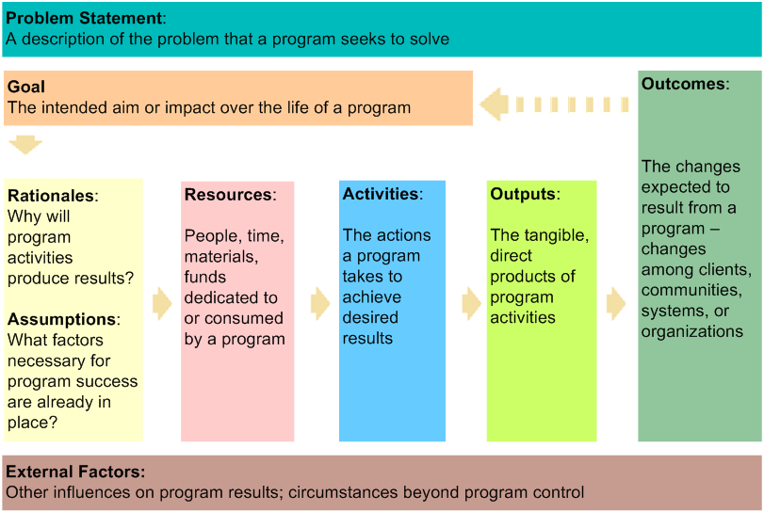

The following quote from the Logic Model Workbook describes the tie between the model and program evaluation:

*The cornerstone of effective evaluation is a thorough understanding of a program: what resources it has to work with, what it is doing, what it hopes to achieve, for whom, and when. In conducting an evaluation, it is tempting to focus most of your attention on data collection. However, your evaluation efforts will be more effective if you start with a logic model. Going through the logic model process will help ensure that your evaluation will yield relevant, useful information. The figure below illustrates how the logic model you will build can serve as the foundation for future evaluation plans*.

Connections between the logic model and evaluation planning:

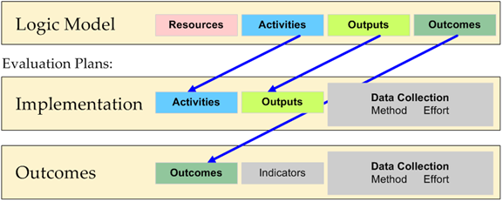

The Healing of the Canoe Project was required to develop a logic model as part of the grant proposal for Phase II of our project. It is found on page 42. It is complex (yours doesn’t have to be this complex), but it spells out what we saw as the rationale for the components of the proposed intervention, the activities that would be involved, and the outcomes we anticipated. Our evaluation plan was informed by this model.

**Choosing evaluation measures**

Interventions are often targeted at the individual level, attempting to modify the attitude and/or behavior of participants. This is often the level of interest to funding sources – they want to see if your intervention has led to a positive change in the target behavior. The logic model will help determine the areas that you will consider for assessment.

If the intervention goal is to prevent or reduce alcohol and drug use, then you need age-appropriate measures of substance use. If the goal is to increase connectedness to tribal values, you may want to choose measures of cultural identity, engagement in traditional activities or traditional spirituality. There are a number of possible areas that can be assessed, and a variety of specific measures that can be used to assess them.

Here are a few things to keep in mind as you choose your measures:

* When possible, use measures that are reliable and valid.
* If available, use measures that have been developed with, adapted for use with, and/or validated for AIAN populations.
* If you plan to measure change in the target behavior(s), then you will need to assess participants prior to and at least upon the completion of the intervention.
* If you want to look at the longer-term outcomes, then you will need additional follow-up assessment(s) at some point after the intervention has been completed.

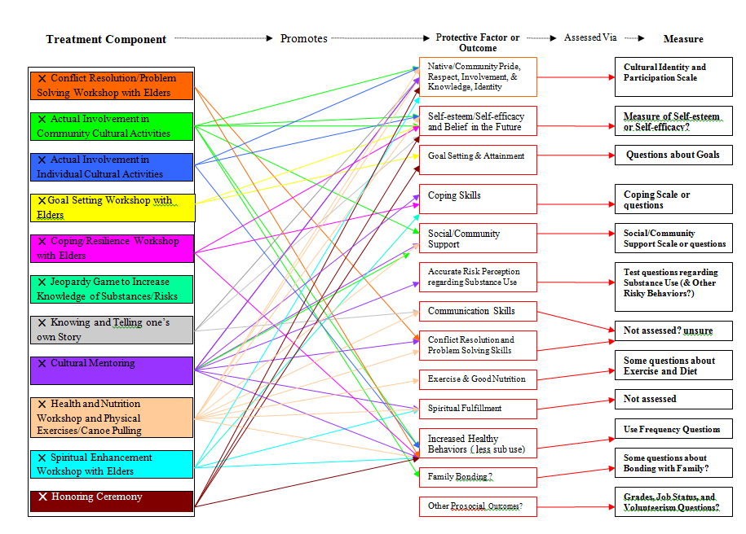

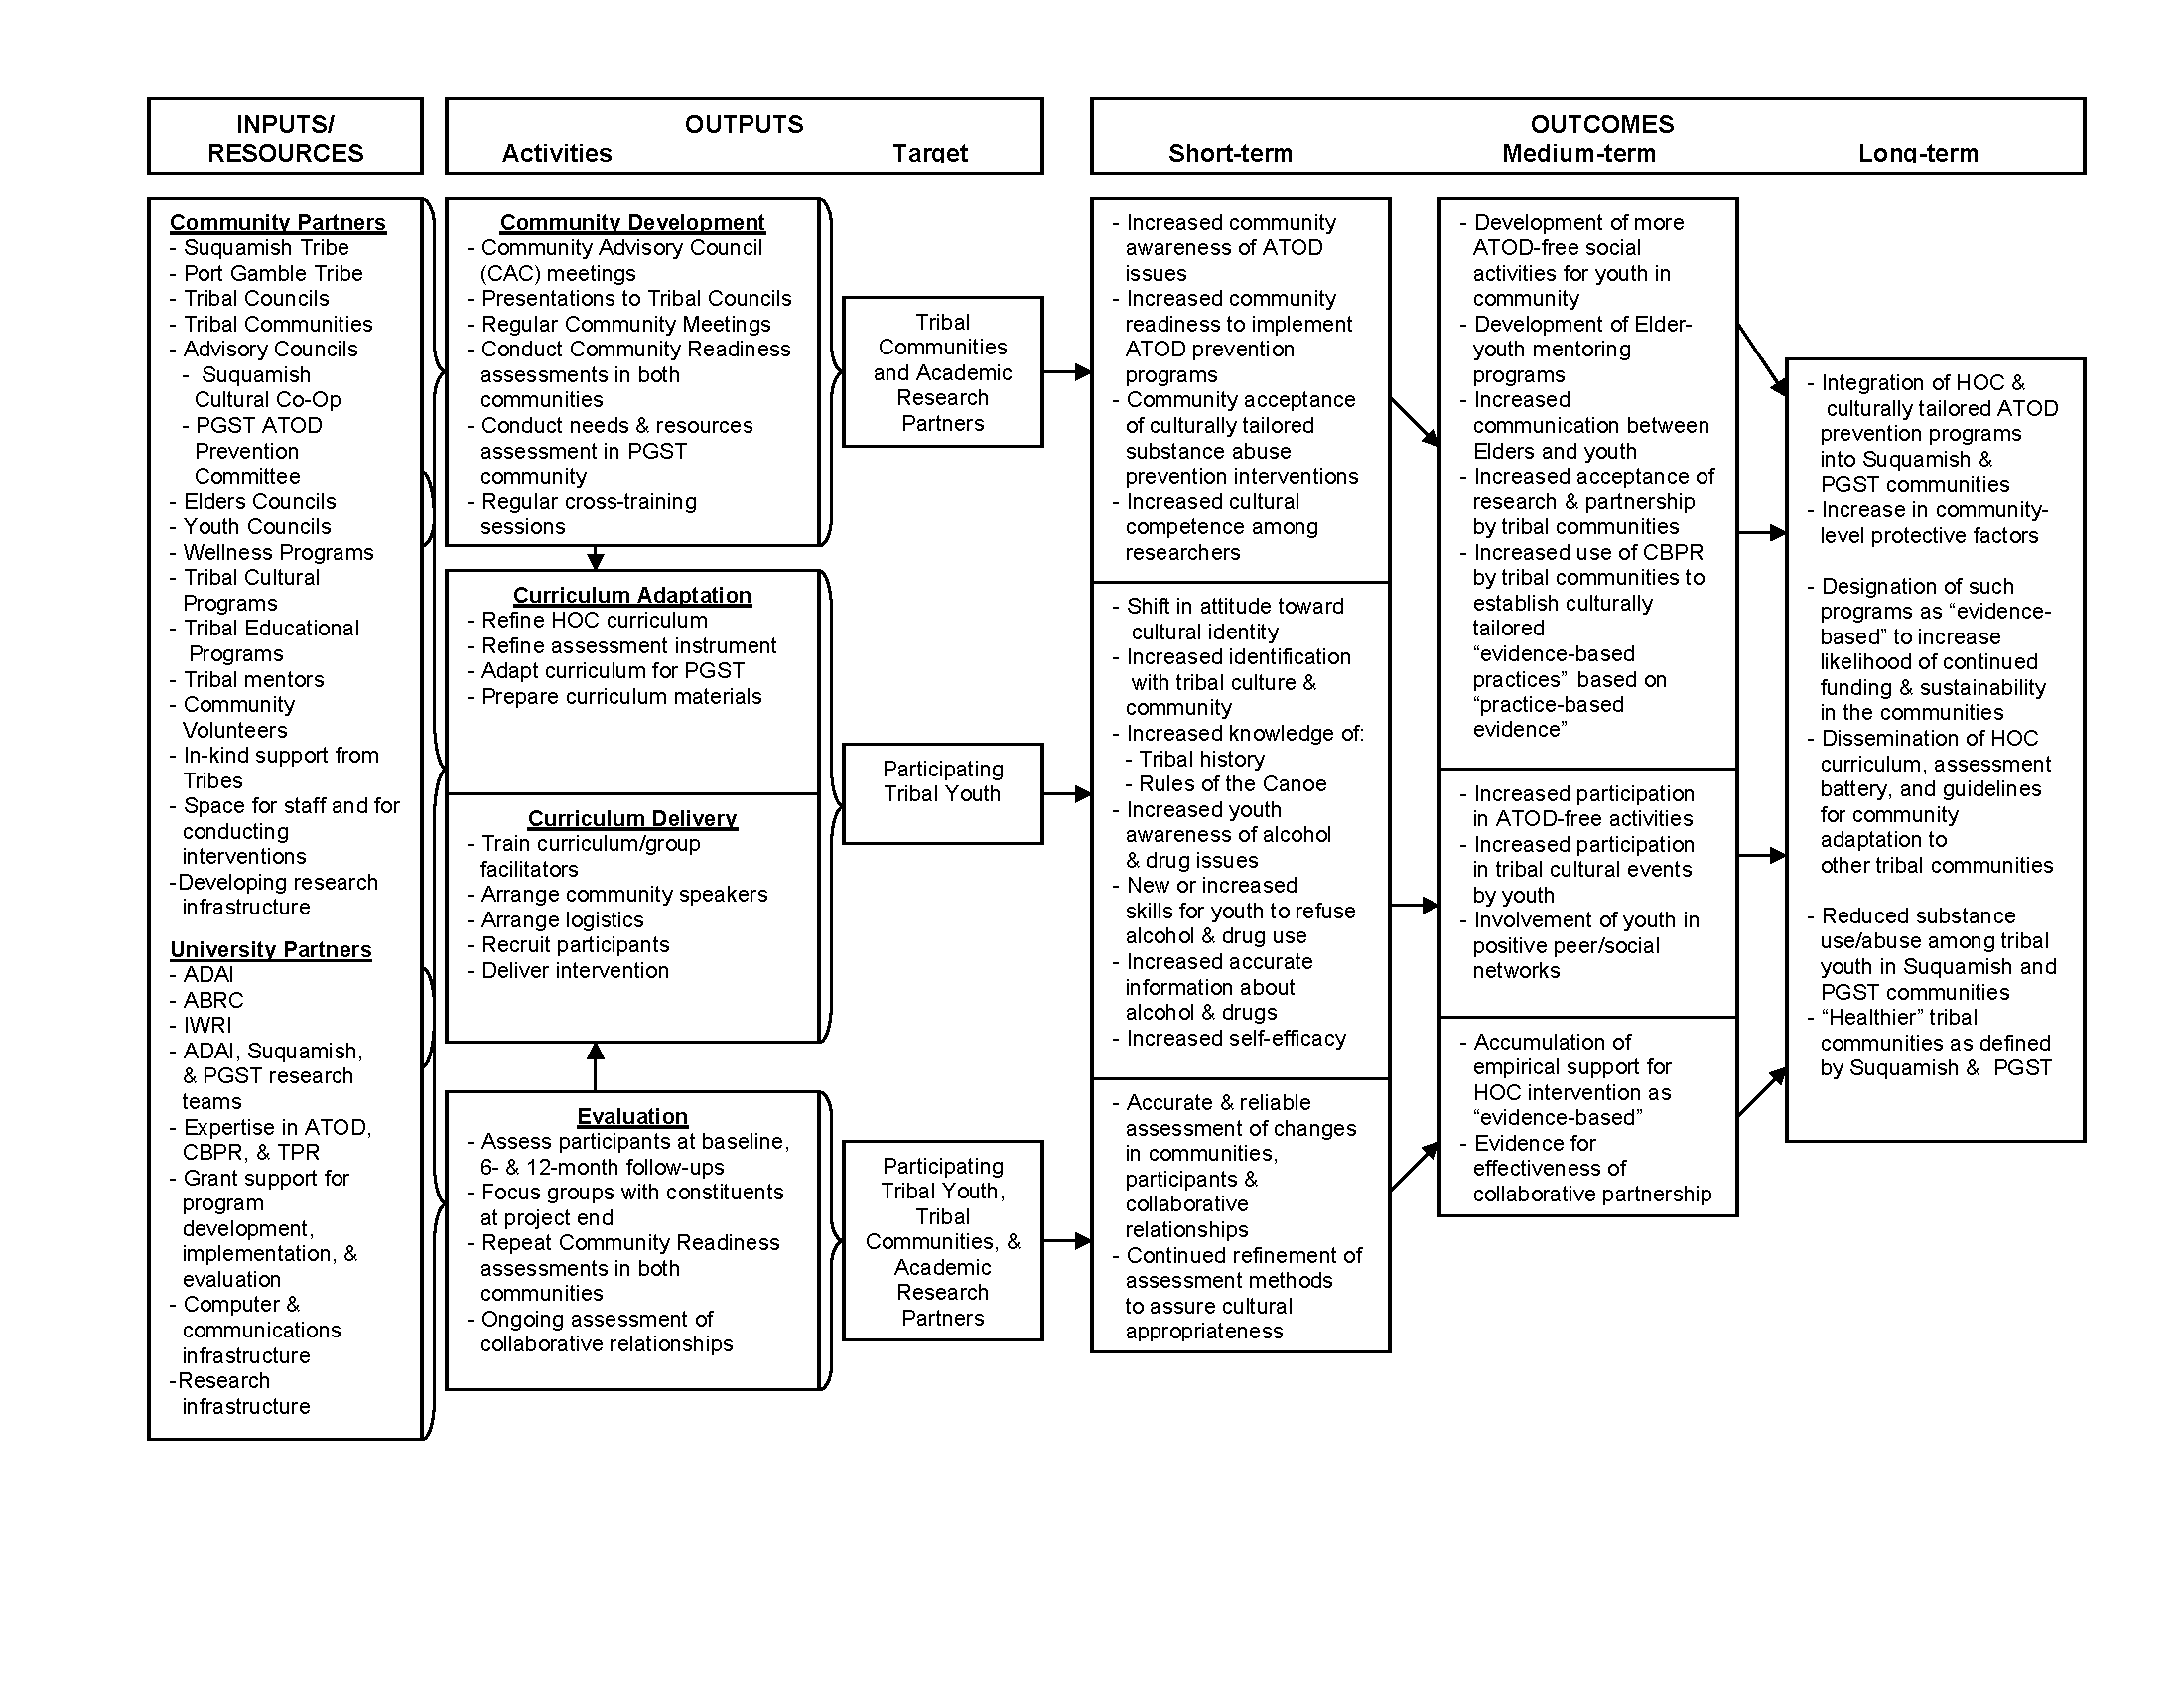

**MOVING FORWARD**

We hope that this training manual has been helpful in demonstrating how to assess needs in your community, and adapt and implement the Healing of the Canoe curriculum/intervention to best meet those needs – utilizing the many community strengths and resources at your disposal. You can return to this manual and your notes as you move through the adaptation and implementation process.

The HOC team is available to help you along the way. We will be offering weekly consultation and technical assistance via regularly scheduled online and conference call meetings. You will be added to an email list so that you can stay informed about the weekly schedule. Consultation meetings will also be an important way for trainees to continue to network with each other and learn from each other along the way.

The HOC curriculum was designed to be a continually evolving work in progress. We hope to learn from your experience and the curriculum’s evolution as you adapt it to fit your community’s needs, beliefs, values and strengths. We will be contacting you periodically to check in and see how things are going. We’d love to get your feedback about the entire process.

We wish you well on your journey!