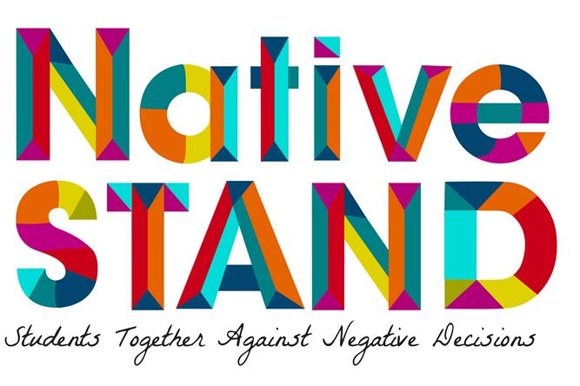
XYZ Tribe’s/Organization’s
Implementation Plan
Month/Year – Month/Year
Lead Educator Contact Information
Name:
Tribe/Organization:
Office # (Direct): Cell #:
Email:

- Don’t do this effort alone! Gather and create a circle of support to help you! Contact List here:

- How will you recruit youth in your community to participate in Native STAND?
(Write a few sentences, thinking about the following questions…)

- Are you building upon an existing youth program or creating a new one?
- How will you reach out to youth and their parents to obtain consent forms, in needed?
- How will you keep in touch with participants and their parents, to schedule sessions?

- When and where will you teach the Native STAND lessons?
(Write a few sentences, thinking about the following questions…)

  - During the school day? Afterschool? Weekends? As a summer program?
  - Do you have an alternate location as back-up?
  - Is the location easily accessible for students?
  - Is transportation an issue or could it be a potential barrier? If it is a barrier, what can you do to support your youth’s transportation needs?
  - In Person, Virtual or Hybrid implementation? (Note: Internet access)

- What is your intented timeline for implementing the Native STAND curriculum?
(Write a few sentences, thinking about the following questions…)

  - How often will you meet?
  - How many lessons will you cover per day, week, month? Will you offer one lesson over multiple days? Multiple lessons in one day?
  - Idea: Will you use a baseline survey? If yes, how and when do you expect to offer it?

- Create a rough timeline and budget for Native STAND
Activities | Specific Steps | Who is responsible? | Timeline for Completion |  |  |  |  |  |  |  |  |  |  |  |  | Budget
 |  |  | Jul  20xx | Aug | Sep | Oct | Nov | Dec | Jan  20xx | Feb | Mar | April | May | June | July 20xx
1.
2.
3.
1.
2.
3.
1.
2.
3.
1.
2.
3.
1.
2.
3.
1.
2.
3.

- How will you keep students engaged?
(Write a few sentences, thinking about the following questions…)

  - How will you re-engage youth if participation rates start to drop off?
  - Will you offer incentives? If so, what will you use; when will you give them out?
  - Tip: Incentives are important! And, Social Media can be helpful for contact.

- Helpful Tip: How will you select your co-facilitator? A co-facilitator is helpful!
(Write a few sentences, thinking about the following questions…)

- What skills/traits will you be looking for?
- How will you train them?
- How will you plan for transition of staff and/or educators, if there is turnover?

- Helpful Tip: Who will you invite to attend your Native STAND class as guest speakers to help on specific health topics? (i.e. sexual health, STDs, reproductive health, healthy relationships, etc.)

  - Clinic staff:
  - Health educator:
  - Counselor:
  - Teen parents:
  - Youth in treatment/recovery:
  - HIV+ community member:

- (Important!) How will you respond to a youth in crisis?
(Write a few sentences, thinking about the following questions…)

  - Do you have a local health clinic or mental clinic that you can refer students to?
  - What are the reporting requirements for your organization, Tribe, or State?

- How will you keep your community informed about the Native STAND program?
(Write a few sentences, thinking about the following questions…)

- Newspapers or Newsletter?
- Social media?
- Email?
- Calendar?
- Tribal Radio?
- Website?

- What are your plans for longer term program sustainability?
(Write a few sentences, thinking about the following questions…)
- Will you offer support to the Native STAND teens to act as peer educators?
- Will you work with your organization to sustain and integrate Native STAND as an ongoing effort?
- Do you plan to leverage community support?

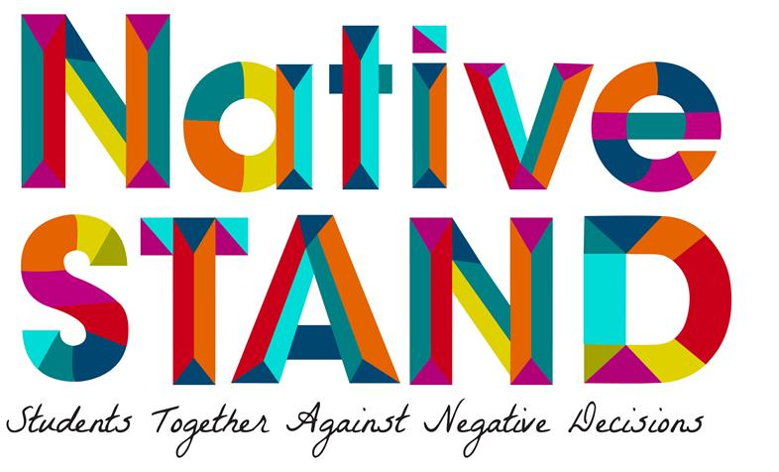
Helpful Reflection Tool: Session & Activity Log

Date Completed | Session # | Session Name | List Challenging Activities | List Skipped Activities | Things you would repeat | How long to Prepare for Session in (H/M) | How Long to Deliver Session in (H/M) | # of Students this session
 | 1 | Welcome & Introduction/Risky Business
 | 2 | Team Building
 | 3 | Acting Out
 | 4 | Culture & Tradition
 | 5 | Honoring Diversity/Respecting Differences
 | 6 | Goals & Values
 | 7 | Healthy Relationships  Part 1
 | 8 | Reproductive Health Part 1
 | 9 | Reproductive Health Part 2
 | 10 | The Downside of Hooking Up
 | 11 | Pregnancy & Parenting
 | 12 | Preventing Pregnancy
 | 13 | Condoms
 | 14 | STDs – Part 1
 | 15 | STDs – Part 2
 | 16 | HIV/AIDS – Part 1
 | 17 | HIV/AIDS – Part 2
 | 18 | Field Trip To a Local Clinic
 | 19 | Taking Care of the Whole Person
 | 20 | Healthy Relationships Part 2
 | 21 | Drugs & Alcohol
 | 22 | Negotiation & Refusal Skills
 | 23 | Decision Making
 | 24 | Being a Peer Educator
 | 25 | The Stages of Change
 | 26 | Effective Communication
 | 27 | Putting It All Together

