The Basics of LGBTQ2S
Terminology
LGBTQ2S - An umbrella term referring collectively to people who identify as lesbian, gay, bisexual, transgender, questioning, and/or queer. Gay used to be the general phrase used, but now LGBTQ is the more current and inclusive term.
Lesbian - An identity for people who identify as women and who are attracted emotionally, erotically, and/or sexually to some other women.
Gay - An identity for people who identify as men and who are attracted emotionally, erotically, and/or sexually to some other men.
Gay used to be an umbrella term to refer to all lesbian, gay, and bisexual people, but using it as such now may wrongly position gay men as representing all LGBTQ people. However, some lesbians and queer folk may use it to identify themselves.
While some folks consider this identity synonymous with “homosexual” (or view it as a more proper way to refer to this identity) many folks that identify as gay may consider it a pathologizing and an awkwardly formal way to refer to members of the community.
Bisexual - An identity for people who are attracted emotionally, erotically, and/or sexually to some men and women. Other identities such as ‘pansexual’ and ‘queer’ may have this same explanation, but this may vary depending on the person.
Transgender or Trans - A broad umbrella term that can be used to describe people whose gender expression is non-conforming and/or whose gender identity is different from their sex assigned at birth. Transgender people may or may not choose to alter their bodies hormonally and/or surgically. People must self-identify as transgender in order for the term to be appropriately used to describe them.
Some people use the term Trans with an asterisk afterwards. Although used by some as a way to make Trans a more inclusive identity, others view it as way to exclude particular trans identities. Therefore, we don't use Trans with an asterisk because of it's hurtful history. To learn more about the history of Trans with an asterisk, check out this article.
Queer - An umbrella term to refer to all LGBTQ people as well as an identity which advocates breaking binary thinking and seeing both sexual orientation and gender identity as potentially fluid. While it has been reclaimed as a unifying, celebratory, and neutral term among many LGBTQ people today, historically it has been derogatory and can still be viewed negatively by some.
Questioning - An identity for people who are uncertain of their sexual orientation and/or their gender identity.
Two-Spirit – An umbrella term adopted by some Indigenous people in the early 1990s as an alternative to Western labels to describe a traditional third-gender ceremonial role in their cultures.

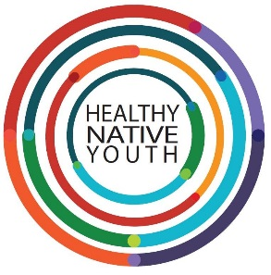
Answering Sensitive Questions
What are the right terms to use?
Language is fluid and contested. Language changes over time, and different people may use the same term differently. A good practice is to educate yourself on the ways concepts and terms are used in your geographic region.
Won’t talking about gays and lesbians put ideas into our kids heads?
Keep your language positive. Let them know we do want to put ideas into youths heads….healthy ones! The earlier, the better!
“Youth get so many unhealthy ideas & messages from media, peers, and irresponsible adults at an early age that we have to provide honest, accurate information in a safe space with caring and supportive adults sooner, rather than later.”
When should I talk to my child about LGBTQ2S issues?
Have your facts ready. Educate yourself as much as possible about LGBTQ2S issues.
“I felt a little uncertain about when was the right time to talk to youth my kids about LGBTQ2S issues. If it’s done in an age appropriate, respectful way it can be done as early as toddler age.
We know that well before adolescents, as early as age 7, youth are aware of being attracted to another person. The average age of youth realizing their gay is 13. When we think about it, there’s only two time points to receive information…before you need it, or after you need it. We are trying to equip them with life skills before they need it.”
It’s important to remember even if your kids aren’t thinking about these things, some of their peers are and they can be a good source of support for their friends.”
Why are people gay?
There is no consensus about the exact reasons that an individual develops a heterosexual, bisexual, gay, or lesbian orientation.
There has been a lot of research that has looked at the possible genetic, hormonal, developmental, social, and cultural influences on sexual orientation. Through this research there have been no findings to narrow down specific factor(s) that determine a person’s sexual orientation. Rather, it’s understood that both nurture and nature play complex roles on sexual orientation.
Why is “that’s so gay” so offensive if people don’t mean anything by it?
Typically when people use this phrase, they are using "gay" as a synonym for something bad, negative, or less desirable. The use of this phrase communicates or perpetuates the prevailing societal view that being gay is less desirable and/or that you may not be supportive of LGBTQ2S people.
Are bisexual people folks who just haven’t come out as lesbian or gay?
No. Bisexual, pansexual, and omnisexual people are open to attraction and physical/sexual connections to people of various gender identities. Some bisexual people may hide their identity from both the heterosexual and lesbian and gay communities, believing neither will accept them. Bisexual identification is often met with skepticism in the gay & lesbian communities and is seen as an attempt to avoid the stigma of homosexuality.
Why do people ‘come out’? Isn’t it harder?
People tell others, or ‘come out’ in lots of different ways, for lots of different reasons. We know that it can have a positive impact on an individual and can foster a greater sense of well-being and mental health.
Being able to discuss one's sexual orientation with others also increases the availability of social support, which is crucial to mental health and psychological well-being. Like heterosexuals, lesbians, gay men and bisexual people benefit from being able to share their lives with and receive support from family, friends and acquaintances. Thus, it is not surprising that lesbians and gay men who feel they must conceal their sexual orientation report more frequent mental health concerns than do lesbians and gay men who are more open; they may even have more physical health problems.
What can I do in my community?
Examine your own belief systems.
Become friends with openly gay people.
Studies of prejudice against gay people, consistently show that prejudice declines when members of the majority group interact with members of a minority group.

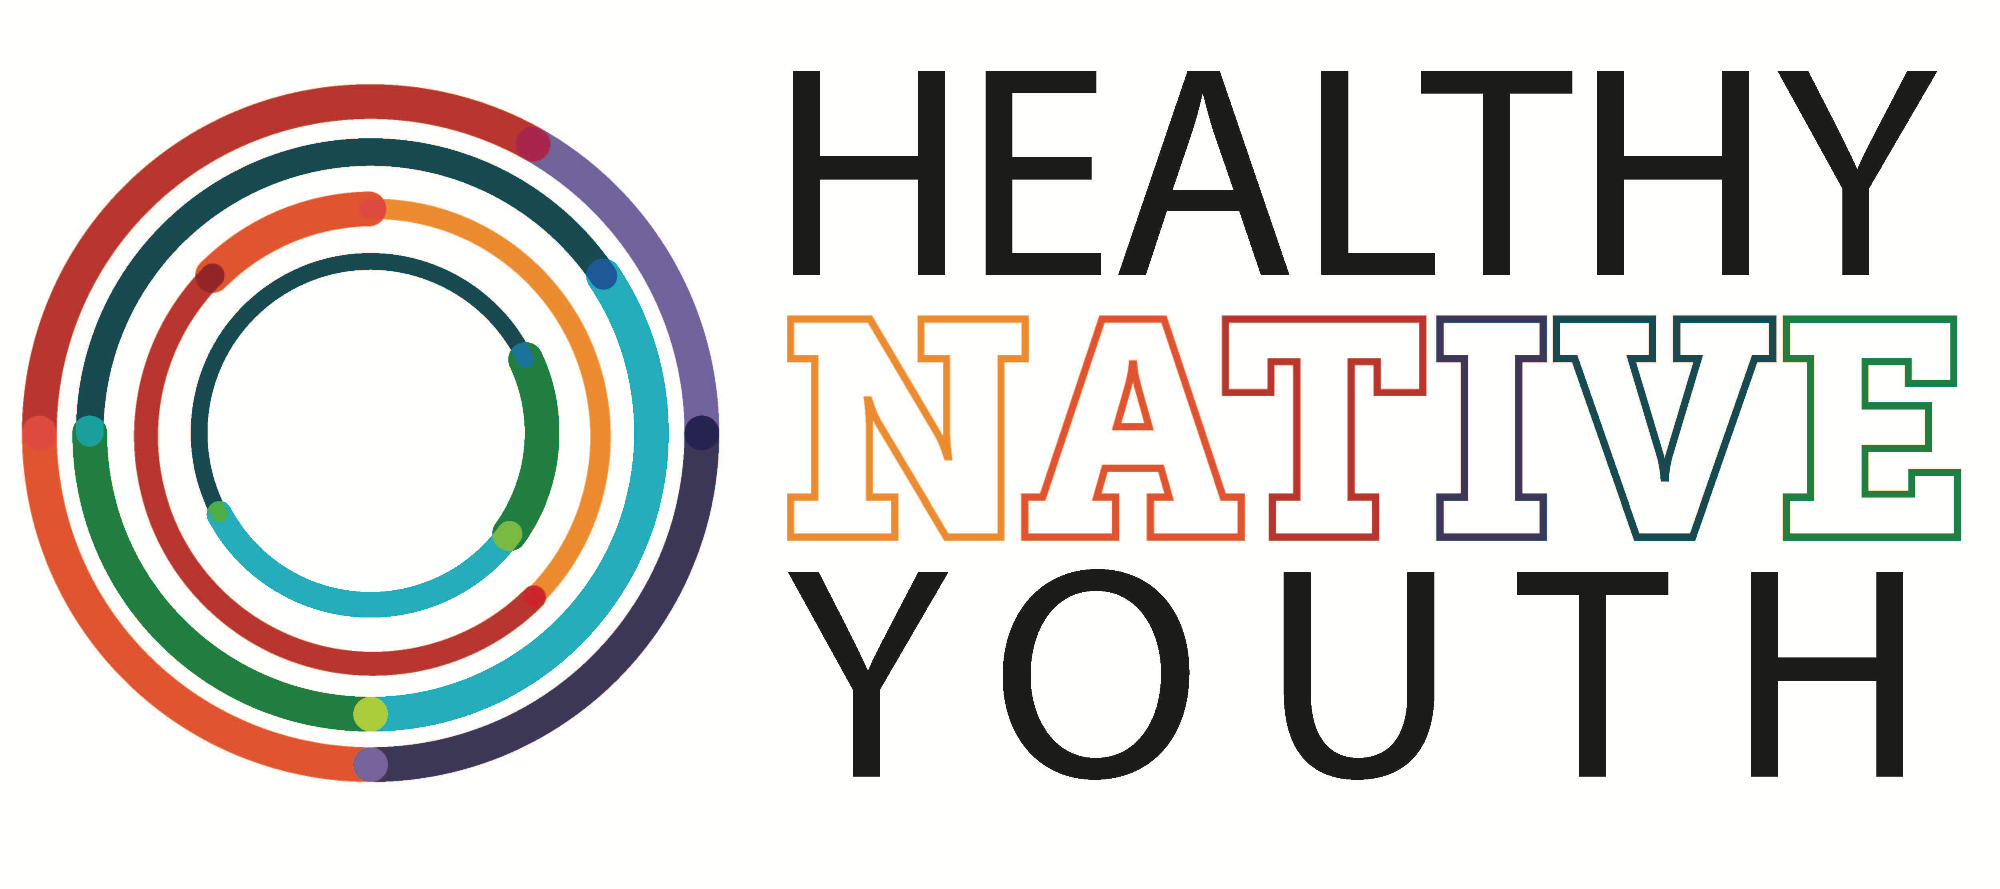

LGBTQ2S Resources

We R Native – https://www.wernative.org/
Ask Auntie: https://www.wernative.org/ask-auntie/all-questions?cat=730674

Native Youth Sexual Health Network – http://www.nativeyouthsexualhealth.com/

Human Rights Campaign (HRC) - https://www.hrc.org/

Gay, Lesbian and Straight Education Network (GLSEN) - https://www.glsen.org/

Family Acceptance Project - https://familyproject.sfsu.edu/

American Psychological Association – https://www.apa.org/pi/lgbt/resources/just-the-facts

American Academy of Pediatrics - https://services.aap.org/en/search/?context=all&k=LGBTQ

Mental Health American (MHA) - http://www.mentalhealthamerica.net/lgbt-mental-health

Trans Student Educational Resources - http://www.transstudent.org/what-we-do/graphics/

The LGBTQ Center - https://www.thelgbtqcenter.org/

The Trevor Project - https://www.thetrevorproject.org/

Suggestions for Inclusion:
Help end bullying at your school with the following actions: • Be alert to signs of distress. • Work with student councils to have programs on respect, school safety and anti-bullying. • Ask school personnel to have a discussion at an assembly or an after-school activity about gay prejudice. • Help start a Gay, Lesbian and Straight Education Network (GLSEN) chapter at your local high school. • Arrange for a group like GLSEN to present bullying prevention activities and programs at your school. • Do encourage anyone who’s being bullied to tell a teacher, counselor, coach, nurse, or his or her parents or guardians. If the bullying continues, report it yourself.
Posters to Print or Order
We R Native: https://www.wernative.org/gear/free-stuff
Native Youth Sexual Health Network – http://www.nativeyouthsexualhealth.com/youthphotoproject.html
Trans Student Educational Resources - http://www.transstudent.org/what-we-do/graphics/

New York University. LGBTQ Terminology [Retrieved from https://www.nyu.edu/students/communities-and-groups/student-diversity/lesbian-gay-bisexual-transgender-and-queer-student-center/glossary-of-important-lgbt-terms.html]
LGBTQ Center – Educating for Equality, University of North Carolina [Retrieved from https://lgbtq.unc.edu/resources/frequently-asked-questions]
American Psychological Association. (2008). Answers to your questions: For a better understanding of sexual orientation and homosexuality. Washington, DC: Author. [Retrieved from www.apa.org/topics/lgbt/orientation.pdf.]

