Virtual
Adaptation
Workbook

Nicole Treviño and Amanda Gaston

Northwest Portland Area Indian Health Board

Authors
This guide was developed by Nicole Treviño and Amanda Gaston on behalf of the Northwest Portland Area Indian Health Board’s Healthy Native Youth Program.
Nicole Treviño is a consultant working in public health, with a focus on adolescent health, sexual health education and integrating culture into prevention programs. She has spent her career working in the nonprofit, government and social sector working to strengthen services for children, youth and families. Nicole previously served as the Project Director for the LEAD Collaborative: a 5-agency training and technical assistance team for the federal Office of Population Affairs and the U.S. Programs Manager at EngenderHealth. She is a co-author of several health programs for youth, including We R Native, Gender Matters (Gen.M.), and RE:MIX. Nicole holds a Master of Arts in Organization Development, a Bachelor of Science in Health Promotion, and is a Certified Health Education Specialist.
Amanda Gaston (Zuni Pueblo) is a consultant working in tribal health and Native youth programming. She hosts Healthy Native Youth’s monthly Community of Practice and leads the Ask Auntie service on behalf of We R Native: a multimedia health resource for Native teens and young adults. Amanda previously worked as the Project Manager at NPAIHB, supporting the Native It’s Your Game Curriculum Adaptation, authoring the We R Native curriculum, and launching the We R Native website. Amanda holds a Master of Arts in Teaching and before coming to the NPAIHB was a Primary Years Program International Baccalaureate teacher in Thailand.
Northwest Portland Area Indian Health Board (NPAIHB) is a non-profit tribal advisory organization serving the forty-three federally recognized tribes of Oregon, Washington, and Idaho. Established in 1972, the NPAIHB strives to eliminate health disparities and improve the quality of life of American Indians and Alaska Natives by supporting Northwest Tribes in their delivery of culturally appropriate, high-quality healthcare. NPAIHB houses a tribal epidemiology center (EpiCenter), manages health promotion and disease prevention projects, and is active in Indian health policy. For more information, visit: npaihb.org.
Healthy Native Youth is a collaborative project between NPAIHB, the Alaska Native Tribal Health Consortium, the Inter Tribal Council of Arizona, Inc. and The University of Texas Health Science Center at Houston. The Healthy Native Youth website contains health promotion curricula and resources for American Indian and Alaska Native youth. The site is designed for tribal health educators, teachers, and parents – providing the training and tools needed to access and deliver effective, age-appropriate programs. For more information, visit: HealthyNativeYouth.org.

Funding Acknowledgement
This project is funded by the Indian Health Service HIV and behavioral health programs. This work is also supported with funds from the Secretary’s Minority AIDS Initiative Fund.

Acceptable Use/ License
This work is licensed under the Creative Commons Attribution-NonCommercial-NoDerivatives 4.0 International License. To view a copy of this license, visit http://creativecommons.org/licenses/by-nc-nd/4.0/ or send a letter to Creative Commons, PO Box 1866, Mountain View, CA 94042, USA.
You are free to share this resource, including copying and redistributing, under the following terms:
- Attribution — You must give appropriate credit, provide a link to the license, and indicate if changes were made. You may do so in any reasonable manner, but not in any way that suggests the licensor endorses you or your use.
- Non-Commercial — You may not use the material for commercial purposes.
- No-Derivatives — If you remix, transform, or build upon the material, you may not distribute the modified material.

Suggested Citation
Trevino, N., & Gaston, A. 2020. Healthy Native Youth: Virtual Adaptation Guide. Portland, OR: Northwest Portland Area Indian Health Board.

Table of Contents

SECTION 1: PREPARATION & PLATFORM SELECTION RESOURCES
1A. Community Needs Assessment Planning Template 5
1B. Sample Needs Assessment Questions 11
1C. Sample Survey Script 18
1D. Survey Template 19
1E. Interpreting Community Needs Assessment Findings 23
1F. Organizational Assessment 25
1G. Implementation Timeline 30
1H. Program Selection Checklist 32
1I. Incentive Sign Out Log 35

SECTION 2: PLANNING RESOURCES
2A. Identifying Stakeholders and Building Partnerships 37
2B. Online Response Plan & 2C. We’ve Got Your Back 39
2D. Program Adaptation Log 43
2E. Detailed Run of Show Agenda 45

SECTION 3: IMPLEMENTATION RESOURCES
3A. Wellness Moments 47
3B. Virtual Program Attendance Log 48

SECTION 4: MONITORING, QUALITY IMPROVEMENT, & SUSTAINABILITY RESOURCES
4A. Fidelity Monitoring Log 51
4B. Quality Improvement Tracker 55

1A. Community Needs Assessment Planning Template

The goal of a simple community needs assessment is to understand:
- What youth, their families, and the broader community want to see in programming
- What resources you have available
- What constraints or challenges need to be addressed

To assist in your process, we have included a planning template which walks you through each of the following steps.
Step 1: Planning & Timing
Step 2: Distribute & Collect Survey
Step 3: Analyze, Integrate, & Disseminate CNA results

Instructions: Use this template to help guide your CNA planning process.

Step 1: Planning & Timing

Guiding Question: Who should provide feedback, input and guidance on the program?

Activities | Select Intended Audience(s) | Who’s Involved | Deadline for Selection
Select Intended Audience(s) | - Youth  - Parents/ Families/ Caring Adults  - Elders or Tribal Leaders  - Community Members  - Schools or Other Implementation Sites  - Partner Organizations  - Other (List)

Guiding Question: What do you want feedback, input, and guidance on?

Activities | Select CNA Topic(s) | Who’s Involved | Deadline for Selection
Select Topics You Want Feedback On: | - Program Content/Topics  - Recruitment/ Retention  - Logistics/ Technology  - Program Implementation  - Other (List):

Guiding Question: How do you want to gather that feedback, input, and guidance?

Activities | Select | Who’s Involved | Deadline for Selection
Select Feedback Collection Methods and Indicate Audience(s): | Paper or Document  - In-Person Form or Survey  - Mail Survey – include Self-addressed envelope  - Email Attachment or Emailed Questions  Electronic  - Social Media Poll  - Survey Link or Online Form (e.g., Survey Gizmo, Survey Monkey, Qualtrics, etc.)  - Zoom Breakout Rooms/ Poll feature  - Other:  Interview  - In-person  - Phone  - Online Event:

Guiding Question: When will you collect and analyze this information and what is the timeframe needed to complete these processes?

Activities | Specific Steps | Who is responsible | Deadline
How long will it take to gather this information (be realistic) and how many sources of this info will you seek? | For example:  - 2 weeks for reg. forms from 10+ students  - 2 weeks to recruit 5 students to join 1-hour online discussion  - 1 week to schedule with 2 elders & complete  - 2 weeks to leave survey open w/a reminder at 1 week
How long will it take you to analyze the information gathered and identify themes? | For example:  - 2 weeks from closing registration time  - 2 weeks from time of online discussion  - 1 week from completing phone calls  - 1 week from completion for each school

Step 2: Distribution & Collect Feedback

Guiding Question: Where can the CNA be distributed (or where can participants be recruited)?

Activity | Select Event(s) | Location(s) | Date(s) & Time | Contact Person | Who is responsible for Organizing
Identify Feedback and Outreach Opportunities: | - Youth Event  Name:
- School Event
Name:

- Community Event
Name:

- Tribal Event
Name:

- Parent Event
Name:

- Cultural Event
Name:

- Create Own Event
Name:

- Other
Name:

Guiding Question: What incentives will you provide for participation (if any)?

Activity | Select Incentive | Person Responsible for Purchasing | Person Responsible for Distributing/ Tracking
Select Incentive Options: | - Shopping Gift Card (Amazon, Walmart, iTunes, etc.):  ___________________________  - Food Gift Card (Starbucks, Restaurant, GrubHub, etc.):  ___________________________  - Project Swag (hoodies, shirts, stickers, etc.):  ___________________________  - Badges/ Points (for shared goal – e.g., pizza party, iPod shuffle, etc.): _______________________  - Other:

Guiding Question: How will you follow-up to collect feedback?

Activities | Reminder Type | Date: Reminder | Date: Final Reminder | Who is Responsible
How and when will you remind folks to submit their feedback? | - Phone calls:
 | - Emails/ Email Listserv:
 | - Youth/Tribal/Local Newsletters:
 | - Local or Tribal Radio Stations:
 | - Local or Tribal Newspapers:
 | - Social Media Channels:
 | - Partner Channels (e.g., school, tribal clinic, Boys & Girls Club, etc.):
 | - Other:

Step 3: Analyze, Integrate, & Disseminate CNA Results
Guiding Question: What did you learn from the CNA (analyze)?

Activity | Who is responsible | Deadline
Look for themes from each audience you collected feedback from.
Identify common themes and differences between audiences.

Guiding Question: How will the findings be used to inform your adaptation and implementation (integrate)?

Activity | Options | Who is responsible | Deadline
What will you do with the information gathered? | - Guide the lesson content and selection of online platform(s) based on student needs, resources and wants  - Inform cultural teachings to include in program  - Make decisions to align implementation to existing policies/ tech at schools  - Other:

Guiding Question: How will you disseminate the results and/or let folks know about how their feedback will be used?
Activity | Options | Who is responsible | Deadline
How will you let folks know about the CNA results? | - Parent/ Youth Event  - Video Event  - Youth Newsletter  - Tribal Newsletter  - Newspaper  - Local or Tribal Radio  - Social Media  - Partner Channels (e.g., school, tribal clinic, Boys & Girls Club, etc.)  - Email Listserv  - Constant Contact  - Other:

1B. Sample Needs Assessment Questions

Below are some sample questions that can be used for surveys, intake/registration forms, focus groups or interviews. These questions are split up into different audience groups, for your consideration. Use them as a guide and starting point to select and tailor for your intended audience. It’s good practice to keep the questions short and to the point. Around 10 questions is a good goal for youth surveys and 15 for adult surveys, but you may want to choose a smaller number of questions if doing interviews or focus groups.
Following these questions is a handout template that you can cut and paste questions into, if you’d like a paper survey. Otherwise, your selected questions can be emailed, put into a survey tool (e.g., Survey Gizmo, Survey Monkey, etc.), or asked of folks verbally either in-person or within a Virtual meeting space (e.g., Zoom, Google Classroom, MS Teams, etc.). You can get creative and use Interaction Software to collect information from folks too like Padlet, Quizlet, Mentimeter, or Zoom polls…or even do a Bingo Data Collection activity.
Below you can find sample questions for:
- Youth
- Parent/ Caregiver
- District Level
- Implementation Site
- 2SLGBTQ Community Readiness
- Teen-friendliness

  - Sample Q’s: Youth Survey/Focus Group Questions

Logistics
- What is your ‘back-to-school’ schedule?
  - All Virtual Learning
  - All In-person Learning
  - Mix of Virtual & In-person Learning
- When are you available to participate in programs online?
  - Weekend Mornings
  - Weekend Evenings
  - Weekday Afternoons
  - Weekday Evenings
  - Other, please describe:
- What is the best way to tell you about programs and events?
  - Email
  - Mail
  - Online Learning App
  - Social Media
  - Text Message/Phone Call
  - Other, please list

Virtual Platform (IT Capacity)
- What equipment do you have available for online learning/programs (Check all that apply)?
  - Cell phone
  - Smart phone
  - Tablet
  - Laptop, computer
  - Other, please list
- Do you have at least one device (phone, computer, tablet) that only you use?
  - No
  - Yes. Please list:
- Do you have internet access?
  - Yes, unlimited
  - Yes, limited
  - Some of the time
  - No access at home
  - No access at all
- What virtual platforms do you like using?
  - Zoom
  - Google classroom
  - Teams
  - FB/ IG Live
  - Other, please list

Household
- Do you have a private space to work/participate in programs?

Temperate Check
- What challenges are you having right now?
- What is going well for you?
- What topics are you interested in talking about or learning about?

  - Sample Q’s: Parent/ Caregiver Survey/Interview Questions

Logistics
- What is your ‘back-to-work’ schedule?
  - All Remote
  - All In-person
  - Mix of Remote & In-person Work
  - Not working
- Please list the ages of children in your household.
- Do youth have a private space to work/ participate in programs?
- What is your child’s (children’s) ‘back-to-school’ schedule?
  - All Virtual Learning
  - All In-person Learning
  - Mix of Virtual & In-person Learning
- What other activities do your youth participate in? How often?
  - Sports
  - Tribal Events
  - Faith Based Events
  - After school programs
  - Other, please list
- What is the best way to tell you about programs and events?
  - Email
  - Mail
  - Online Learning App
  - Social Media
  - Text Message/Phone Call
  - Other, please list

Virtual Platform (IT Capacity)
- Does your youth have access to at least one device to participate in online programs?
  - Yes (please list)
  - No
  - Not Sure
- How reliable is your internet?
  - Most of the time
  - Some of the time
  - Hardly ever
  - Doesn’t work

Temperate Check
- What type of program would your youth be interested in?
- What challenges is your youth experiencing right now?
- What are some of your youth’s strengths that you want to support?
- What type of programs or services would be helpful for your family/ your youth?
- What type of support would be helpful for you as a parent/caregiver?

  - Sample Q’s: District Level Survey/Interview Questions

Logistics/Plans for Virtual Implementation
- Does your district have a ‘back-to-school’ schedule? If so, please share.
- Is your district planning to utilize a traditional, virtual, or blended learning format?
- Will your district be utilizing asynchronous, synchronous, or both types of learning?
- At what frequency will this type of learning be offered?
- Are you currently allowing community-based organizations to implement programs in your district?
- How does your district communicate with parents/ caring adults?
- What restrictions do your districts have for community partners? (e.g., start date, number of visitors, specific days, etc.)
- Would in-person or virtual programs for youth be preferred?

Virtual Platform (Internal Staff Capacity/Training)
- What virtual platforms will the district be using (e.g., zoom, google classroom, teams, etc.)

Challenges
- List any challenges associated with virtual implementation

  - Sample Q’s: Implementation Site Questions

Logistics/Plans for Virtual Implementation
- What date do you plan on starting virtual implementation?
- What population do you plan to serve?
- In what setting will this virtual implementation take place (e.g., via a school-based program, out- of-school, juvenile justice, etc.)?
- If in a school-setting, how might you navigate implementation plans with a staggered school schedule in which not all students would be in the school building on the same day?
- What’s the approximate cohort size?
- What curriculum do you plan to implement?

Virtual Platform (Internal Staff Capacity/Training)
- What virtual platforms (ex. Zoom) do you plan to utilize?
  - Is the platform/sessions being provided live or pre-recorded?
- Do you have PowerPoint Presentations for the intended curriculum?
- How do you plan on tracking participation? Attendance?
- How do you plan on obtaining active parental consent?
- How do you plan to collect pre- and post-surveys?
- What resources will be needed? (Costs for platforms, training for staff, etc.)
- How many staff would you ideally need to implement programming?
  - What ‘roles’ do you see staff facilitating?

Adaptations to curriculum
- What types of adaptations will be needed?

Challenges
- List any challenges associated with virtual implementation

  - Sample Q’s: 2SLGBTQ Community Readiness Survey Questions
*Check out Healthy Native Youth for the Full Guide & the recorded Community of Practice Session from 2/12/20.

- Why do you think it’s important for Native youth to learn about 2SLGBTQ topics (e.g., terminology, history of Two-Spirit, safety, acceptance, resources, etc.)?
- At what age should 2SLGBTQ education begin?
- What topics are important for youth to learn about 2SLGBTQ inclusion?
- Do you think 2SLBGTQ youth are comfortable talking about their sexual orientation or gender identity with teachers and other youth at your school?
- If you hear a comment that is negative about 2SLGBTQ identities, are you comfortable speaking up to disagree with or correct that comment?
- Does your school, community center, or other buildings have gender-neutral restrooms?
- What programs, clubs, or services exist in your community for 2SLGBTQ youth?
- Can 2SLGBTQ youth in your community participate in gender-neutral (co-ed) sports teams or in the sports team that aligns with their gender identity?
- What is the best way to engage community members in an 2SLGBTQ inclusive program?
- What are the barriers for an 2SLGBTQ inclusive program in your community? How can these best be overcome?
- What health services (e.g., reproductive health, substance use, mental health) are available to 2SLGBTQ youth in your community?
- How easy/hard is it for 2SLGBTQ youth to access these services confidentially? How could this be improved?
- Anything else we should know?

  - Sample Q’s: Teen-friendliness Survey Questions

Adapted from the Teen-friendliness Clinic Survey from Native It’s Your Game.
*Check out Healthy Native Youth for the BINGO Data Collection activity.
- Do you know what the clinic hours of operation are? If so, what are they?
- Where have you seen clinic hours posted or publicized?
- Where would you recommend they be posted or publicized?
- What hours or days would you recommend the clinic be open to make it easier for teens schedules?
- Do you know what the clinic service costs are (e.g., low-cost or no-cost for tribal members)?
- Where would you recommend the clinic post their service costs?
- How and when does the clinic send out appointment reminders?
- Are there other ways and times teens might like to receive reminders?
- Can teens receive an appointment within the same week they call?
- Does the clinic have a hotline? Do you know that number?
- How easy to see are clinic signs?
- How teen-friendly do you think clinic signs are?
- How LGBTQ2S friendly do you think clinic signs are?
- Would you recommend any changes to clinic signs to be more inclusive for teens, LGBTQ2S youth, or Indigenous languages speakers?
- Where would you recommend these signs be posted or publicized?
- Is there any way the clinic can have a more private entrance?
- Where would you recommend creating a separate waiting area for youth (i.e., an obscure corner or alcove or behind a divider)?
- Where would you recommend waiting rooms signs be posted that assure youth their information is kept private and confidential, as well as the assurance they will be seen, even if they are not able to pay for their services be posted?
- Are there ways the clinic can be better at keeping people who are walking by from seeing who’s inside the waiting room?
- Do you have any recommendations to improve or include transportation for teens to get to the clinic and back home?
- What teen-friendly magazines, music, games, or LGBTQ2S materials would you suggest for the waiting room?
- What pamphlets or health education materials or topics would you recommend the clinic display?
- What recommendations would you give to make clinic forms more teen-friendly?
- In what ways could clinic staff better support teens during their appointment?
- Where could condoms be confidentially stored?
- What recommendations would you give for clinic staff to build ongoing professional health care relationships with teens?
- Is there anything that we’re missing?

1C. Sample Survey Script

Instructions: Below is a sample script that you can cut and paste from for your CNA surveys, be it intake/registration forms, focus groups, interviews, etc. Personalize the language to fit your personality and your community. Feel free to jazz it up!
Provide Brief Summary
Hello! I’m [insert name] from [insert organization]. I am reaching out to youth in our community to learn more about their availability and interest in the [insert program name]. This survey will help us understand how to best offer our youth programs online during this time.
The survey will take about 10 minutes to complete. Your responses to other questions are confidential and will not be seen by anyone outside of our staff team. Your help is VERY IMPORTANT to us. Once we hear from you and other youth in our community, we’ll begin planning our programs based on your feedback.
We want to say a HUGE thank you for helping us today!
Survey Instructions
Please fill in the survey questions as best you can. Your responses will be kept private. This is not a test and there are NO RIGHT OR WRONG ANSWERS.
Next Steps
Once we’ve gathered everyone’s feedback, we’ll look closely at all the responses. We will take time to plan our upcoming programs around your needs. We will report the overall results back to the community through the [insert – e.g., newsletter, community event, social media, etc.]
As a ‘thank you’ gift for completing the survey, we will be giving you a [insert type of incentive] once you’re done. This will [insert distribution method- handout, text, email, mail, drop off, etc.].
If you have any questions or want to discuss this survey with us, please contact: [insert contact information].

1D. Survey Template

Instructions: Below is a three-page template you can edit on Canva. You do not need to have a Canva account, just click on the link to edit, download, and share.
Canva link: https://www.canva.com/design/DAEFieQAWxI/cfRyVozkXzmH0bcT_cK2YQ/view?utm_content=DAEFieQAWxI&utm_campaign=designshare&utm_medium=link&utm_source=sharebutton&mode=preview

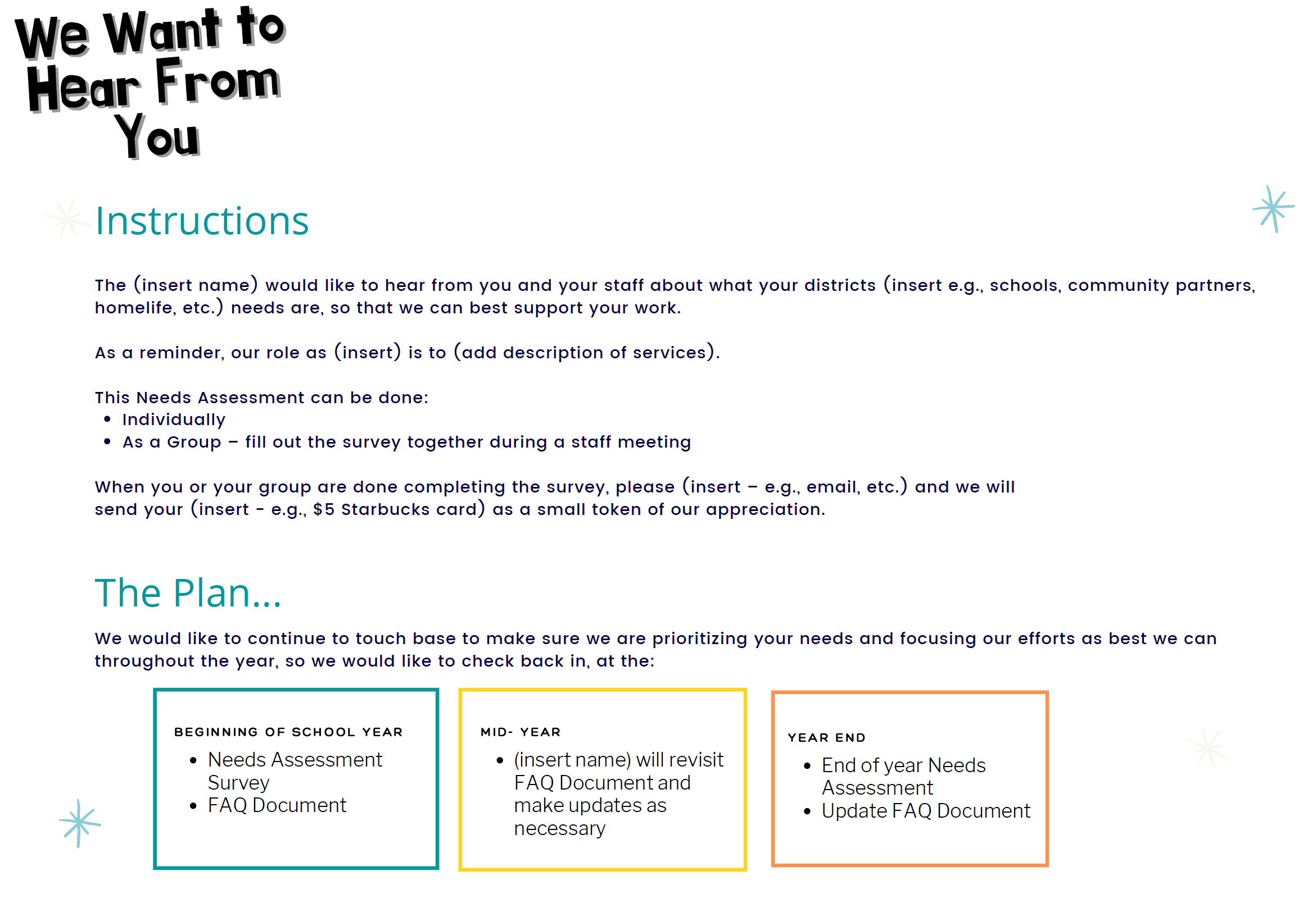

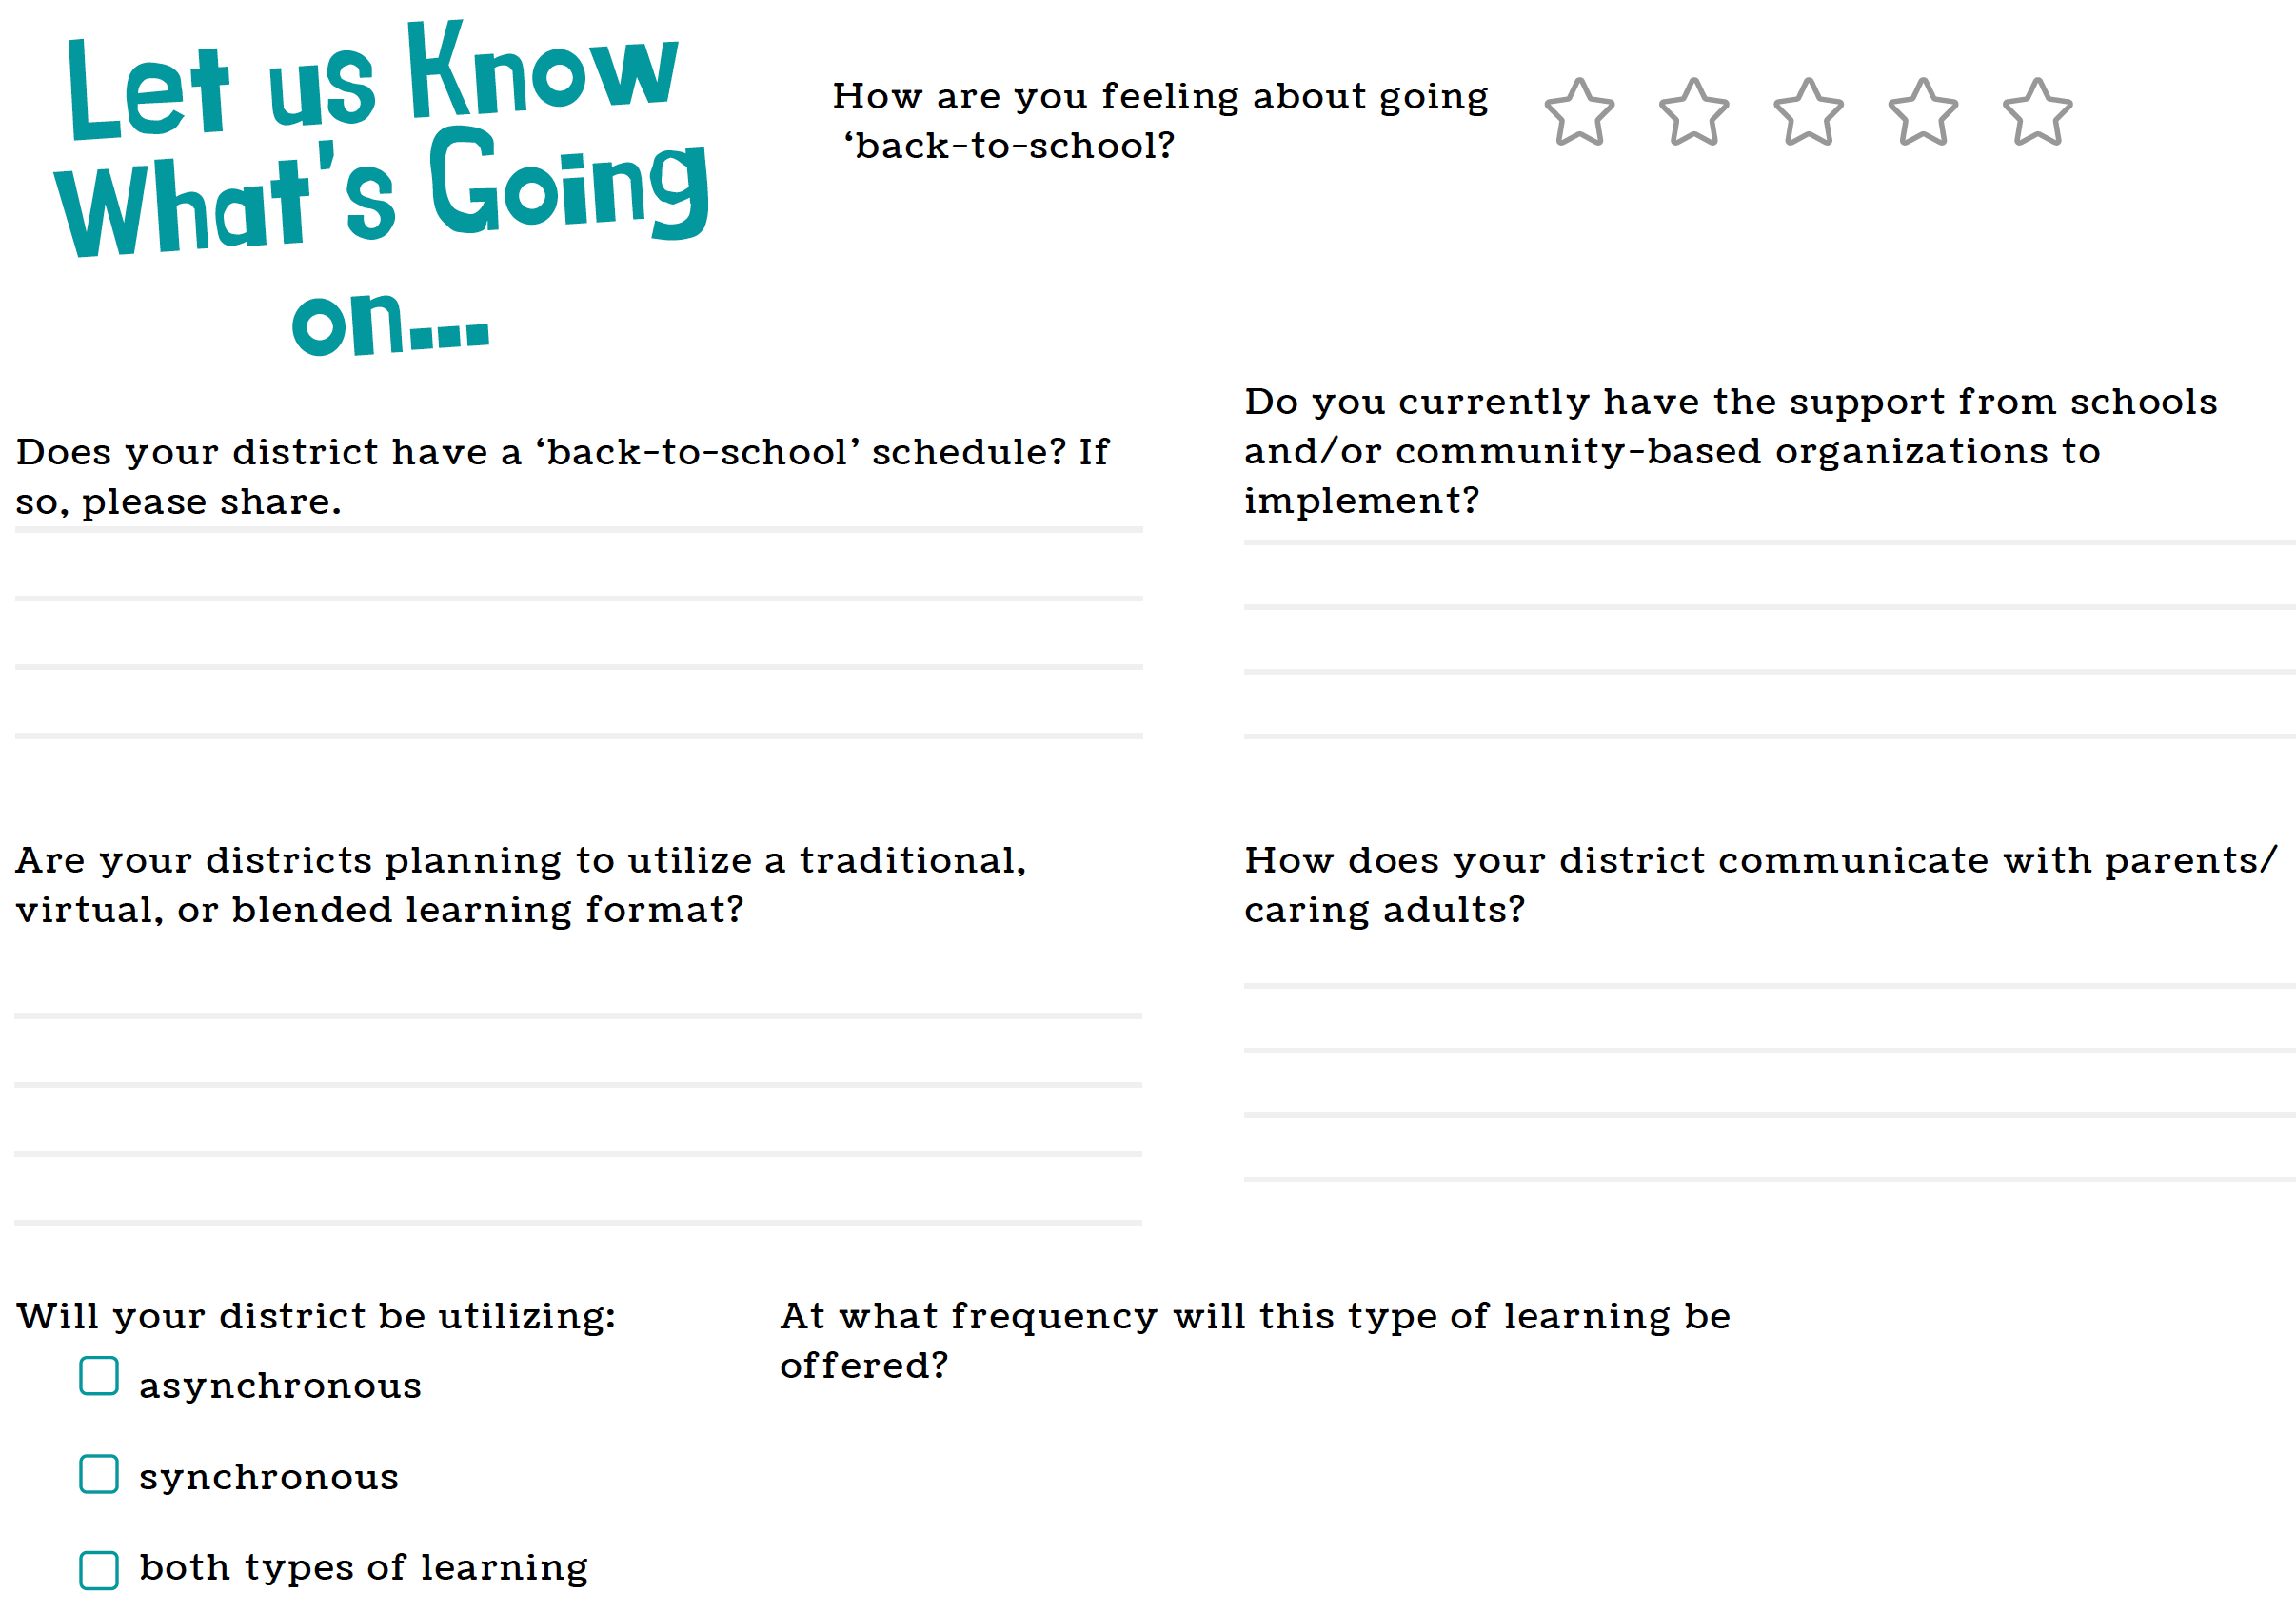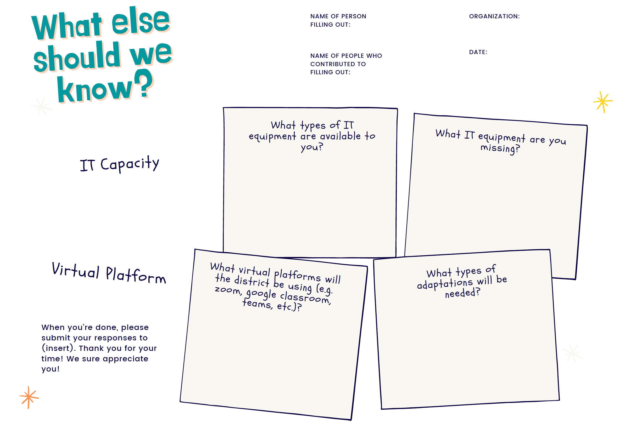

1E. Interpreting Community Needs Assessment Findings

Reflect on what you have learned throughout the needs assessment process and identify some key themes as discussed above. You can review what information stands out as areas of strength or need and begin to consider how to address or support these areas with your programming. You can also identify who or what organization may be able to help you.
Instructions: Below is a simple template for interpreting your findings. You can edit this template on Canva. You do not need to have a Canva account, just click on the link to edit, download, and share.
Canva link: https://www.canva.com/design/DAEKHmKzi-s/Sht3K7bGK49r6m0_4WD9Cg/view?utm_content=DAEKHmKzi-s&utm_campaign=designshare&utm_medium=link&utm_source=sharebutton&mode=preview
Virtual Adaptation Tip: If meeting virtually, consider hosting breakout sessions to discuss your needs assessment findings.

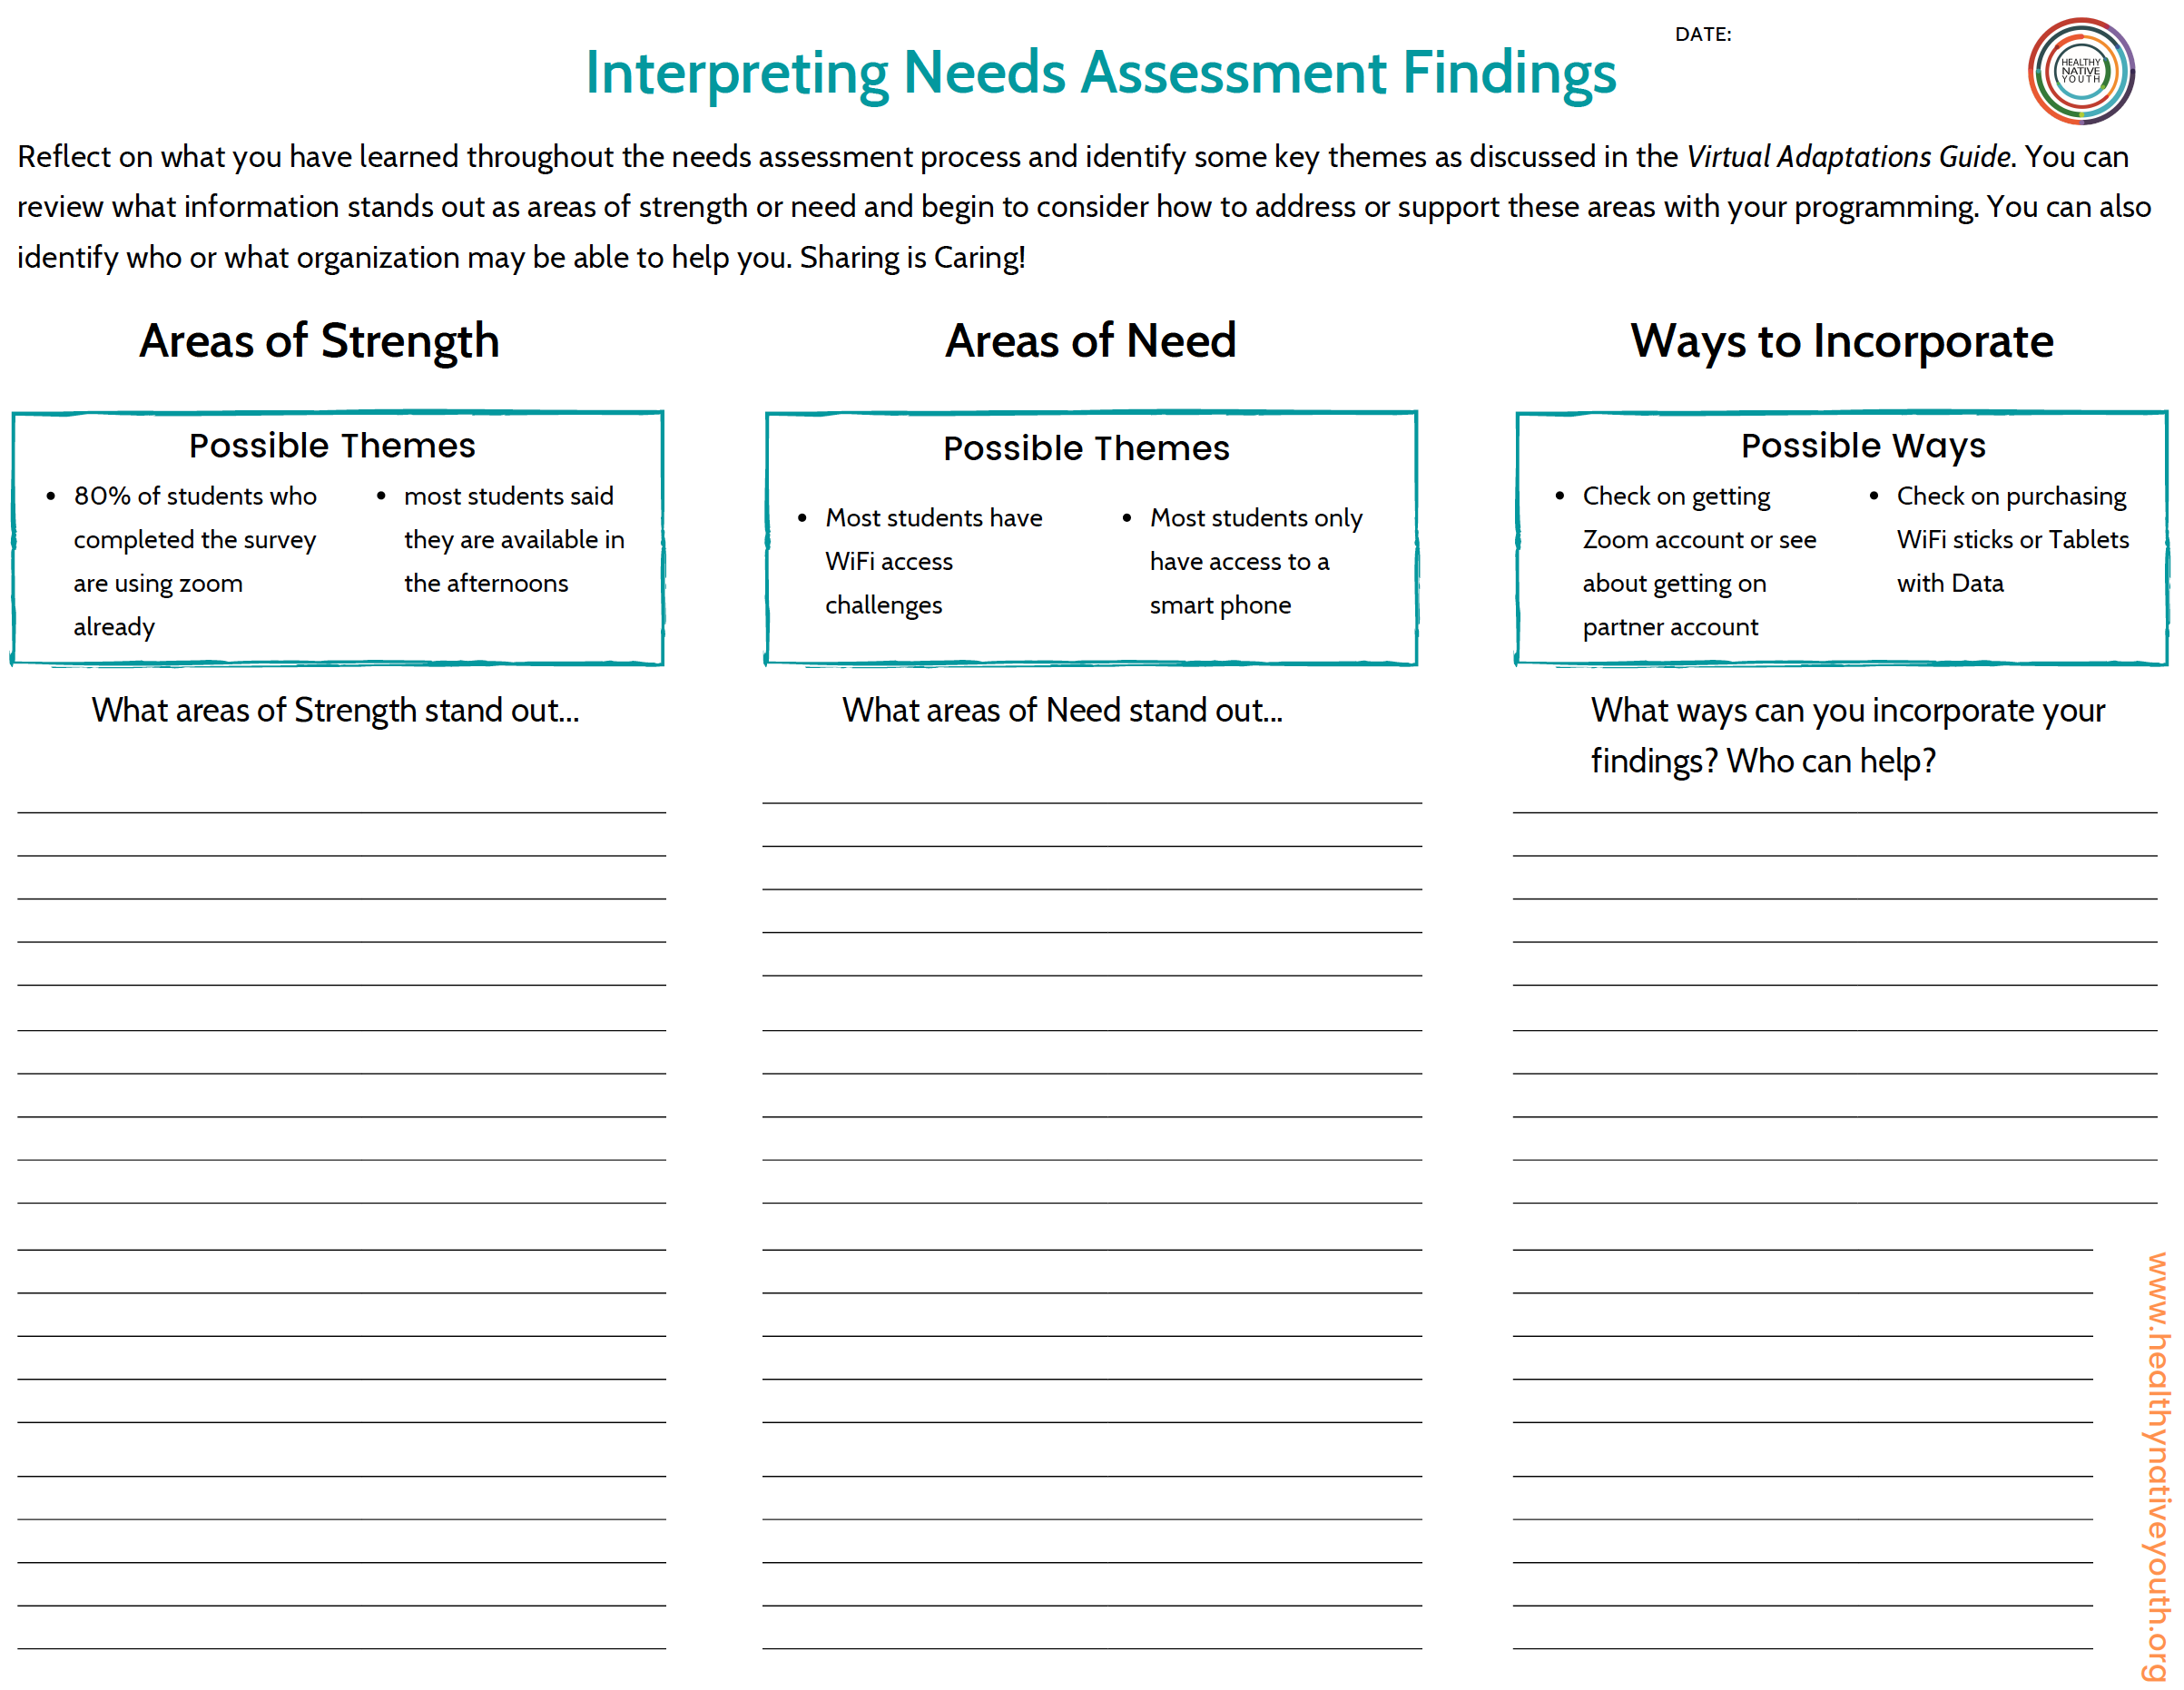

1F. Organizational Assessment

Instructions: Below are some sample self-assessment questions you can ask of your team. Use them as a guide, to pull from and reflect upon. This is a great checklist to complete together with your team.
Virtual Adaptation Tip:
If meeting virtually, consider hosting breakout sessions to discuss how you would rate your organization and what ideas or suggestions you have for addressing areas where you may have rated less positively.

This Organizational Assessment can help identify some of the areas you are doing well in and areas you need to do more preparation and planning in.

Organizational Assessment
Questions to Assess Plans for Virtual Implementation: Complete checklist together with your team.

Planning and Capacity
Question | 1-  Strongly Disagree | 2-  Disagree | 3-  Neutral | 4-  Agree | 5-  Strongly  Agree | Suggestions
Our organization has a plan in place for how we will adapt our programming for virtual implementation.
Our team has the skills and/or training to deliver our programming virtually.
We have created a plan for recruiting students for virtual programming.
We have a plan for supporting youth experiencing trauma within our virtual programming.

Logistics/Plans for Virtual Implementation
Question | 1-  Strongly Disagree | 2-  Disagree | 3-  Neutral | 4-  Agree | 5-  Strongly  Agree | Suggestions
We have identified which platform(s) we will use to implement our programming virtually.
We have identified a date to begin virtual implementation and a timeline for delivery of our programming.
We have identified what setting our virtual implementation take place (e.g., via a school-based program, out- of-school, juvenile justice, etc.).
Our team has identified how many students we can provide programming to virtually.

Partnerships and Community
Question | 1-  Strongly Disagree | 2-  Disagree | 3-  Neutral | 4-  Agree | 5-  Strongly  Agree | Suggestions
We have the support from schools and/or community-based organizations to implement virtually.

We have identified the population we plan to serve.

If in a school-setting, we have identified how we might navigate implementation plans with a staggered school schedule in which not all students would be in the school building on the same day.
We have identified partners and/or community organizations that can support us in making our virtual programming successful.

We have a plan for obtaining active/passive parental consent.

Virtual Platform (Internal Staff Capacity/Training)
Question | 1-  Strongly Disagree | 2-  Disagree | 3-  Neutral |  | 4-  Agree | 5-  Strongly  Agree | Suggestions
We have identified a budget for shifting our programming to a virtual platform.

What virtual platforms (ex. Zoom) do you plan to utilize?
Are the sessions being provided live or pre-recorded? | Live |  |  | Pre-recorded |  |  |  | Not Sure
Do you have PowerPoint Presentations for the intended curriculum? | Yes |  |  | No |  |  |  | Not Sure
How do you plan on tracking participation? Attendance?

What resources will be needed? (Costs for platforms, training for staff, etc.)

Adaptations to Curriculum
Question | 1-  Strongly Disagree | 2-  Disagree | 3-  Neutral | 4-  Agree | 5-  Strongly  Agree | Suggestions
We have identified what curriculum or program model we will deliver.

Our team has identified what types of adaptations will be needed for virtual delivery.

We have identified adaptations to ensure all students feel included and successful in our virtual program.

We have a plan for integrating cultural teachings into virtual programming.

Challenges
List any challenges you have associated with virtual implementation.

We have a plan for monitoring challenges and identifying opportunities for improvement.

List any barriers or challenges you have identified to youth participation.

1G. Implementation Timeline

This can help you see all of the tasks you need to accomplish and can help you plan and stagger tasks to ensure you will be successful. Look at the full scope of what you are planning and use the timeline to make sure you aren’t overcommitting your team at any point.
The activities can be categorized by type, such as Community Needs Assessment, Program Adaptation, Youth Recruitment, etc.
Instructions: Column 1 - Plug in your activities/sub-tasks, then consider:
- Who will complete that task?
- When it needs to be completed.
- Identify the full span on time needed to meet the deadline.
Below include some examples that have been added in italics.

Implementation Timeline
Plug in your activities/sub-tasks into the first column, then consider who will complete that task, when it needs to be completed and then identify the full span on time needed to meet the deadline. This can help you see all of the tasks you need to accomplish and can help you plan and stagger tasks to ensure you will be successful. Look at the full scope of what you are planning and use the timeline to make sure you aren’t overcommitting your team at any point! The activities can be categorized by type, such as Community Needs Assessment, Program Adaptation, Youth Recruitment, etc. Some examples have been added below in italics.
Activities | Person Responsible | Deadline | Timeline: | Oct | Nov | Dec | Jan | Feb | Mar | Apr | May | Jun
Community Needs Assessment
Design youth survey |  |  |  | X | X
Disseminate survey/ Recruit youth |  |  |  |  | X | X
Analyze Results & Identify key themes |  |  |  |  |  | X | X
Program Adaptation
Identify adaptations based on Needs Assessment findings |  |  |  |  |  |  | X | X

1H. Program Selection Checklist

As you begin the platform selection process, think about the needs you’ve identified in your community needs assessment, organizational assessment, implementation site assessment as well as your curriculum, logistics or other needs identified.
The resource provided below allows you to plug in some of those needs and identify which platform functions meet those needs, platform options to consider, and assess whether they meet all or some of your needs.
Instructions: Below is a simple resource to help you get started with the logistics of implementation.
Virtual Adaptation Tip: If meeting virtually, consider hosting breakout sessions to discuss your selection checklist.

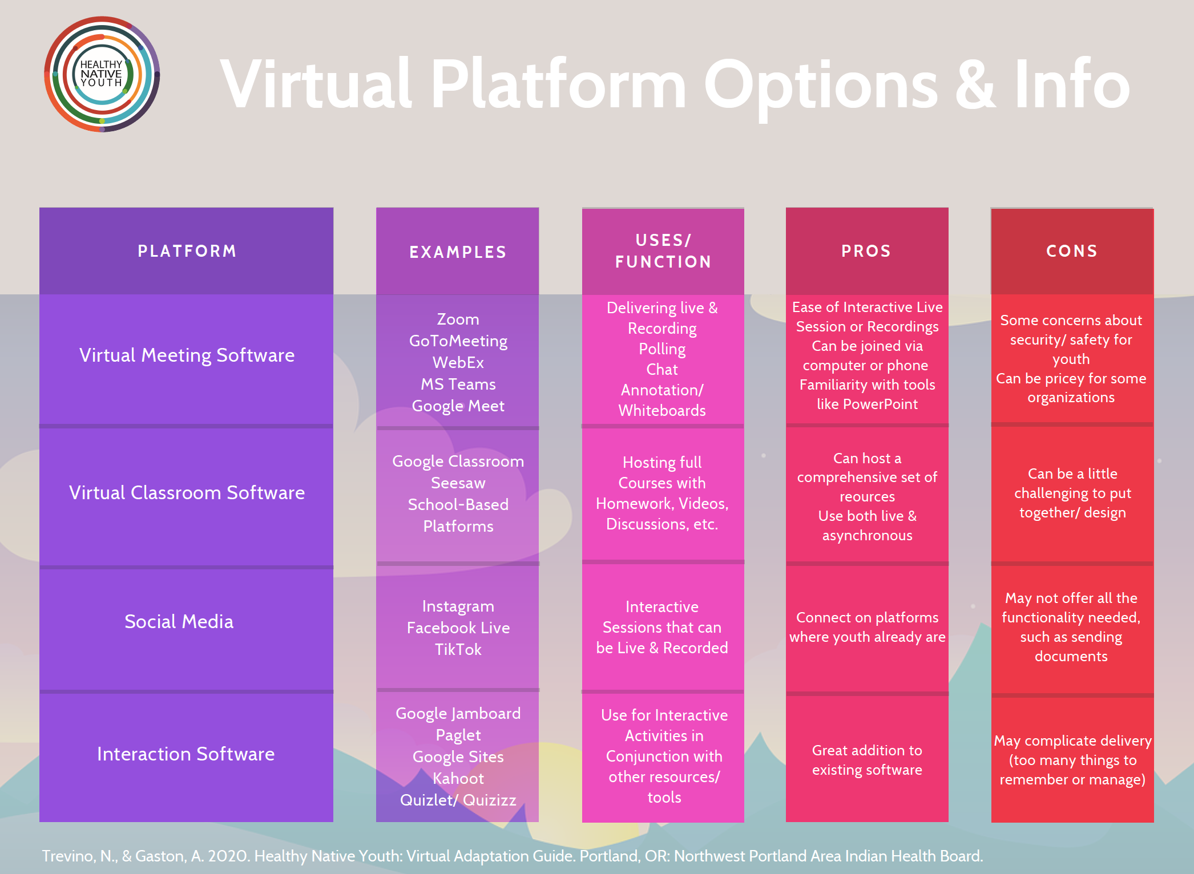

Program Selection Checklist
Needs Assessment Themes Identified: | Organizational Assessment Themes Identified: | Implementation Site Themes Identified: | Curriculum Needs: | Logistics Needs: | Other Needs/ Themes:
Platform(s) Functions Needed
- Virtual Meeting Software  - Virtual Classroom  - Interaction Software  - Social Media  - Other: | - Virtual Meeting Software  - Virtual Classroom  - Interaction Software  - Social Media  - Other: | - Virtual Meeting Software  - Virtual Classroom  - Interaction Software  - Social Media  - Other: | - Virtual Meeting Software  - Virtual Classroom  - Interaction Software  - Social Media  - Other: | - Virtual Meeting Software  - Virtual Classroom  - Interaction Software  - Social Media  - Other: | - Virtual Meeting Software  - Virtual Classroom  - Interaction Software  - Social Media  - Other:
List Possible Platform(s)
Criteria Met
- Meets All Needs  - Meets Some Needs  - Does Not Meet Needs | - Meets All Needs  - Meets Some Needs  Does Not Meet Needs | - Meets All Needs  - Meets Some Needs  Does Not Meet Needs | - Meets All Needs  - Meets Some Needs  Does Not Meet Needs | - Meets All Needs  - Meets Some Needs  Does Not Meet Needs | - Meets All Needs  - Meets Some Needs  Does Not Meet Needs

1I. Incentive Sign Out Log

Instructions: Below is a simple template to help keep track of incentives distributed.

Incentive Sign Out Log
# | Student Name | Student Signature  (Student Signs Name) | Gift Card # | Coordinator Initials
1
2
3
4
5
6
7
8
9
10
11
12
13
14
15
16
17
18
19
20

2A. Identifying Stakeholders and Building Partnerships

Below is a resource to help you identify which stakeholders you can build partnerships with and how they might support you in your virtual programming. These stakeholders may have resources or contributions beyond what you can think of, so stay open to learning about what they are doing and how they want to work together.
Instructions: In the left column brainstorm and identify potential and existing partners that can support your work. Include actual names or organizations, if you know them. There are a few categories of stakeholders written in to get you started and a few “Other” spaces included for partners that don’t fit into the other boxes. In the right column identify ways these partners can support or participate in your programming.
You can edit the template on Canva to better meet your needs. You do not need to have a Canva account, just click on the link below to edit, download, and share.
Canva Link:
https://www.canva.com/design/DAEQnYz7Wyo/xzFjvw_b6MyHO2D-Jzi0iw/view?utm_content=DAEQnYz7Wyo&utm_campaign=designshare&utm_medium=link&utm_source=sharebutton&mode=preview

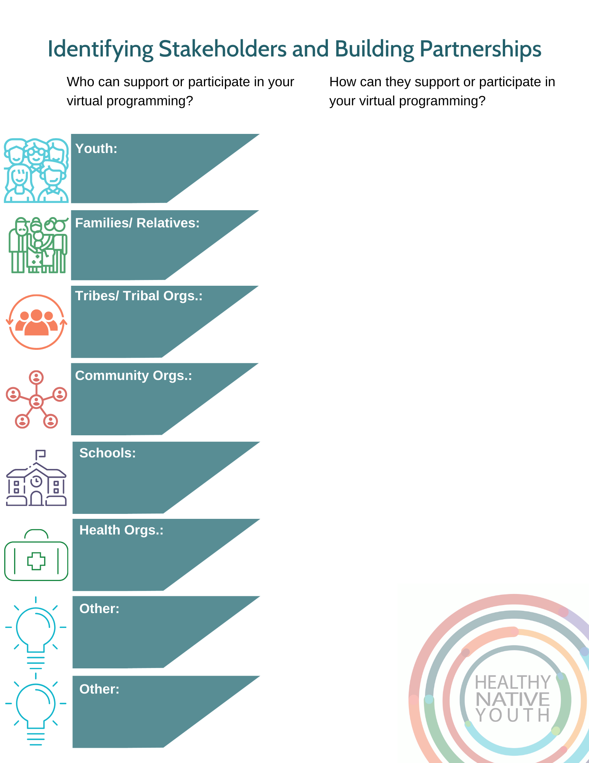

2B. Online Response Plan & 2C. We’ve Got Your Back

The Online Resource Plan is a resource to help you establish safety protocols with youth, anticipate potential needs, and identify community resources to support youth’s mental health and wellbeing, especially if they are in a crisis or emergency situation. It’s best to plan ahead to aid in quick decision-making to support youth. Use this document for your internal planning purposes.
The We’ve Got Your Back resource can be given to youth and their relatives to share both national and local resources.
Instructions: Before meeting with youth, plan ahead for how you might respond to a mental health crisis or other emergency involving youth. You can edit the Online Resource Plan template on Canva to include local resources. You can also edit We’ve Got Your Back to include local resources or resources you have identified as youth friendly. You do not need to have a Canva account, just click on the links below to edit, download, and share.
Online Response Plan: https://www.canva.com/design/DAEKBoatc_0/Yr8wcyDK7KW3wusI2YNCPw/view?utm_content=DAEKBoatc_0&utm_campaign=designshare&utm_medium=link&utm_source=sharebutton&mode=preview
We’ve Got Your Back:
https://www.canva.com/design/DAEIiXOUx_k/_ajbU7Yw1BGZLtK4IbnG_A/view?utm_content=DAEIiXOUx_k&utm_campaign=designshare&utm_medium=link&utm_source=sharebutton&mode=preview

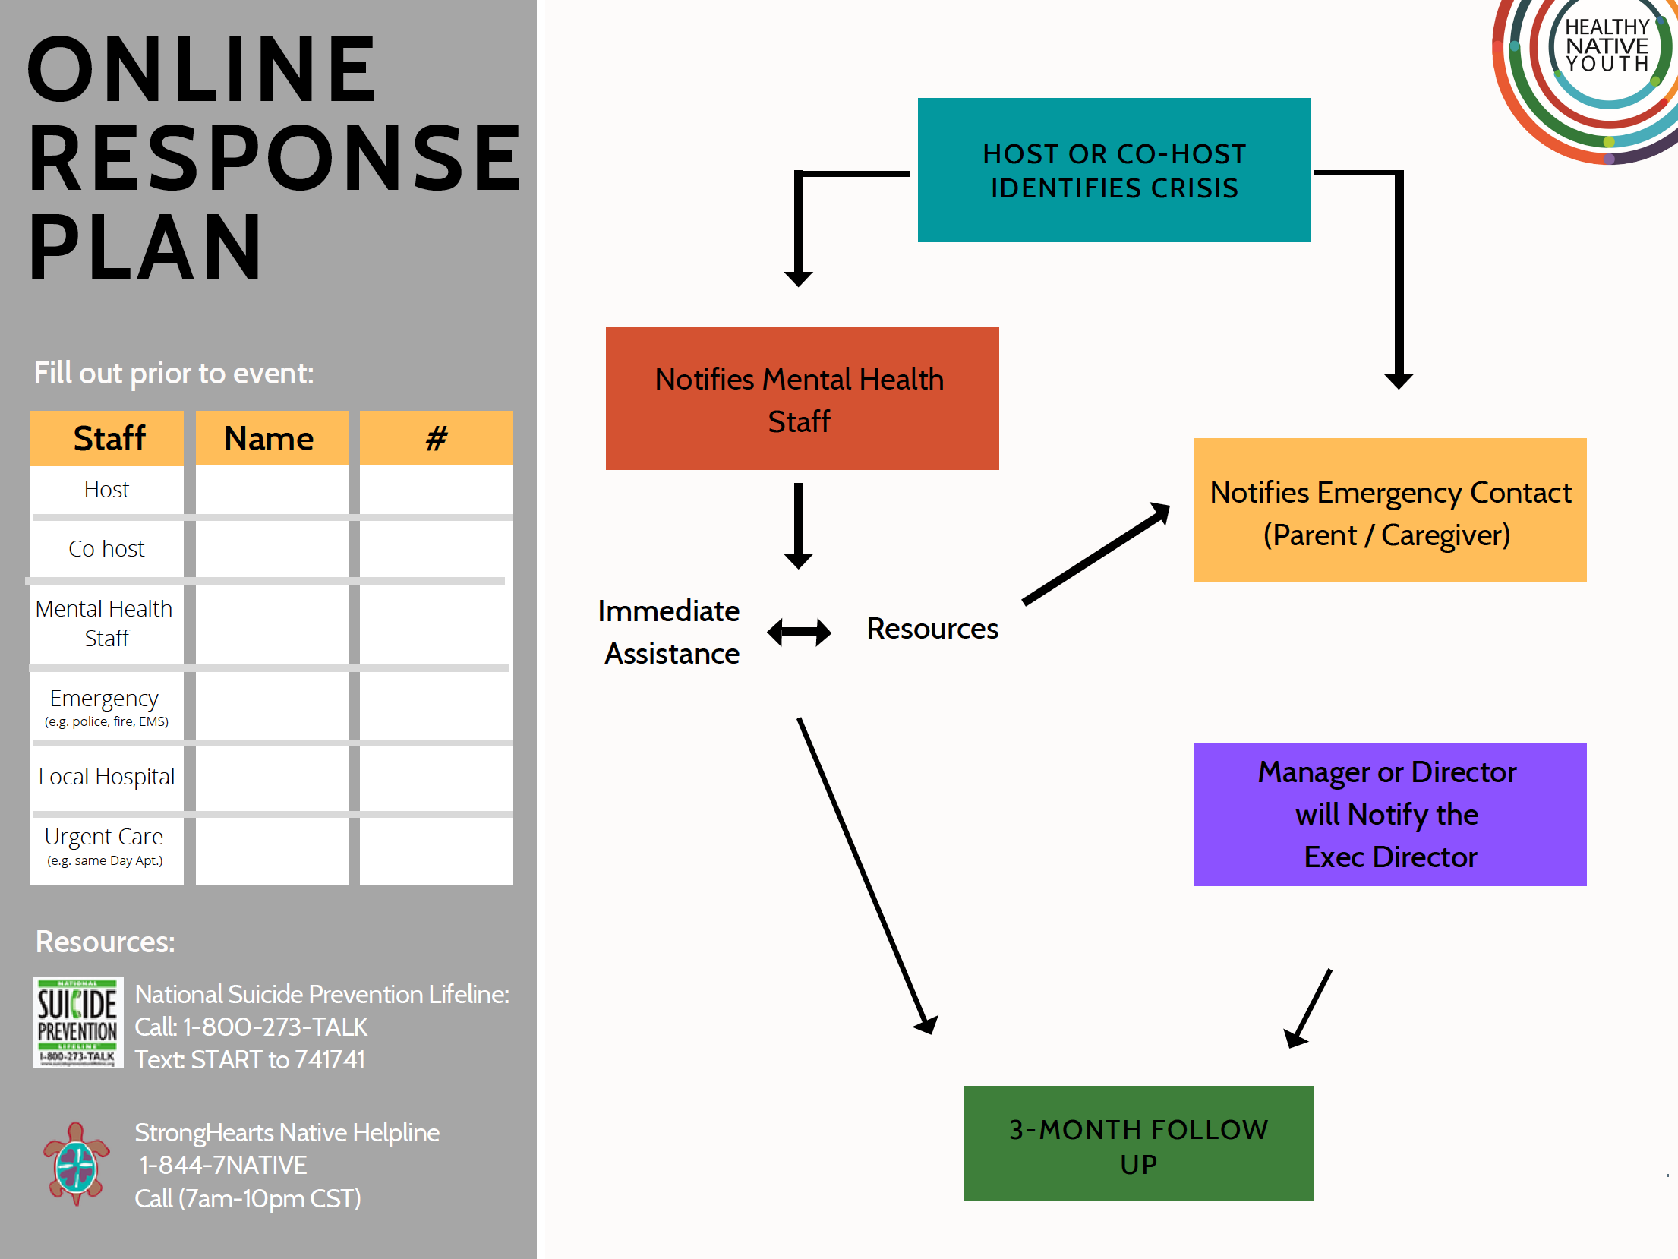
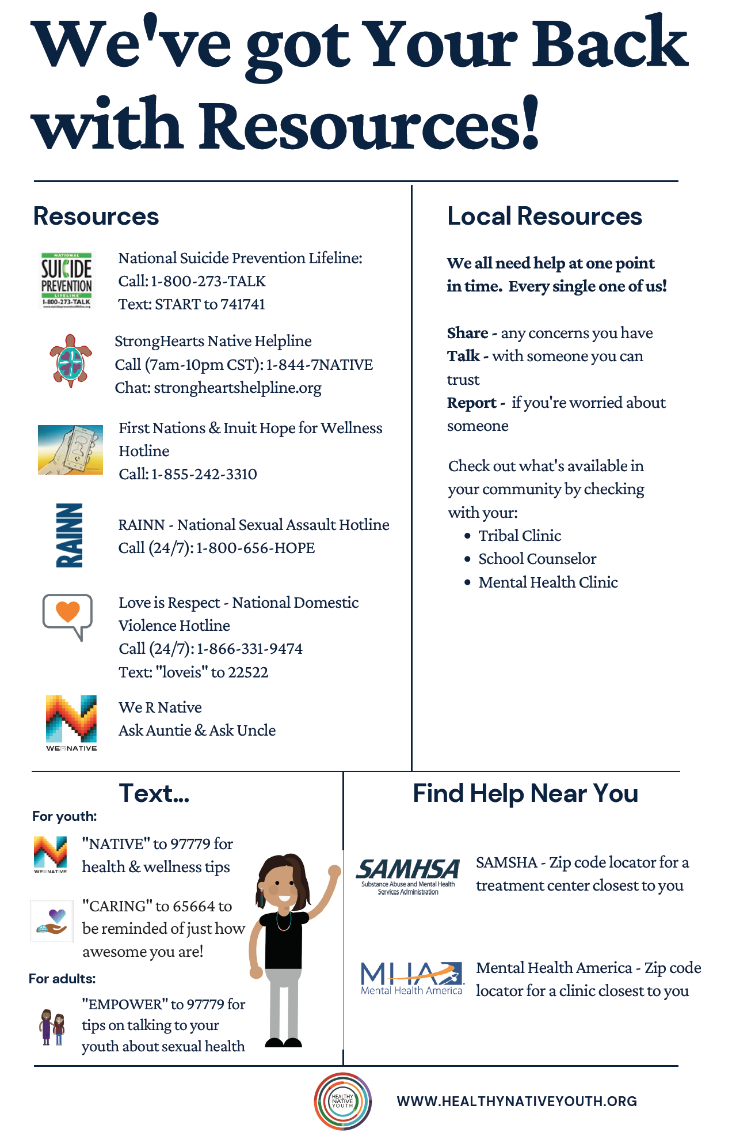
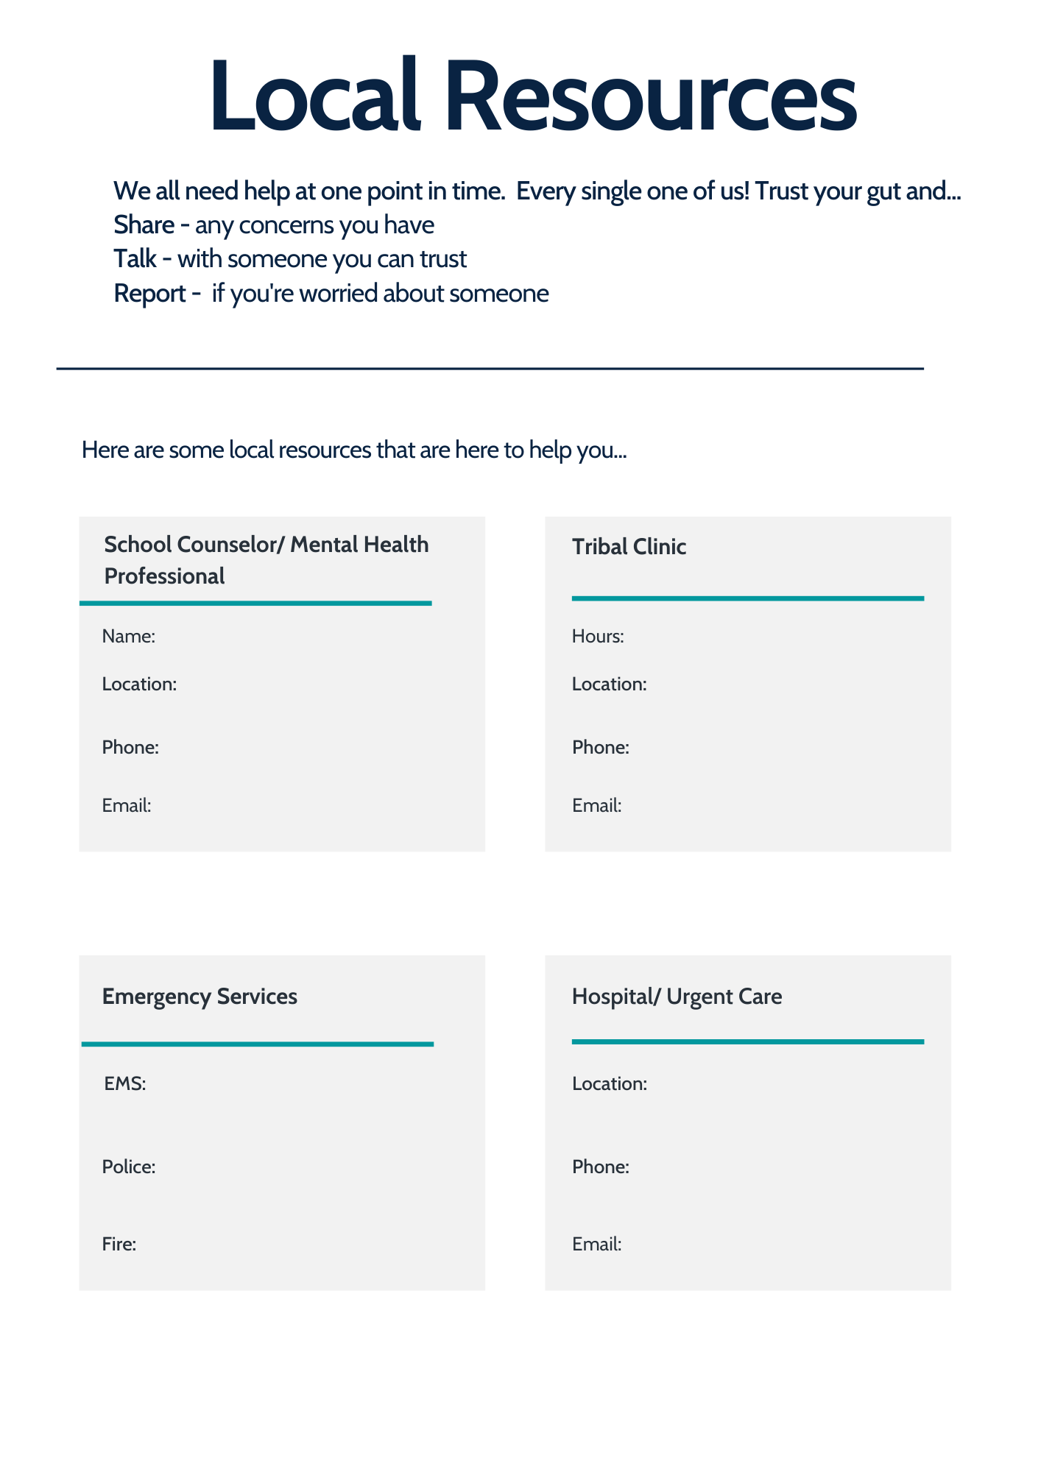

2D. Program Adaptation Log

Instructions: Use this template to track adaptations needed for each session of your program, along with technology needs and time adjustments. For each adaptation identified, detail a justification for adapting to ensure you are only adapting your program as much as needed to align with your community needs assessment findings and virtual implementation needs.

Adaptation Log
[Resource Title]
Session X: [Lesson Title]

Session Purpose or Learning Objectives:

Session Outline: | Adaptations Needs & Details: | Technology Needs/ Tools: | Time Adjustments: | Justification:

2E. Detailed Run of Show Agenda

To mitigate IT challenges and to keep things flowing and on time, it’s good to lay everything out ahead of time, especially if you’re incorporating guest speakers, activities, media links, polls, or breakout sessions.
Instructions: Fill out the Run of Show and share it with guest speakers to be clear on the line up, responsibilities and roles.
Zoom Platform Tip: Assign a co-host in case of internet issues. They can also help monitor the chat feed, which is super helpful if you are sharing your screen. They can type in any questions you may ask throughout your sessions and include links and/or other resources that you might be sharing.
One More Tip: Share your slides with your co-host too, in case you have internet issues and they need to take over.

Detailed Run of Show Template

Date and Time:
Zoom link or location:
Host + contact info:
Co-host + contact info:

Goals and Reminders for team:
Learning Objectives
Start | End | Min | What/activities | Lead  (Presenter and speaker) | Background lead  Computer, screen | Materials/ Links:
11:15am | 11:45am | 30 | Prep – adults on – share screen capabilities, break out rooms set up, polling q’s set up, co-hosts designated  Open PPT for Kickoff | Name | Name | Content – Name responsible
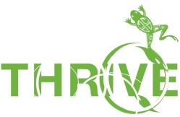

3A. Wellness Moments

Please visit the Resources Section of HealthyNativeYouth.org to find slides with brief wellness activities to incorporate into your virtual sessions with youth.
Instructions: Use wellness moments to break up your lessons and teach youth healthy self-care strategies.

3B. Virtual Program Attendance Log

In this section, you will complete information about the youth who participate in the lesson, date of facilitation, and start and stop times. The aim of this section is to make it easy to identify the cohort or group that received the lesson. This is especially important when evaluating behavior change due to your intervention.
Instructions: Below are two logs: 1) asynchronous and 2) synchronous. The asynchronous log can be used if youth are completing program activities on their own. The synchronous log can be used when all youth are participating at the same time.

Virtual Program Attendance Log – Asynchronous
Lesson & Implementation | Lesson 1  Date |  | Lesson 2  Date |  | Lesson 3  Date |  | Lesson 4  Date |  | Lesson 5  Date |  | Lesson 6  Date |  | Lesson 7  Date |  | Lesson 8  Date |  | Lesson 9  Date |  | Lesson 10  Date
Participant Names: |  | 9/10 |  | 9/11 |  | 9/15

Virtual Program Attendance Log - Synchronous
Lesson & Implementation | Lesson 1 | Lesson 2 | Lesson 3 | Lesson 4 | Lesson 5 | Lesson 6 | Lesson 7 | Lesson 8 | Lesson 9 | Lesson 10
Date:
Start Time
Stop Time
Participant Names:
*This resource was adapted from the We R Native Fidelity Monitoring Guide.

4A. Fidelity Monitoring Log

The fidelity log can be customized for each of the lessons of your newly adapted virtual program.
To customize fidelity logs for your program, just fill in the lesson information including lesson title at the top and lesson outline sections (such as: major activities) and subsections (such as: components of the activities).
Tip: Fidelity logs are easiest to complete when you print each lesson’s fidelity log and note the information required before and after each lesson.
Instructions:
Fidelity Log Rows 1-5: Fidelity and Adaptation Monitoring
- Answer questions based on how you provided/delivered each section of the lesson. This section has check boxes for you to indicate whether you were able to complete each section of the lesson and which adaptations, if any, you made.
- Please fill this out honestly as it will provide important information on adaptations needed for future implementations and quality improvement.
- A list of common adaptations is included to make this form easier to complete.
- If you make an adaptation that is not listed, please select “Other” and describe your adaptation in the “Details” box below the list of adaptations.
- Include your challenges faced in the “Challenges” box. This will help you track challenges to include in your quality improvement plans. If you did not complete a core component, record why in the Other Notes section on the bottom row of the fidelity log.

Fidelity Log Row 6: Additional Session Monitoring
- Include any cultural teachings in the lesson
- Select “yes” if you have brought in a cultural teaching in the form of a story, poem, quote, speaker, or other activity and used it during the lesson. You should also select “yes” if you included a written cultural teaching that was part of the curriculum.
- Level of engagement of the students. Do your best to estimate how actively involved the students were in the lesson:

- Include Notes with additional info that help explain adaptations or special circumstances further. Example: “we lost internet connection during the lesson and we were unable to complete the lesson”

*This resource was adapted from the We R Native Fidelity Monitoring Guide.

Fidelity Monitoring Log

Lesson #____ Fidelity Log: [Lesson Title]
Lesson Outline and Core Content Components: | [Section 1 Title]  - [Subsection] | [Section 2 Title]  - [Subsection] | [Section 3 Title]  - [Subsection] | [Section 4 Title]  - [Subsection]
Did you complete these Core Content Components? | - Yes, completely  - Yes, with adaptations  - No (please write why in other notes section) | - Yes, completely  - Yes, with adaptations  - No (please write why in other notes section) | - Yes, completely  - Yes, with adaptations  - No (please write why in other notes section) | - Yes, completely  - Yes, with adaptations  - No (please write why in other notes section)
Please indicate adaptations made, if any: | - Activity Timing  - Instructional Methods  - Content  - Order of Activities  - Cultural Adaptation  - Other: | - Activity Timing  - Instructional Methods  - Content  - Order of Activities  - Cultural Adaptation  - Other: | - Activity Timing  - Instructional Methods  - Content  - Order of Activities  - Cultural Adaptation  - Other: | - Activity Timing  - Instructional Methods  - Content  - Order of Activities  - Cultural Adaptation  - Other:
Please detail adaptations made:
Please describe any challenges experienced:

 | [Section 1 Title]  - [Subsection] | [Section 2 Title]  - [Subsection] | [Section 3 Title]  - [Subsection] | [Section 4 Title]  - [Subsection]
Did your lesson include a Cultural Teaching (Poem, Song, Activity)? | - Yes  - No | - Yes  - No | - Yes  - No | - Yes  - No
How engaged were youth during this lesson? | - Very Engaged  - Somewhat Engaged  - Not Engaged | - Very Engaged  - Somewhat Engaged  - Not Engaged | - Very Engaged  - Somewhat Engaged  - Not Engaged | - Very Engaged  - Somewhat Engaged  - Not Engaged
Notes:
Youth Feedback:

4B. Quality Improvement Tracker

Reflect on how it is going, identify possible opportunities for improvement, and make note of any solutions to challenges you face. It’s as simple as answering some standard reflection questions at a regular interval throughout your implementation process, such as each week after your programming.
Tip: The most important part of monitoring and quality improvement is to write down your reflections and insights throughout the process, so you don’t forget what you learn over time.
Instructions: Fill in reflections after each lesson. Use those themes to make adjustments before your next round of implementation to achieve an ever-improved program!

Quality Improvement Tracker

Insert Lessons Title: | Strengths: What did we do well? | What to Continue Doing? | Challenges: What didn’t go so well? | Ideas for Addressing Challenges? | Ideas for Changes?
Other Program Components:
This resource was adapted from the Program Planning and Implementation Workbook.

