Concerning Messages Protocol Handbook

Suicide Ideation Protocol

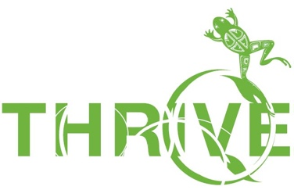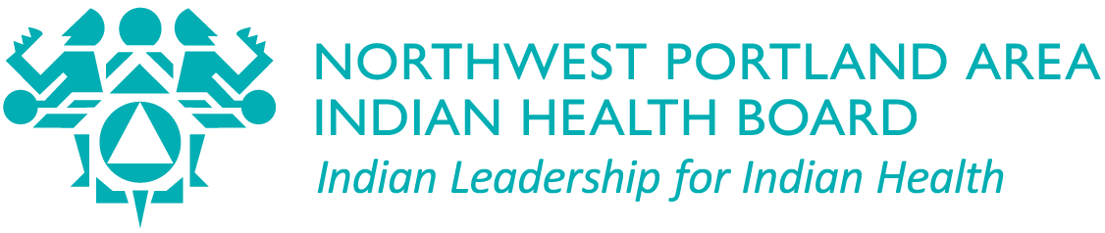

Your Organization Name:
Website/ logo:

How to Use this Guide

Authors
This guide was developed by Celena McCray, Colbie Caughlan, Dr. Stephanie Craig Rushing, Lael Tate, David Stephens, Amanda Gaston, and Asia Brown on behalf of the Northwest Portland Area Indian Health Board’s THRIVE and We R Native Programs.
Northwest Portland Area Indian Health Board (NPAIHB) is a non-profit tribal advisory organization serving the forty-three federally recognized tribes of Oregon, Washington, and Idaho. Established in 1972, the NPAIHB strives to eliminate health disparities and improve the quality of life of American Indians and Alaska Natives by supporting Northwest Tribes in their delivery of culturally appropriate, high-quality healthcare. NPAIHB houses a tribal epidemiology center (EpiCenter) that manages health promotion and disease prevention projects and is active in Indian health policy. For more information, visit: npaihb.org.
THRIVE provides regional support for suicide prevention with a focus on cultural pride, resilience, and traditional healing.
We R Native is a multimedia health resource for Native teens and young adults. The service includes an interactive website (weRnative.org), a text messaging service (Text NATIVE to 97779), a Instagram, Facebook page, TikTok, YouTube channel, Twitter account, and print marketing materials. Special features include an “Ask Auntie/ Ask Uncle” Q&A service and medically accurate information reviewed by experts in public health, mental health, community engagement, and activism.

Funding Acknowledgment
This document was developed, in part, under grant number SM082106 from SAMHSA. The views, opinions and content of this publication are those of the authors and contributors, and do not necessarily reflect the views, opinions, or policies of CMHS, SAMHSA, or HHS, and should not be construed as such.

Acceptable Use/ License
You are free to share this resource, including copying and redistributing, under the following terms:
- Attribution — You must give appropriate credit and indicate if changes were made. You may do so in any reasonable manner, but not in any way that suggests the licensor endorses you or your use.
- Non-Commercial — You may not use the material for commercial purposes.
- No-Derivatives — If you remix, transform, or build upon the material, you may not distribute the modified material.

Suggested Citation
McCray, C., Caughlan, C., Craig Rushing, S., Gaston, A., Stephens, D., Tate, L., Brown, A., 2021. THRIVE: Concerning Messages Protocol. Portland, OR: Northwest Portland Area Indian Health Board.

Purpose of this Guide
The Concerning Messages Protocol is designed to support tribal communities in the event a person expresses suicidal thoughts through their organization’s communication channels (e.g. website, social media channels, text-message service, email, etc.), or is in a mental health emergency. It is intended to be a guide on which to build upon at an organizational and community partnership level.
The guide can help with the following:
- General Organization Flow Chart
- Managing and Tracking Incoming Messages (Management Doc)
- Protocol for Suicide Ideation WITH & WITHOUT Contact Information
- Notification of Crisis Response Team
- “Q&A” Service Algorithm for Answering Incoming Questions
- 3-month Follow-up: Caring Contact
- Resources

Suicide Ideation Protocol

In the event a person expresses suicidal thoughts or is in a mental health emergency, staff at (insert) (with the help from professional mental health counselors) will follow the Concerning Messages protocol.

Organizational Flow Chart

(Insert organization name) resources have (insert number of) sources of incoming messages:
(For example)
Text Message. (Name of) campaign(s).
Ask Auntie/Uncle. An anonymous “Q&A” service.
Social Media platforms/email. Email, web submission, Instagram, Facebook, and/or Twitter. Each message’s source will initiate their own protocol and will involve three attempts to contact and a three month follow-up.
Concerning Message
*Text Message

Track communication and follow-up
Three attempts to connect

3 month follow-up
Concerning Message
* “Q&A” Service
Concerning Message
*Social media inbox
*Gmail inbox
*web submission

“Management Doc” Tasks

“Q&A” Team Members (edit list, then list names + emails)
(For example,)
Project Director:
Auntie:
Elder:
Clinical Psychologist or Behavioral/ Health Specialist:

Template Box Link: https://npaihborg.box.com/s/n9apqfc7xwsrffgqriqe4xsaij3eac28
Color Key: Red = Incomplete/ Urgent, Orange = No answer, Green = Complete

Monthly Posting Schedule & Completed Tabs | Person Responsible
- For new upcoming month: Cut and paste past “Monthly Schedule” into the “Completed” tab
- Create new monthly schedule by updating questions and assigning (refer to monthly health observances – can check previous year’s Q’s too for guidance)
- Include website link when Q’s are updated with text and video response

“Contact Info Queue” Tab | Person Responsible
Initial Documentation – Update with question, contact info, date, and person it’s assigned to.
Highlight in:
RED – until updates are made (i.e. draft date, link, title)
Orange if question is not answerable (e.g. “Hi” or inappropriate)
Second Documentation: When “Q&A” draft is complete, update in GREEN the date of draft, folder link, title
Third Documentation: the date notification was made in GREEN, along with website link (if applicable)

“No-Contact Info Queue” Tab | Person Responsible
Initial Documentation: Update with question, date submited, and person it’s assigned to.
RED if Urgent.
Second Documentation: When “Q&A” draft is complete, update in GREEN the date of draft, folder link, title
Third Documentation: in GREEN the date of SM post + links

“Urgent Q’s – Caring Contact” Tab | Person Responsible
Initial Documentation: Update with question, date submited, and person it’s assigned to.
RED – until all notification attempts (3) have been made
Second Documentation: GREEN when 3-month “Caring Contact” is made

Protocol for Suicide Ideation WITH Contact Information

Tailor to the channels your organization uses: Below are examples:
“Q&A” Service | Social Media Channels | Text Message
When a concerning message is submitted with contact information, the “Q&A” team will automatically send the following reply to the contact info provided:  On the submission form:  “We care about how you are doing. Please know this line is NOT monitored 24/7. If you need immediate help text "NATIVE" to 741741 for free 24/7 support or call the Suicide Prevention Lifeline at 1-800-273-8255.” | When someone messages SM channel(s) a concerning message, staff will automatically send the following reply:  “We care about how you are doing. Please know this line is NOT monitored 24/7. If you need immediate help text "NATIVE" to 741741 for free 24/7 support or call the Suicide Prevention Lifeline at 1-800-273-8255.” | When someone texts a concerning message the staff managing the text service will send the following reply:  “We care about how you are doing. Please know this line is NOT monitored 24/7. If you need immediate help text "NATIVE" to 741741 for free 24/7 support or call the Suicide Prevention Lifeline at 1-800-273-8255.”

- Staff member who identified the concerning post will evaluate if the post is high risk or low risk.
  - High risk: suicide ideation, proceed with protocol and contact Mental Health Staff
  - Low risk: non-suicide related, refer to “Q&A” algorithm (see below)

- If the message includes content suggesting suicide ideation with contact information, staff will send an email or text (with High Importance! flagged) to counselors so that someone with formal counseling training can offer assistance:
  - If the high-risk concerning post has a phone number available, and if the on-call staff are unavailable, staff will contact (crisis line name you are in agreement with) and share the post and phone number
  - (Name of crisis line your organization is in agreement with) staff will reach out to the person of concern by phone and conducting a thorough suicide risk assessment, provide resources, and try to resolve the crisis
  - After the call, (name of crisis line your organization is in agreement with) will send a call report your organization sharing whether they made contact with the referred person and share only the information needed for coordination of care

Draft Email to Crisis Response Team

To: Insert emails (e.g. clinical psychologist, behavioral/ health specialist, etc.)
cc: Project director, etc.
Subject: Concerning Message (with High Importance! flagged)

Hello –
The (insert) received a concerning message from (Name, email address, cell number, etc.), and we are concerned about possible suicide ideation (or name the concern here). We don’t know their age or gender, this is the only information we have.

Here is how we will keep track:
Question | Contact Info | Date Submitted | Assigned to | First Contact | Second Contact | Third Contact
Ex. I need a change but not sure what to change? |  | 2013-08-29 14:12:23 | Ex. Ursula

Would any of you be able to contact the individual? You might open the conversation with something like (first message):

“Hi. I’m a volunteer/counselor with (insert organization name). I got your number from their “Q&A” service and I wanted to reach out to you. How are you doing?

Would you like me to connect you to someone in your community that you can talk to?

Thank you for reaching out for help.

In the meantime, you can text "NATIVE" to 741741 for free 24/7 support or call the Suicide Prevention Lifeline at 1-800-273-8255. They’re available 24/7. You don’t have to be in a mental health emergency to use these resources. Also, nowmattersnow.org has videos and resources that others have found useful if you are having a mental health emergency. You can also, text “CARING” to 65664 to receive caring messages.”

Thank you so much for your assistance!
-Staff

Protocol for Suicide Ideation with - NO Contact Information

- Staff may use the reverse look-up to identify local resources: mental health center, police.
If the reverse look-up city and state are correct, the caller’s local resources are:
- The Suicide Prevention Lifeline 1-800-273-8255 or call 988 (launching in July 2022)
- The Crisis Text Line, text “NATIVE” to 741741
- Local mental health number: here
- Local police number: here

When you contact the individual, please cc’ all, so we do not make multiple contacts.

- If the person who submitted the message does not respond to the counseling team via phone, text, or email within 24 hours, staff may call the local resources to see if they can intervene. This will be at the discretion of staff based on the content that was initially submitted by the individual.

- Staff will use the “Management Doc” (see above template link) to track communication and follow-up with the individual in three attempts.
  - The FIRST contact by the staff assigned will be to connect with the individual to clarify the individual’s intent within 48 hours of the message being sent.
  - The SECOND contact will be made if there is no response from the individual. Staff will follow-up with resources, sent no later than one week, after the initial post.
  - The THIRD contact will be made if there is still no response from the individual. Staff will send this message about one week after second attempt:

“Hi. I am a staff member from (insert). I wanted to let you know that I am worried about you and care about your well-being. Please get in touch with us again if you’re ever feeling overwhelmed or down. We’re here for you. Text "NATIVE" to 741741 for free 24/7 support or call the Suicide Prevention Lifeline at 1-800-273-8255, if you need to. You can also, text “CARING” to 65664 to receive caring messages.Thanks for reaching out. You’re not alone.”

*This will be the last attempt to reach out with specific resources

Caring Contact (3-months later)

3-months after the first contact, staff will be prompted to send one caring contact message to individuals. The caring contact messages are often brief and simply let the person know that someone cares about them and wishes them well. Staff will send this message:

“Dear ___
I wanted you to know what we are thinking of you and hope things are going well for you. You are loved. You are not alone. We Need You Here. If you are ever in a mental health emergency please call the Suicide Prevention Lifeline at 1-800-273-8255 or text “NATIVE” to 741741. You can also, text “CARING” to 65664 to receive caring messages.
With Love, insert Team”

Track the date of this message on “Management Doc” tracking log. This concludes the communication with this individual.

TIP: send out a calendar invite to appropriate team members as a reminder to follow-up at 3-months.

“Q&A” Algorithm
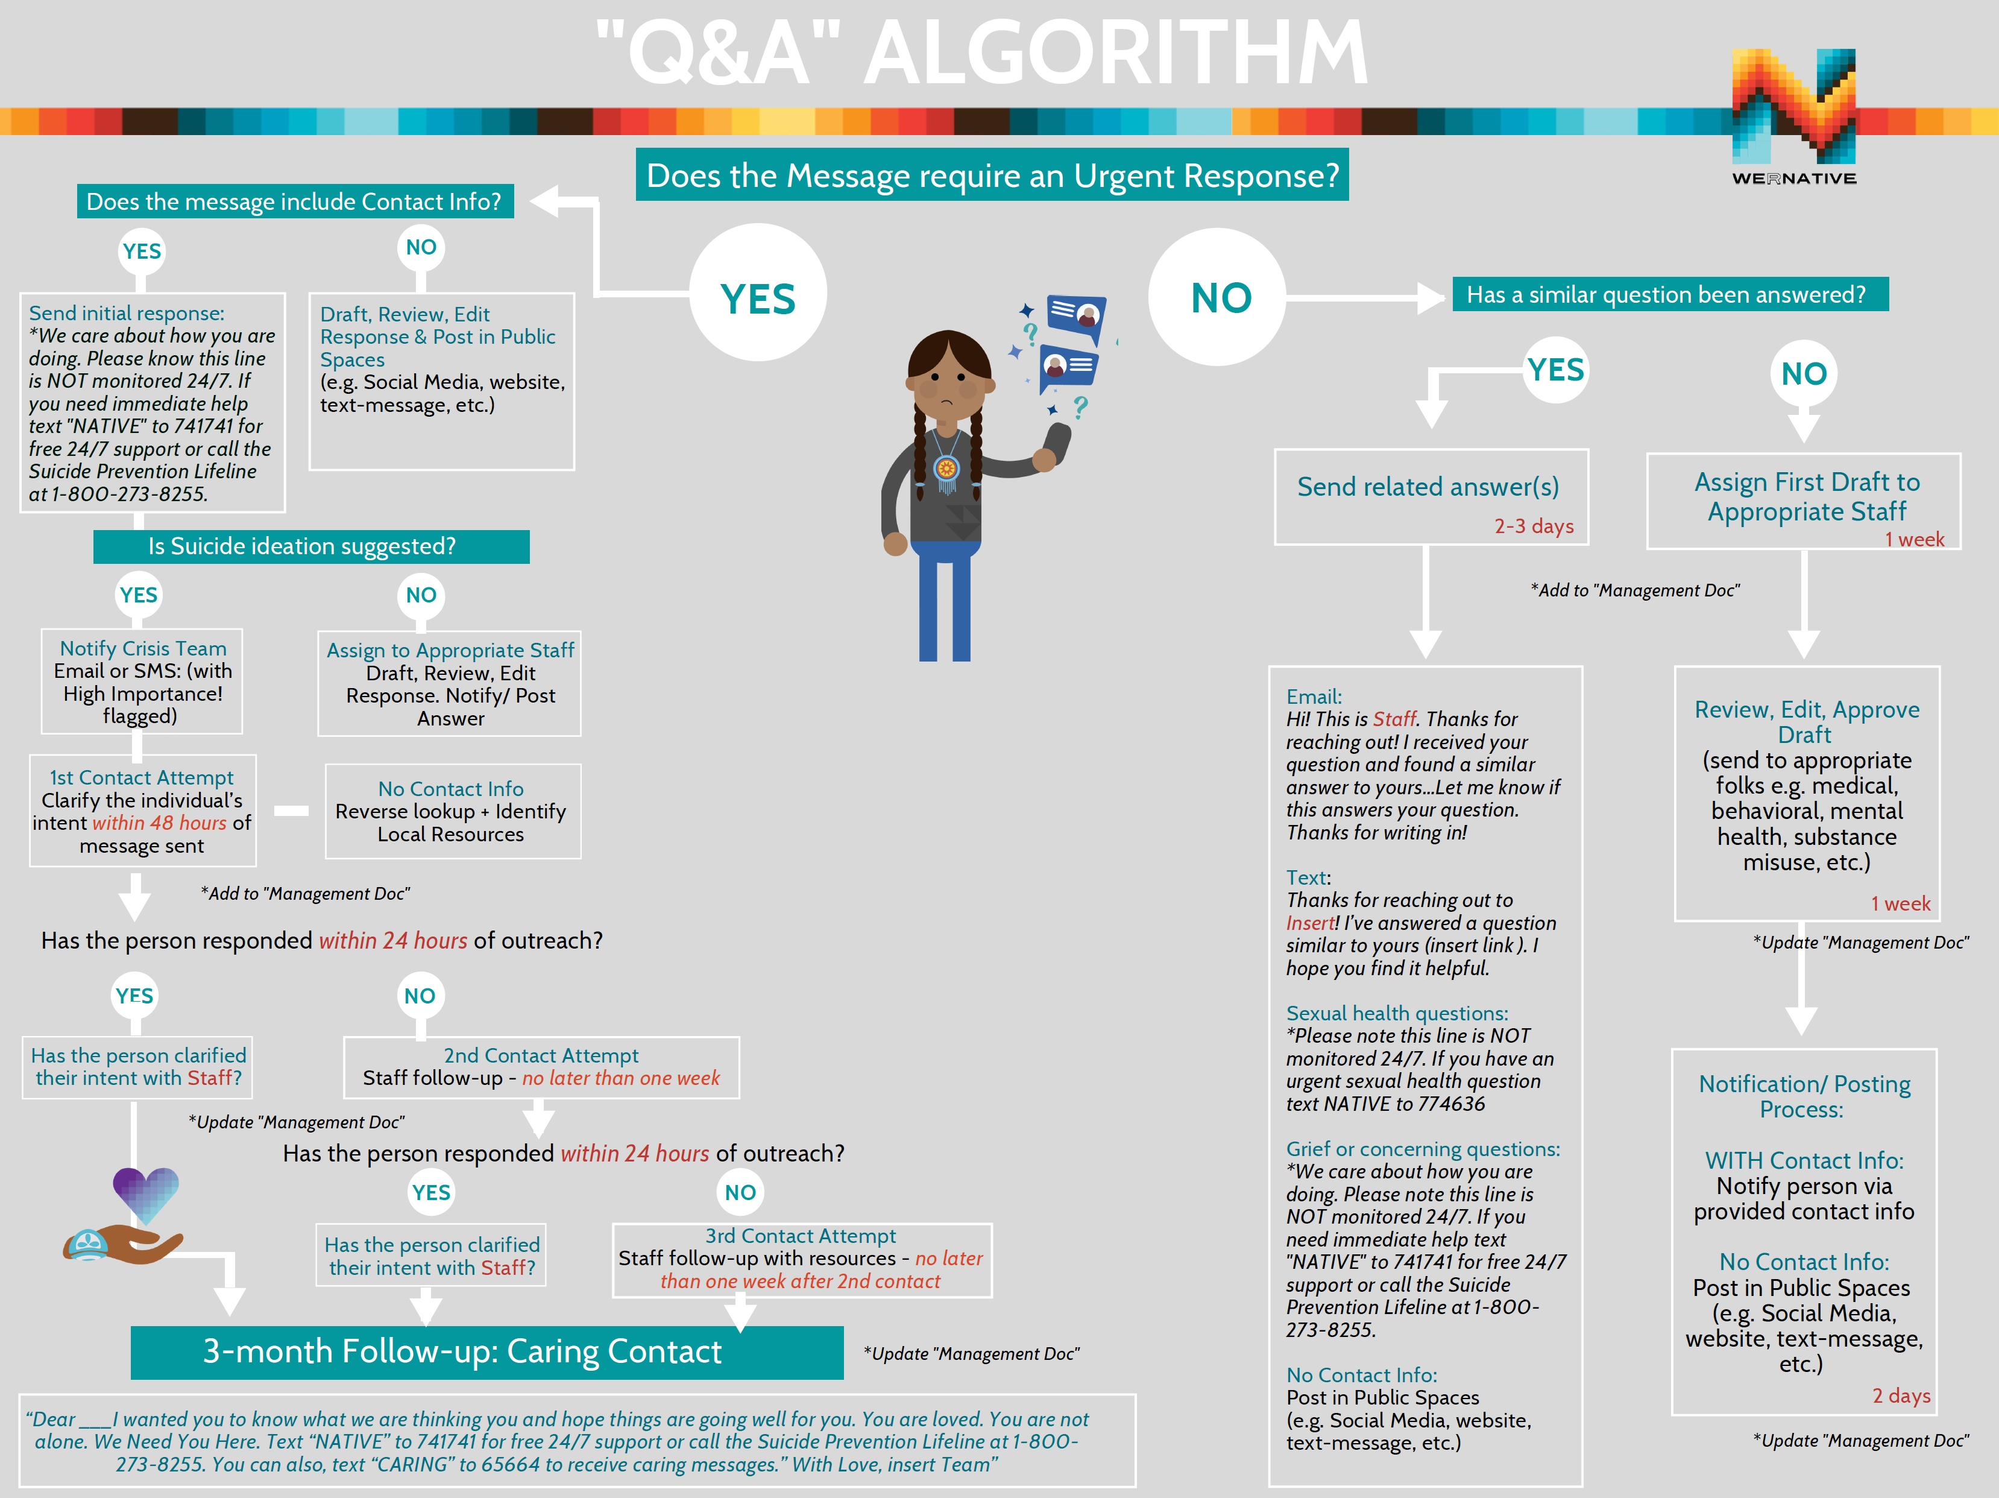
Canva Template: https://www.canva.com/design/DAEeLE26iwc/HDQWqQRhNfakDfIqpky79g/view?utm_content=DAEeLE26iwc&utm_campaign=designshare&utm_medium=link&utm_source=sharebutton&mode=preview

WITH Contact Info
Non-Urgent Q’s Draft & Review Process (To the Right) |  | Person Responsible
1 | Assign Question & Notifiy person writing first draft based on their background/ experience or interest/ availability (1 week)
2 | Review, Edit, Approve Draft by a second/ third person  (check for: accuracy (medical review by appropriate peoples), grammar, correct and appropriate resources)
3 | Notification/ Posting Process: (2 week turnaround time)  - Notify contact info provided  - Update “Management Doc”
Urgent Q’s Draft & Review Process (To the Left) |  | Person Responsible
1 | Assign Question & Notifiy person writing first draft based on their background/ experience or interest/ availability (48 hours)  Forward Urgent Q + Contact info
2 | Follow-up attempts up to three attempts then track using the “Management Doc”
3 | 3-month “Caring Contact” – set calendar reminder and send to appropriate team members
NO Contact Info
Urgent Q’s Draft & Review Process (To the Right) |  | Person Responsible
1 | Assign Question & Notifiy person writing first draft based on their background/ experience or interest/ availability (48 hours)
2 | Post on Social Media (website, etc.) with the hope that this person will see it
3 | Track on “Management Doc”

Additional Caring Contact Examples:
https://www.nowmattersnow.org/wp-content/uploads/2019/01/CaringMessages.pdf
Additional resources include: http://www.preventtheattempt.com/?utm_source=Weekly+Spark+8%2F21%2F15&utm_campaign=Weekly+Spark+August+21%2C+2015&utm_medium=email

