PREPARE

Invite and Prepare Guest Speakers

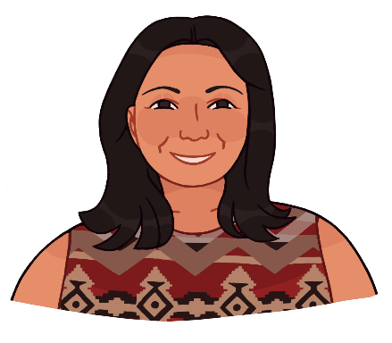

Remember: You do not have to deliver this curriculum on your own! Invite topical experts and guest speakers to help broaden your students’ circle of support. Community experts can include:

- Clinic staff
- Parenting teen(s)
- Teen(s) in recovery
- Elders or Cultural Advisors
- Tribal or non-profit organizations

Get Support: To keep things flowing smoothly, it’s a good idea to lay everything out ahead of time, especially if you’re inviting guest speakers.
Instructions: Fill out the Detailed Class Agenda and share it with guest speakers to be clear on the line up, responsibilities and roles.
Virtual or Zoom Tips: If your hosting the class virtually, assign a co-host in case of internet issues. They can also help monitor the chat feed, which is super helpful if you are sharing your screen. Share your slides with your co-host too, in case you have internet issues and they need to take over.
Need more support? Watch a recorded CoP session for planning ideas, tools and resources. Join Healthy Native Youth’s monthly Community of Practice to get support from peers working across Indian Country and Alaska. HNY also hosts past CoP session recordings on YouTube.

Source: Adapted from Trevino, N., & Gaston, A. 2020. Healthy Native Youth: Virtual Adaptation Guide. Portland, OR: Northwest Portland Area Indian Health Board. Resource 2E:
Detailed Run of Show Agenda.

Detailed Class Agenda and Prep for Guest Speakers

Class Date and Time:
Zoom link or Class location:
Host + contact info:
Co-host + contact info:
Start | End | Min | What/activities | Lead  (Presenter and speaker) | Materials/ Links:
11:00am | 11:15am | 15 | Welcome students, open PPT for class Kickoff  Introduce guest speaker | Facilitator’s Name | Flip chart, markers, name tags
11:15 | 12:00 | 45 | Talking Point to Cover  - Add  - Add  - Add | Guest’s Name
Note to Guests: Our classroom
- Promotes skills development (e.g., communication, negotiation, refusal, assertiveness, contraceptive use) with practice and feedback.
- Teaches youth to initiate risk reduction conversations with friends and family.
- Teaches youth how to communicate with messages that target risk-related attitudes, norms, intentions, and self-efficacy.
- Uses active learning techniques.
- Uses non-heterosexist language and positive role modeling.
- Is “sex-positive,” teaching that sexual expression under the right circumstances is normal and healthy.
- Focuses first on knowledge, attitudes, and behaviors, then on how to promote positive social norms in the community.
- Supports youth as they set personal goals.

