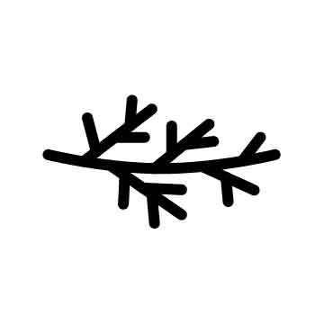 | Letter to Parent or Guardian  Date: Add

Dear Parent or Guardian:
We are very excited to inform you that your child will have the opportunity to participate in a health education program that we will be implementing in the [school, after-school program, summer program, etc.], called Native STAND (Students Together Against Negative Decisions). This curriculum is designed to help students make better decisions about their health. The curriculum is a comprehensive health curriculum that addresses sexually transmitted diseases, HIV, unplanned pregnancy, drugs and alcohol, dating violence, mental health, and other important issues that impact our youth today. After the training program is over, your child will be able to help themselves and their friends make healthy decisions.
There are 18 sessions in the curriculum that last about one hour each. These may occur weekly, or more frequently, depending on the program is delivered.
Your child’s participation in the program is voluntary. You or your child may choose not to take part. Please let me know if you do not want your child to participate in the Native STAND program.
Thank you for consideration.

Tribal Health Educator
[CONTACT INFORMATION HERE]

___ (Check here) I want my child to participate in the program.
___ (Check here) I do not want my child to participate in the program.
Child’s Name (Print):____________________________________________________________
Parent/Guardian Name (Print): _____________________ Signature: ______________________
Date:________________

