Bounce Back for Classrooms Fact Sheet

Bounce Back for Classrooms: A Social Emotional Learning Curriculum for 2nd-5th Grade Elementary Students is a curriculum that supports students in better understanding the normal effects of stress and trauma and helps them build skills and healthy coping strategies that promote healing and resilience. The curriculum is for 2nd – 5th grade students and can be taught in classroom or other educational settings.

In 12 lesson plans, students will learn about:

- The body’s danger response
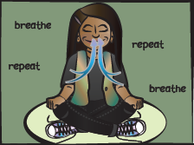
- Signs of stress and trauma
- Connections between thoughts/feelings/behaviors
- Identifying feelings in self and others
- Measuring intensity levels of feelings
- Regulating feelings
- Identifying helpful and unhelpful thoughts
- Generating helpful thoughts
- Social problem-solving
- Identifying resources of support

Bounce Back for Classrooms (BBC) can be implemented by teachers or others skilled in supporting children’s social, emotional and behavioral development. There are 12 lesson plans, each requiring approximately 50 minutes once per week for 12 weeks.

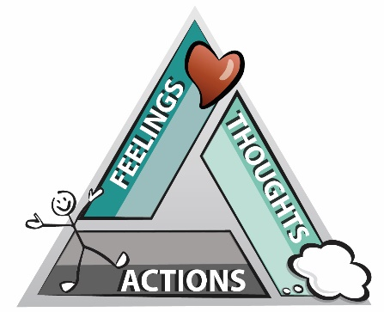

For more information contact:
Debra Klemann or Amy Foster Wolferman
National Native Children’s Trauma Center
www.nnctc.org
Debra.Klemann@umontana.edu
Amy.FosterWolferman@umontana.edu

Bounce Back for Classrooms is an adaptation of the Bounce Back: An Elementary School Intervention for Childhood Trauma intervention developed by Drs. Audra Langley and Lisa Jaycox.

