GATHER

Identify Youth Advocates and Community Partners

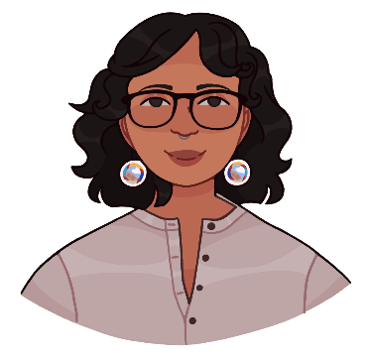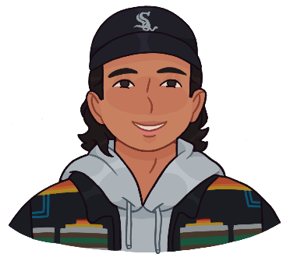

**Get Support**: This is a resource that can help you identify community partners and key decision-makers that can help support the delivery and implementation of your program. These partners may have resources or contributions beyond what you can think of, so stay open to learning about what they are doing and how they want to work together.

**Instructions**: In the left column, brainstorm potential and existing partners that can support your work. Include actual names or organizations, if you know them. There are a few categories written in to get you started and a few “Other” spaces that can be used for partners that don’t fit into the other boxes. In the right column, list ways these partners can support or participate in your programming.

**Canva Link**: You can edit the template on Canva to better meet your needs. You do not need to have a Canva account, just click on the link below to edit, download, and share.

[https://www.canva.com/design](https://www.canva.com/design/DAEQnYz7Wyo/xzFjvw_b6MyHO2D-Jzi0iw/view?utm_content=DAEQnYz7Wyo&utm_campaign=designshare&utm_medium=link&utm_source=sharebutton&mode=preview)

**Source**: Adapted from Trevino, N., & Gaston, A. 2020. Healthy Native Youth: Virtual Adaptation Guide. Portland, OR: Northwest Portland Area Indian Health Board. Section 2.1 Identifying & Building Partnerships.

