IMPLEMENT

Energizers and Wellness Moments

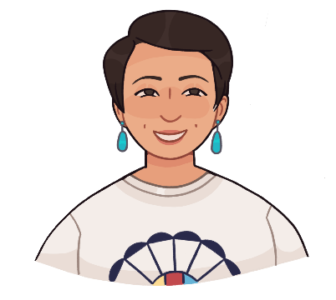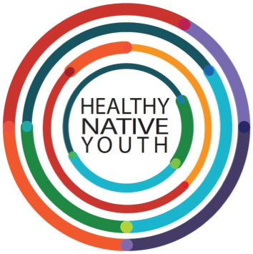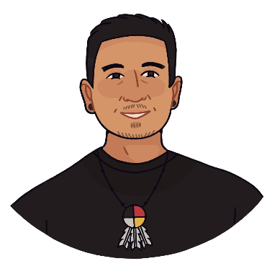
Instructions: Now the fun part – you get to work with youth and teach them important life skills along the way. Your participants will need time to process all the new things they are learning so be sure to schedule in energizers and wellness breaks. Here are a few tools to help increase youth engagement and buy-in, so you can implement your program with confidence!

Use energizers and wellness moments to break up your lessons and teach youth healthy self-care strategies.
In-Person Ideas
- Helpful link: HNY Icebreakers
- Cultural Sharing - Make time for cultural sharing at the beginning of sessions and ask for volunteers to bring something to share or prepare to talk about something from their culture that is important to them. This can be a great way for youth to get to know each other and to bring culture into the room. Cultural sharing can include sharing a description or picture of their favorite cultural food, a cultural item they can show to the group, a word in their Native language, a virtual smudge or a story. Cultural sharing can also be done using the image search option on Jamboard.
- Nature Walk - Take a walk and encourage your students to engage all of their five senses in observation.
- Deep Breathing - Take a deep breath in through your nose. Breathe out through your lips. Take your time with each breath. Do this breathing 3 to 10 times. Notice how you feel at the end of the exercise.
- Mindful Observations – Observe one thing that you can feel. Observe one thing that you can see. Observe one thing that you can hear. Observe one thing that you can smell...
- More Mindfulness Ideas: www.waterford.org/resources/mindfulnes-activities-for-kids

Virtual Ideas
- Participant Photos - Ask youth to submit a picture so you can use it in class if they can’t be there in person. They can also use the photo for their Zoom profile picture in case they have to turn off their video.
- Breakout Groups - Use breakout groups to split youth into smaller groups and use small group energizers/activities the way you normally would. These small groups are great for getting to know each other through discussion questions.
- Cameras on/Cameras off - Have youth use the Zoom video settings to select “hide non-video participants.” Then ask all youth who are able to turn their cameras on. Then select one youth to share something they like or something about themselves that might be true for others too. Everyone who agrees or also likes what was shared can keep their cameras on, those who disagree or don’t like what was shared can turn their cameras off. The youth who shared can select someone with their camera on to go next. Continue until all youth have shared. Make sure that everyone gets a chance to go, even if they don’t or can’t share their cameras.
- Draw your neighbor - Draw the person to your right and share your drawing via camera or shared screen.
- Online Brainstorm - Use Jamboard, Peardeck, or Padlet to get youth brainstorming for lesson activities or as opening/closing activities. These activities can be done anonymously or with youth logged in. Youth can respond to fun questions such as: what is your superpower, what are your favorite things to do in your community, etc. This type of activity can also be great to have youth provide responses to reflection questions or other lesson topic brainstorming.
- Get to Know You - Pose a “get to know you” question (e.g., what’s your favorite song right now, what are you watching on Netflix, how would you describe your TikTok persona, etc.) and allow youth to answer round robin style or in small breakout groups.

